CHAPTER ONE
THE PIT ON THE DOWNS

Built into a hill which hides it from the East and, to the West mostly obscured from the community it serves, by a pit heap, Eppleton Colliery in 1975 reached a unique target - 150 years of mining. On October 5th, 1824, agreement for the development of a colliery at Eppleton was reached between Francis Mascall, and his son Francis, the landowners, and the owners of the Hetton Coal Company, Archibald Cochrane; George Baker; James Dalton; John Tower; William Shotton; William Charleton; John Wood; Robert Watson Darnell; Arthur Mowbray; John Collingwood Tarleton, John Dunn; William Erskine Cochrane; and William Lynn Smart.

The sinking of the Jane shaft at Eppleton began on May 23rd, 1825, and little is known of the subsequent development of the pit until 1828. In May of that year a Mr John Buddle wrote to Mr Francis Mascall informing him of a proposition to lay a railway line through the Eppleton Estate which would connect to the railway line used by Lord Londonderry to transport coal from his Rainton Collieries to Seaham Harbour. Mr Buddle's letter to Mr Mascall ended with comment that the Eppleton Colliery was doing quite well. It is interesting to note that at this point of time Eppleton Colliery belonged with Hetton Lyons and Elemore Collieries, to the Hetton Coal Company.

Following the sinking of the Lyons Colliery in 1820, the Hetton Coal Company had engaged George Stephenson, the famous engineer, to design and lay a railway from the Lyons to the company's Staithes on the River Wear at Sunderland. Opened on November 18th, 1822, the line was eight miles long, had three locomotives (puffing billies), five self acting inclined planes, five fixed engines and there were seven drops at the staithes for the shipping of the coals. The sinking and the development of Eppleton Colliery, some years later, can be seen in the context of these moves, to be part of a plan by the owners to build a mining complex of collieries, and their subsidiaries, allied to a 19th century rapid transit system.

But the making of a coal mine in those days also involved the making of a community. Often self contained, and frequently inward looking, these local villages were so closely identified With the daily life of the pit, that the story Of Eppleton Colliery is also a part of the social history of its community. Much of the history of that time has come down from its local diarists - men of the mine - whose landmarks were mostly dates of deaths, union struggles and pit disasters, and one of these landmarks came with the county wide strike of 1832.

It was a strike against a form of human bondage for in those days miners had to sign a yearly bond, binding them to the owners. Many men were unable to write their own names, but it was a form of illiteracy which did not stop them from helping to write one of the first pages of local union history. Miners unions were not firmly established, or organised, but there existed the Co-operative Union known locally as "Tommy Hepburn's Union", and this was to provide the voice of the miners in the bitter struggle which followed.

With all the Collieries, including Eppleton at a standstill, the owners engaged new hands to replace the men on strike. But the strangers needed accommodation, and the local colliery houses were in the hands of the strikers. The solution was resolved in a policy of forcible ejection backed by a strong force of London police and the military, while workmen who had refused to join the strike were armed for their own protection. No resistance was offered as families were evicted and the furniture put on the streets. As the evening came near there were many ominous signs that the peace that had characterised the proceedings would be broken at night. The events of the one night were to become part of the local folk-lore of Hetton with the discovery, next morning, of the dead body of a man named Errington who had been shot to death.

Formerly a Union man, Errington was one of the few miners in Hetton who had agreed to rebound, and he had continued to work during the strike. The following Monday morning, the coroner, Mr T C Maynard arrived, and after an investigation which lasted ten days, a verdict of wilful murder was returned against George Strong and John Turnbull, as principles, and against John Moore and Luke Hutton as accessories before the fact. Detailed in the History of County Durham, published by William Fordyce in 1857, the incident was recalled as follows- "The four men charged with murder, were committed to Durham Jail under an escort of Cavalry, were loudly cheered by their comrades, and so strong was the feeling of the occasion, that when the funeral of Errington was passing the doors of the pitmen, they assailed it with yells and excretion".

More special constables were now sworn in and armed, and the rights of free assembly withdrawn as the police were under orders, wherever they found a few miners standing together, to lock them up either in stables or in the empty houses. A contemporary record of the time recalls that a large number of arrests were made, and those so taken treated with great injustice and indignity. One of the methods of the time being to bind those arrested hand and foot against the mangers in the stalls where they remained all night. Resistance meant the reprisal of having a threatening cutlass, or pistol, held to their faces. It was also observed that it was not the most riotous or disorderly who were always arrested and treated in this manner, but frequently the men who had played the leading role in local union affairs.

With cajolery and intimidation added to the harassment of those persons being punished in this way, many gave in and the owners succeeded in getting the collieries to work again in some parts of the County. Rumour was added to ferment dissatisfaction against union leaders, men were not permitted to gather for fear of arrest, and as newspapers were not widely circulated, the strikers had only their delegates' reports on the progress of the strike.
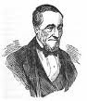
So the strike began to draw to the close toward the end of 1832 as the men agreed to sign the yearly bond. But there were many the owners would not have back, and these were chiefly union men. One of these was Tommy Hepburn, and it was not until he had promised to cease his union activities that he was allowed to work at Felling Colliery. Tommy Hepburn also has a special place in the Eppleton story, as he worked at the Hetton Colliery in 1831 and was their miners' delegate to the union.
Thomas Hepburn

In 1833 the first coals at Eppleton were drawn from the Jane shaft and the inhabited area of the district had most houses was situated near Eppleton Hall. For workmen and sinkers at the colliery there was a settlement of houses made of sod in the Low Downs district, while a "Fad" (or compound where all the colliery horses were kept) was situated in Low Downs Square.

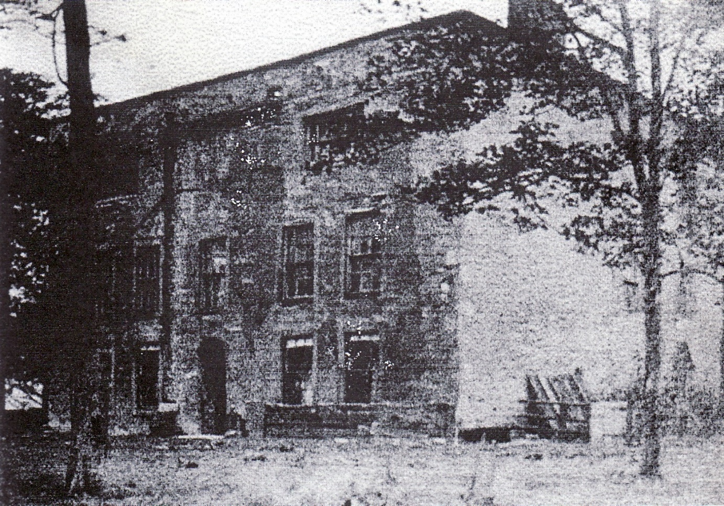
Eppleton Hall 1950’s

The controversial years of 1832 had seen the men of Eppleton win a pit for production and take part in a losing strike. It is one of the ironical facts of history that the quiet progress in human affairs usually passes without comment, and the next mention of Eppleton Colliery is delayed for four years, until 1896, when the colliery had its first disaster.

CHAPTER TWO
THE WIND BLEW SO STRONGLY

“The wind blew so strongly as to induce him to believe that an explosion had occurred in some other part of the Mine", was part of the statement made by Henry Gustard, a Deputy Overman in the South Pit, when he gave evidence on the twenty men killed in the explosion at Eppleton Colliery in 1836. The death roll reported in the Durham Advertiser, read;
George Newton aged 40, left a wife and five children.
Thomas Kay, Downs Lane, aged 38, left a wife, confined with her eighth child, which died afterwards, and was buried with him.
William Wears, Houghton, aged 35, and Richard Findley, High Downs, aged 31, left a wife and two children each.
Simon Tate, Hetton, aged 31, left a wife and three children.
James Cowens. Downs Lane, aged 25, and John Milburn, aged 23, left a wife and one child each.
John Clegram, High Downs, aged 30, left a wife.
John Clegram, a cousin of the aforementioned, aged 24;
Thomas Findley, the brother of Richard Findley, aged 27;
William Halliday, High Downs, aged 19; Mark Dodds, Hetton aged 18; William Surtees, High Downs, aged 17; and William Henry Blake Costdle, High Downs, aged 17, were all single. Two minors, John Gardiner, Hetton aged 16; and Anthony Cummings, Downs Lane, aged 12 years.

The following were taken out alive, but have since died: Robinson Harland, Hetton, aged 23, single; John Walton, Downs Lane, aged 14; Edward Dodds, Hetton, aged 13; brother to Mark Dodds; and William Ward, Hetton, aged 20, single.

The inquest was held at the New Inn, Hetton le Hole, before the Coroner of the Easington Ward, Mr T C Maynard, on the bodies of three of the deceased - John Gardiner, Mark Dodds, and John Milburn, and lasted two days. The compilers of this record believe it to be relevant to recall the tragic sequence of events by looking at some of the evidence given at the hearing.

John Kendall, of the Brickgarth, Easington Lane, one of the Deputy Overmen in charge of the First North Board Way, recalled that he went down the pit on Thursday morning at a quarter before two o'clock. He visited all of the workings of the district where part of the men were working, but the others had not yet arrived. The second shift men however had all come in before he left, which was about ten minutes past ten o' clock. He considered the pit at the time of his examination to be perfectly safe, adding that none of the men had made any complaint about the working being in a foul state. The pit itself had not been worked for very long, and the workings themselves were very small. The air was very good and there was a sufficient quantity of it to enable the men to work with safety. There would be fourteen men working in that part of the pit when he left.

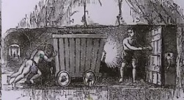
Kendall went on to describe the situation, and operation of the trap door in the district which was to play such a crucial role in the tragedy, because the shutting and the opening of it governed the course of the air. The men of the district worked with candles, and no lamp were used except in the Waste. To direct the air into that part of the pit where the men were working, it was necessary to keep the trap door shut; and every possible precaution had been used to prevent the accident. The boy in charge of the door, aged about 12 years, was named Anthony Cummings. At about eight o' clock in the morning Kendall had found the door opened, although it had been closed when he was there about five minutes before. Kendall had observed that the tubs, on which the coals were being carried to bank, had been placed so as to prevent the door being shut. He had found fault with the putters for this; but they in turn had complained about the young trapper for keeping them behind with their work. Witness had then moved the tubs backwards and closed the door, pointing out to both putters and trapper the danger of this door being left open. He had received their promises that this would not happen again. The trapper boy and putters, he added, would not be changed in the usual course of events until half past four in the afternoon.
Trapper Boy

Continuing his evidence, Kendall said that he went down the pit yesterday afternoon about half past three. He found that the trap door had been blown away and a stopping substituted to give the air a proper direction. He was of the opinion that the door must have been open at the time of the explosion. Because if it had been kept closed there would not have been a sufficient accumulation of foul air as would have caused an explosion. No person at the pit had anything to do with the trap door apart from the trapper and the putters. Cummings, the young trapper, was dead, as were three of the eight putters employed in the district - William Halliday, Mark Dodds and Edward Dodds. Witness said that he had been employed in the pit for three months and had never seen anything which made him believe there was any danger of an explosion. Neither had he heard of any such fears of the kind from any of the workmen. He repeated part of his previous testimony by saying that the last thing he did before he left the pit in the morning was to warn the trapper and putters to keep the door closed.

Ralph Joplin, the Deputy Overman, who had to succeed witness, had not gone down when he left. He had to go down at two o' clock. Kendall explained that the Deputy Overman of the North Board Way takes charge of the first of the four hours when there is no Deputy there. At about six o' clock in the morning, he had met Cummings at the first wall from the flat - the place where the tubs were put upon the rollers - about ten yards from the trap door. He had censured the boy for leaving his door, but the lad had replied that William Halliday had sent him. Cummings had said that he thought there was little harm in him doing this when no person was at the flats. He had cautioned the boy not to let this happen again.

Henry Gustard, another Deputy Overman, in the South pit, testified that he was at work in the West part of the pit, at between one and two o' clock in the afternoon, when the wind blew so strongly as to induce him to believe that an explosion had taken place in some other part of the mine. He hurried with the men and boys under his charge to the shaft. Gustard's description of the scene in the First North Board Way when he reached it was graphic. He was told that the crossing had been blown away, so he went to bank and got some brattices which he took down and laid over the crossings so as to convey the men into the workings. With William Clark, he then began to explore the workings and found Robinson Harland lying exhausted on the ground, and this man was conveyed to the shaft. Cummings and two other boys were discovered lying dead about six yards from the trap door. John Wears and John Cleghorn were lying dead on the tramway near to the trap door. After passing the trap door they found John Liddell lying in the First South Wide Board exhausted by the effect of the afterdamp, but not burnt. He was got out and alive. Further on they found Thomas Kay and Richard Findley dead. As Liddell was being taken to safety Gustard had noticed four other men lying apparently dead, as he passed these to go in search of others who might be alive. John Milburn was also found lying dead in the First North Board. It was Gustard's opinion that the explosion had taken place there, and he had no doubt it had been caused by leaving the trap door open. He did not think it could be caused otherwise.

The last part of Gustard's testimony concluded with a number of observations which would appear to be astonishing, in view of later developments in pit safety standards, although it should be remembered that his opinions conformed with the general thinking of the day. After corroborating the last witnesses' testimony as to the general state of the mine, he said the pit was considered to so safe that the use of the Davy Lamp was considered to be unnecessary, but there had been no objections to its use by any of the pitmen. The district had had a slight fire a week ago, but no one had been injured, such fires he said occurred in the best ventilated pits. He believed that if Davy Lamps had been used there would have been no explosion. The method of getting coal in First North Board Way was by working with gunpowder - which was easier for the men, and he did not believe there was any danger in its use in a pit where it was safe to use candles. The workings of the Downs Pit were not extensive, and there would be no lesser accumulation of foul air in it than in other pits with more extensive workings. The pit was safer in that respect than many others that he had worked in.

Medical evidence on the victims was given by Mr R Edgar, Surgeon at Hetton le Hole, who said that he went down the pit after the explosion and found Richard Findley, Thomas Findley, George Newton, John Gleghorn, Thomas Kay, John Gleghorn (cousin of the former person with then same name), James Cowens, Simon Tate, John Milburn, John Gardiner and John Wears, all lying dead. He had no doubt that the deaths were due to an explosion of hydrogen gas. Mark Dodds had been badly burned and he had died in consequence. William Surtees had similar injuries and had also died, while Edward Dodds, who had been got out of the pit alive, died later that day. William Halliday had also been badly burned, but the witness was of the opinion that his death had been caused by his skull being crushed leading to concussion of the brain. William Edward Costdle had been killed by something heavy falling on his breast, while William Ward, John Walton and Robinson Harland had been severely burned and were not yet out of danger.

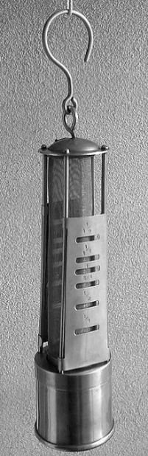
Ralph Joplin, who had been referred to in the evidence of a previous witness, said that he descended the pit about two o' clock in the afternoon after some men had come to bank and reported that an explosion had occurred. He described the finding of some of the victims in the workings. He expressed an opinion that an explosion had taken place in the First Wide Board close to the trap door. He had examined the pit carefully before he left work at ten o’clock on Wednesday night. There was not only no accumulation of inflammable air, but what he described as "a particularly good air". He had considered the pit perfectly safe for men to work without using the Davy Lamp, but he also expressed the opinion that if these lamps had been used, he did not think the explosion would have happened. He also said that there would have been no explosion, even with the use of candles, had the trap door been properly closed. He concurred with the opinion of the witness Gustard, about working the pit with gunpowder. Joplin said that he had never known the boys who kept the trap door to neglect their duties. But he had made a point of cautioning these lads every day to be attentive to their duties. Describing the operation of the trap, he said that it was on the barrow way. It was not used by the horses as the trams with the tubs of coal were taken through the trap door by the putters. Six trams were at work in that part of the pit, and if all these were to pass through together, it would not take more than six minutes. If the door was only kept open that length of time at once, it would not render the pit foul, or at all dangerous. If all the trams were to come into the flat together, he added, there was sufficient room for them to stand without interfering with the trap door. He was quite convinced that the explosion must have occurred because the trap door had been kept open too long.
Davy Lamp

In his evidence, William Clark, one of the Overmen of the Pit, said that he took charge of the whole of the mine from two o' clock in the afternoon until ten at night. He carried out an examination the night before the explosion and found every part of the pit safe. He attributed the cause of the explosion to neglect of the trap door and the blame would lie with the trapper. But it was a fact that these boys were often forced from their duties by the putters who were older. Witness had never heard the men complain about the pit being unsafe, or express any wish for Davy lamps to be used. In fact they objected to its use even in places where danger was known to exist because they received better light from a candle.

Similar evidence was given by John Maughan, another Overman, who stated that in some parts of the workings inflammable air accumulated more rapidly than in others. The accumulation of inflammable air in the area where the explosion had occurred had not been any more pronounced than any other part of the pit under normal conditions. Maughan expressed his view that he had not the slightest fear of any danger while working in this part of the pit.

The above was the whole evidence given on the first day of the inquest.

CHAPTER THREE
CANDLES AND GUNPOWDER

A pit village mourned its dead, and there was no generation gap among the deceased. Wives had lost husbands, children their fathers, and parents their children, as there was no exemption from the hard life of the mine for the very young. The Durham Advertiser again takes up the story in providing a record of the evidence of the second day of the inquest.

First to be called was Mr George Hunter of Penshaw, a Viewer (mine owners agent) to the Marquess of Londonderry, who said that he had yesterday examined the workings of the pit in company with Mr Buddle and Mr Appleby. He had found the workings quite clear and the ventilation restored, and concluded in these circumstances that the pit must have been in a safe working state, with the exception of the First Wide Board where the explosion had taken place.

The cause of the explosion attributed by him, to be due to the trap door being left open too long, because of the neglect of the trapper. Ventilation has been so speedily restored after the explosion that he had no doubt that the workings would have been in a safe state had there not been negligence with the trap door. Hunter was also of a definite opinion that the candles would have been safely used prior to the explosion had due attention been observed at the trap door. He was also of the opinion, with a reservation as to the present ventilation, that the candles might now be safely used there if the trap door was properly attended.
Gunpowder, he observed, might be safely used in a mine where candles are employed, and he went on to state that when the trap door is improperly kept open, then the atmospheric air is diverted from its proper course. The boards become foul and explosion ensues. Witness did not think that the passing of the tubs through the trap door would be sufficient to render the air impure, and added that the use of iron tubs in the mine would not, in his opinion, have the effect of causing the air to deteriorate. On the contrary, he considered them to be advantageous rather than otherwise. To the best of his judgement, and speaking from his knowledge of the use of iron tubs in South Hetton Colliery, the use of iron tubs did not make the slightest difference to ventilation. He had, not in his experience, discovered any difference between the use of iron tubs and corves.

Confirming evidence to Mr Hunter's statement was offered by Mr John Appleby of East Rainton, Coal Viewer.

In his evidence, Mr Joseph Hall, a Pitman, said that he was at work in the mine on the day before the explosion. The First Wide Board was in a very bad state due to the lack of fresh air when he had left about three o' clock in the afternoon of that day. This part of the pit was not usually in a bad state of ventilation, but it was on that day. Hall said that he had used candles and gunpowder, but in his opinion it had not been fit to use candles at that time. He had told Kendall, a previous witness, that the pit was very slack of fresh air. Kendall had been in the First Wide Board before that, and Hall saw him put some fresh brattice in. Kendall had told Hall that he had pulled some of the stone off the top of the fall, at the back of the brattice, to let some more air in, but Hall had noticed little difference in the ventilation. Hall also observed that he thought he was working in a dangerous place, but he had only worked there for nine days. In the previous quarter he had worked in the Board adjoining the First Board, and found the air slack. He had made no complaint concerning the Board because, in his own words, "he thought it needless to do so because they could make no better of it as it was the hindmost of the air" He added, however, that had he done so, he had no doubt that the problem would have received attention. The air depended on the trap door being closed, but had this been attended to, he could not say that the pit would have fired. He believed, however, that the door had been neglected sometimes.

Thomas Sanderson, a Pitman who had worked in the Fourth Wide Board, near the scene of the explosion, said that neglect of the trap door would have been sufficient cause for the explosion. He had worked thirteen years in the pit and had never known anything refused that was requested for the safety of the mine. He believed, however, that the big tubs in the shaft injured the air.

George Wear, another Pitman, thought in his evidence that there should have been a door at the First Wide Board end. He believed that this would have prevented that part of the mine from becoming foul. He had suggested such a door to Kendall three months ago, and then to Maughan who had ordered the door to be put up. When this had been done it had cleared the air at the Board. This door had stayed there, from pillar to pillar, for the last three months he had worked there. But when he left the course of the air had changed because the door was not hung on the pillar and the air had become slack. It was his opinion that had such a door been in operation then the explosion would have been prevented. He concluded by saying that it was the duty of the trapper to keep the door closed as much as possible. But had it been left open, even for an hour, such a door as he had recommended would have prevented an explosion by causing some circulation of air.

Comment: The witnesses Hall and Sanderson had previously expressed an opinion in favour of the type of door suggested by Wears, but they both admitted that if the trap door had been neglected then such a door would have been of no "avail".

Robert Patterson, a Pitman, said that he was at work in the Third North Board about twenty five yards from the trap door on Thursday. At the time the state of the workings was perfectly good and he saw no deficiency whatever. The air was perfectly good and there was no lack of it. The explosion took place at about half past one o' clock in the First North Wide Board. He attributed the cause to the trap door being kept open too much. He had no fault to find with the tubs or anything but the trap door. The men had used candles and gunpowder with safety and this could only be done in a well ventilated pit. Kendall had explained that it was not necessary to hang a door such as suggested by Wears because the air was changing. It would not have prevented an explosion and it would still have been necessary to keep the trap door shut.

Giving evidence, George Hills, a Pitman, who was in the pit when the explosion occurred, said the mine had previously been in its normal state. He did not know the cause of the explosion, but it was necessary to the safety of the pit that the trap door should be kept closed as much as possible.

The last person to give evidence at the inquest was John Robson, Viewer of Hetton Colliery. After giving an explanation of the method in which the Downs Pit was ventilated, he went on to say that he was down the pit on the Saturday previous to the accident. The ventilation on that occasion was good, quite sufficient for every purpose — and amounting to 20,000 cubic feet per minute through the whole of the workings. He said that he had gone down the pit again, about an hour after the explosion, and he described the means resorted to for getting a current of air into the workings. It was his opinion that the workmen killed who had not been burnt by the explosion must have been suffocated by the after-damp. He also stated that the use of candles and gunpowder in the pit was safe, and also that the explosion must have occurred through neglect of the trap door. The iron tubs could not have produced foulness in the ventilation. The ventilation at present was very good and sufficient for safe working.

The evidence having gone through, the Jury returned as their verdict-"That the deceased had come to their deaths by the accidental and casual explosion of a quantity of inflammable air in the Pit".

CHAPTER FOUR
PENNY WISE AND POUND FOOLISH

Following the resumption of work at Eppleton after the explosion, things settled down to normal everyday working at the pit, and continued without serious incident until 1844, when once again Miners through-out the County went on strike. The strike was against the enforced reduction in wages and the signing of the yearly bond. Evictions and sufferings were again experienced by the Miners and their families. The Coal Owners brought in strangers to fill the places of striking miners. But, different from the strike in 1832, the strikers exercised restraint against violence, and after nineteen weeks, due to hunger, and for sheer survival, they succumbed to the Owners' demands. Those who were allowed to, returned to work for a reduction in wages.

Two strikes in twelve years had gone side by side with winning of the pit and its subsequent technical development. The Caroline shaft which was started in 1824, and abandoned after sinking about 65 fathoms because the volume of water was too great for the pumps, was reopened, and further sinking was begun on 29th September 1853. The Hutton seam was reached on 8th August 1855. These dates are recorded in an old diary, and a further note in the diary informs that the Maudlin seam was proved and got in November 1866.

The hazards of early mining, however, were ever present, and in the next year the colliery faced danger from an unusual source when a fire occurred in a wood cabin near the shaft -"Fire at Eppleton Colliery", is the heading in the Durham Advertiser of Friday 15th November 1867. Mr T C Maynard, Coroner, held the inquest at Mr Walker's, the Hetton Colliery Inn, concerning the death of Robert Thompson, a Deputy. It appears from the evidence that between two and three o' clock on the morning of 7th November, 1867, a fire broke out in a cabin situated on a wooden stage near the shaft. Every effort was made to extinguish the flames and prevent the fire from spreading, but without success.

Within ten minutes of the time the fire was first discovered, the pulley frames of the screens had taken fire and the flames raged above the pit shaft. Thick volumes of smoke descended the shaft and extended into the workings of the Colliery. A large number of men were in the mine at the time and as soon as they found the air becoming stythey from the smoke they attempted to make their way out. A Deputy Overman named Gardiner, who had a number of men under his charge, conducted them from the intake in which they were working and along the return and they ascended by the upcast shaft. It had been the custom at the colliery for the Deputies and their men to travel the return every three months so that they could be familiar with it and it was expected that Thompson and his men would come out this way. When however they did not make an appearance, an exploring party was sent down to search for them. Several of Thompson's men were found lying in the intake in a state of insensibility, and Thompson himself and three of his men were found lying near the downcast shaft. From this it would appear that they had left their district and gone up to the intake towards the downcast shaft in the face of the smoke. It was proved that they had plenty of opportunities to get into the return because on their way from Thompson's district to the shaft they had passed five main doors which led into the return and safety.

The men were taken out of the pit as speedily as possible by return, and upcast shaft, and sent to their homes, but Thompson only survived about three hours after his arrival there. The unfortunate man, who was 43 years of age, left a widow and two children. Mr Thomas Hepplewhite, Eppleton Colliery Viewer, said in his statement that there was a small portion of fire at the shaft, but nothing that could cause any harm. He had examined the returns and found them in good state. The smokey stythe had entered the return but was nearly exhausted, and a man could not have been affected by it. He added that there was nothing to prevent any of the men from getting into the return as it was a custom to travel the return with the Deputies every three months so that they might be able to avail themselves of it in case of emergency.

The wooden cabin which first took fire contained a small stove and was situated at the end of a wooden stage at the foot of the screens and at about six or eight yards from the pit shaft. The fire which defeated all efforts to extinguish it had quickly spread from the cabin to the screens and pulley frames and also to some frames. The Jury returned the verdict "The deceased died on the 7th inst., from suffocation by smoke in the Eppleton Colliery caused by a fire at bank".

The Coroner, in his comments, thought it was a "penny wise and pound foolish to put a wooden cabin so near to the shaft".

The death of two men who had probably pioneered much of the mine's early development occurred in the next two years; George Wales, Viewer at Eppleton, died June 23rd. 1858, and John Wales, Viewer at Hetton, Elemore and Eppleton Collieries, died April 3rd , 1859, an entry which leaves us wondering if the two men were related.

CHAPTER FIVE
TRUE GRIT AND LOYALTY

Since those early days of "Tommy Hepburns" Union, the Union throughout County Durham grew in stature and strength; the first meeting of the Durham Miners' Association took place on 20th November 1869, in the Market Hotel, Durham City. On August 12th 1871, the first Durham Miners Annual Gala was held in Wharton Park, and thereafter the Gala was to be held on the Racecourse. Tommy Hepburn, who was at one time employed at Hetton Colliery and was the Union delegate, died in 1864 after a series of strokes; he kept his promise never to become actively involved in union affairs, but his dream of a united Miners' Union was finally realised, something he never lived to see.
Thomas Hepburn

The very first meeting between the Durham Miners' Association and the Coal Owners' Association, which took place on 17th February, 1872, was most significant and successful; it resulted in the abolishment of the "Yearly Bond", whose accursed shackles had been finally broken.

Sinking commenced on the New Pit, or Lindsay shaft, in 1870, and on the 16th March. 1874, the shaft started daily coal drawing. The Jane and Caroline engine houses were built in the Autumn of 1880, an electrical signalling system was installed in the Caroline shaft and commenced man riding in April 1883, three years after the death of John Fawcett on 5th February, 1880, the first man to appear in the records as a manager at Eppleton Colliery.

Eppleton, now with three shafts on daily coal drawing, was proving to be one of the major collieries in the area, and with its growth, so too was the community growing. With the three collieries operating in Hetton it had become a closely knit mining community.

True grit and loyalty are part of the miner's make-up which has been proved on several occasions by the men of Eppleton, especially during crises and tragedies. On one such occasion this was highlighted when three men lost their lives on Friday, 13th December, 1895. The incident is reported in the Durham Advertiser and well worth a repeat here.
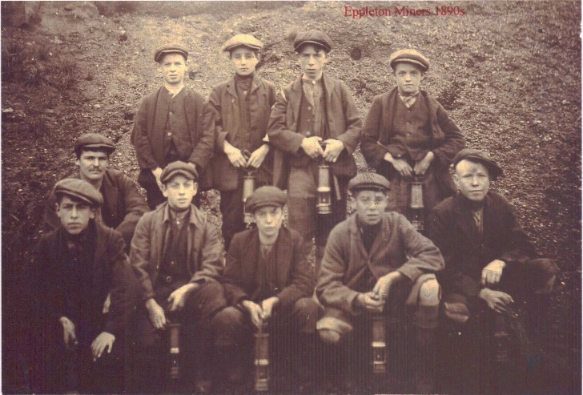
Eppleton miners circa 1890
"THREE LIVES LOST - GALLANT CONDUCT OF RESCUE PARTY" - A sad calamity occurred on Friday last at Eppleton Colliery, whereby three men lost their lives and two others were placed in extreme danger. The heroism displayed on the occasion stands out nobly as a direct contradiction to the aspersions cast upon the pitmen of Durham by one of her Majesty's Judges at the recent Assizes held for the County. From what can be gathered, it appears that on Friday morning Mr Mold, manager of the mine, during his usual rounds discovered an accumulation of bad gas in a district in the Main Coal Seam known as Third East. He gave instructions that this particular place be abandoned and battened up. The duty, it seemed, for the completion of this work to be carried out fell upon a young man named Thomas Brown, a Deputy aged 26 years. Before proceeding to put up the stopping, Brown determined to bring out a tub which in bye. Another Deputy named Heeding, endeavoured to dissuade Brown from so doing. Brown, however, persisted in his resolve and asked a putter, named R Lawns, 20 years of age, to go with him. The two men entered the place from what was subsequently discovered it would seem that after getting so far they left their lamps behind, and must have continued their journey in the dark. The action of Brown was known only to another putter named Laverick, who had been at work with Lawns. Laverick watched for the return of the two men with the tub. After a reasonable time had elapsed, and Brown and Lawns not appearing, Laverick became alarmed and hastened to the places of three hewers named James Evans, Anthony Harrison and Patrick McDermid, and informed them that Brown and Lawns had gone in the place condemned by the Manager, and he believed they had been overcome by the fumes of the poisonous gas which was known to be present. The three men at once rushed off to the rescue of their fellow workmen, never hesitating to thin for a moment of the deadly peril they were subjecting themselves to. The noble trio failed however, to reach Brown and Lawns falling victims to the overpowering influence of the vitiated atmosphere which surrounded them. The lad Laverick was still on watch, and when also Evans, McDermid and Harrison did not come back he became seriously alarmed, and running about the pit from one part to another he made known his fears as to the fate which had befallen the men mentioned. At this juncture Robert Hawxby, a Deputy in a different part of the mine, heard of the affair and speedily made his way to the place which the five men had entered. Hawxby raised the regulator, an apparatus used for the purpose of increasing the current of fresh air which is sent through the workings of the mine. This soon proved a wise precaution and the bad air was to some extent beaten back. An attempt was then made to get to where the five men were without doubt lying insensible. Hawxby led the way. Hall took charge of the lamp so as to give light to the other brave men who were with him.

The rescuers could only creep on their hands and knees or drag themselves along the ground. Hawxby had a nail in his mouth. This he believed was effective in drawing in what good air there was to be got below the thickened cloud of noxious gas through which he was passing. Others of the rescuers kept their mouths to the iron tramplates and thus benefitted to the same extent as Hawxby did. In this way the recuing party proceeded between fifty and sixty yards.

Hawxby felt himself touch the hand of one of the men who were being searched for. By this time he was beginning to feel so overcome by the impurity of the air that he was unable to bring out the man he had touched. Fortunately the condition of Hawxby was observed by Palmer who although suffering similar symptoms as the first named had sufficient strength remaining to drag his comrade out to a part of the place where the air was felt to be better. The other rescuers were compelled to follow; after a few minutes rest, and feeling themselves somewhat refreshed Hawxby again headed a glorious band and made a second attempt to reach the five men.

The rescuers were this time however able to get only about fifty yards when, owing to the effect of the suffocating air, they again had to retreat. This, Hawxby and his mates say, was a dreadful experience. They could hear the most agonising cries being given vent to by the poor fellows whom they were powerless for a time to reach. Their grief was such indeed that they declared in their weakened condition they wept like children. After another short rest the party felt themselves sufficiently revived to make a third attempt and this time in the course of a slow and tedious journey Hawxby got hold of one of the men. This man proved to be Evans, who was pulled out by his legs.

Evans was found to be alive and efforts were at one made to fully restore animation, which ultimately proved successful. The rescuing party put Evans into the hands of a number of miners who had gathered from all parts of the pit ready to give assistance in whatever form it might be wanted.

The rescuers were now too exhausted to gain return at once in the noisesome dungeons. While resting previous to make second rescue Mr Mold, Manager, Mr George Thompson, Undermanager, and Matthew Hall, Overman, arrived. Mr Mold was at home when the accident occurred but he lost no time in getting to the Pit on hearing the serious nature of the accident. The Manager, Undermanager, and Hall now formed themselves into a rescuing party, which Hawxby, although gravely fatigued and exhausted, again joined. William Hall also accompanied with lamp, and Palmer and the others were like wise in the party. All being ready the rescuers made their way into what was truly the jaws of death, having to drag themselves along the bottom of the seam as had previously been done.

The party succeeded after a painfully slow journey in reaching another man who was identified as McDermid. This man was, like Evans, insensible, but willing hands soon quickened his pulsation by a vigorous method of respiration.

Continuing their gallant labours the rescuing party were able to next bring out Harrison, then Brown and lastly Lawns, all of whom it is mournful to relate, were dead. When this became known the sorrow among the noble fellows who had dared so much was overwhelming.

The survivors were sent out of the pit to their homes where they were attended by doctors. The bodies of the dead men were decently enshrouded in pit clothes and sent out of the pit and afterwards tenderly conveyed to the homes which they had left a few hours before in the whole vigour of life. Brown and Lawns were not married. Harrison was married as was Evans and McDermid.

The newspaper ended the report with the following comment: "Eppleton Colliery is one of the most important in the East Durham Coalfield and 2,600 tons of coals are drawn from it daily. It belongs to the Hetton Coal Company of which Mr Lindsay Wood JP, is chairman, and Mr J Lishman JP, registered agent".

A tragic footnote to the story of the rescuers was added some years later when one of the heroes, the Undermanager George Thompson, was killed by a full set in the Jane Pit on Friday, 25th August, 1905.

CHAPTER SIX
OUR OWN KIND

The beginning of the new century provides the pause to look at what had been achieved so far in this history. In 1821, the population of the district was 919, and had risen by 1895 to over 12,700, so that Hetton had become an urban district consisting of three wards, Hetton, Hetton Lyons and Easington Lane. The gamble of the Hetton Coal Company, formed in 1819, had paid off, and the three collieries had become firmly established with Eppleton as the major contributor. Some idea of the rate of growth of the new community had been evident as early as 1831 when the foundation stone for the new Episcopal Chapel in Hetton had been laid for the services of the Church of England. It was also in the Coronation year of William IV, and a stone engraved with these characters was laid by a George T Fox Esq., of Durham City in the presence of the Coal Owners. A building known as St Nicholas' House was built in Front Street, Hetton, and served initially as a school for the children of Hetton Coal Company Viewers, and later was added to with adjoining Laburnum House, as residence for the Managers of Eppleton and Elemore Collieries, when a new school was built in Front Street. In his address for the occasion by Reverend ES Thurlow, Rector of Houghton le Spring, he described the chapel as "likely to be of great service to a neighbourhood where a population of between five and six thousand souls had sprung up within ten years from the successful workings of the Hetton and Elemore Collieries".

With improving conditions and wages in the mines, and a strong union to support them, improvements were becoming evident in the life of the community. But the need to look after
their own kind was always present, and the social conscience of the miners had already set up schemes which were to bear fruit. A first entry in the records of Hetton, Eppleton and Elemore Accident Fund shows a payment to a George Scott on 23rd May, 1864, of £33.12s.6d. Other funds were also beginning to operate to pay benefits to injured workmen, the main one being the Northumberland and Durham Miners' Permanent Relief Fund which had been formed in 1862. The social horizon was also brightening with the building of Aged Miners' Homes in the County, while a short step away into the future lay the provisions of pithead baths, Institutes, playing fields and parks. It is a reasonable argument that the men building the local community were also among the early pioneers in the kind of ideas which later helped to build the modern welfare state.

On Febraury 5th, 1880, John Fawcett, the first man to be named in the records as a manager of Eppleton Colliery, died. The pit itself, continued to provide the hazards of mining, for on December 13th, 1895, three men were suffocated in the Caroline Pit, namely, Thomas Brown. Anthony Harrison and Robert Lawns, and the diarist of the time also noted that it was a pay Friday. The community involvement with the pit has been remarked on several times in this record, and two incidents at the time saw tragedy reaching out of the confines of the mine and on to the streets of the village. In February, 1897, a man named Tom Taylor was killed by a locomotive on the line near the bridge at Cemetery Road, Hetton. An even more grisly incident occurred some years later on March 29th, 1905, when a George Fletcher, formerly of the Queen's Head, Richard Street, Hetton was found dead on the railway below the coal trucks at Hetton. It was reported that forty five full wagons and the locomotive had passed over his body.
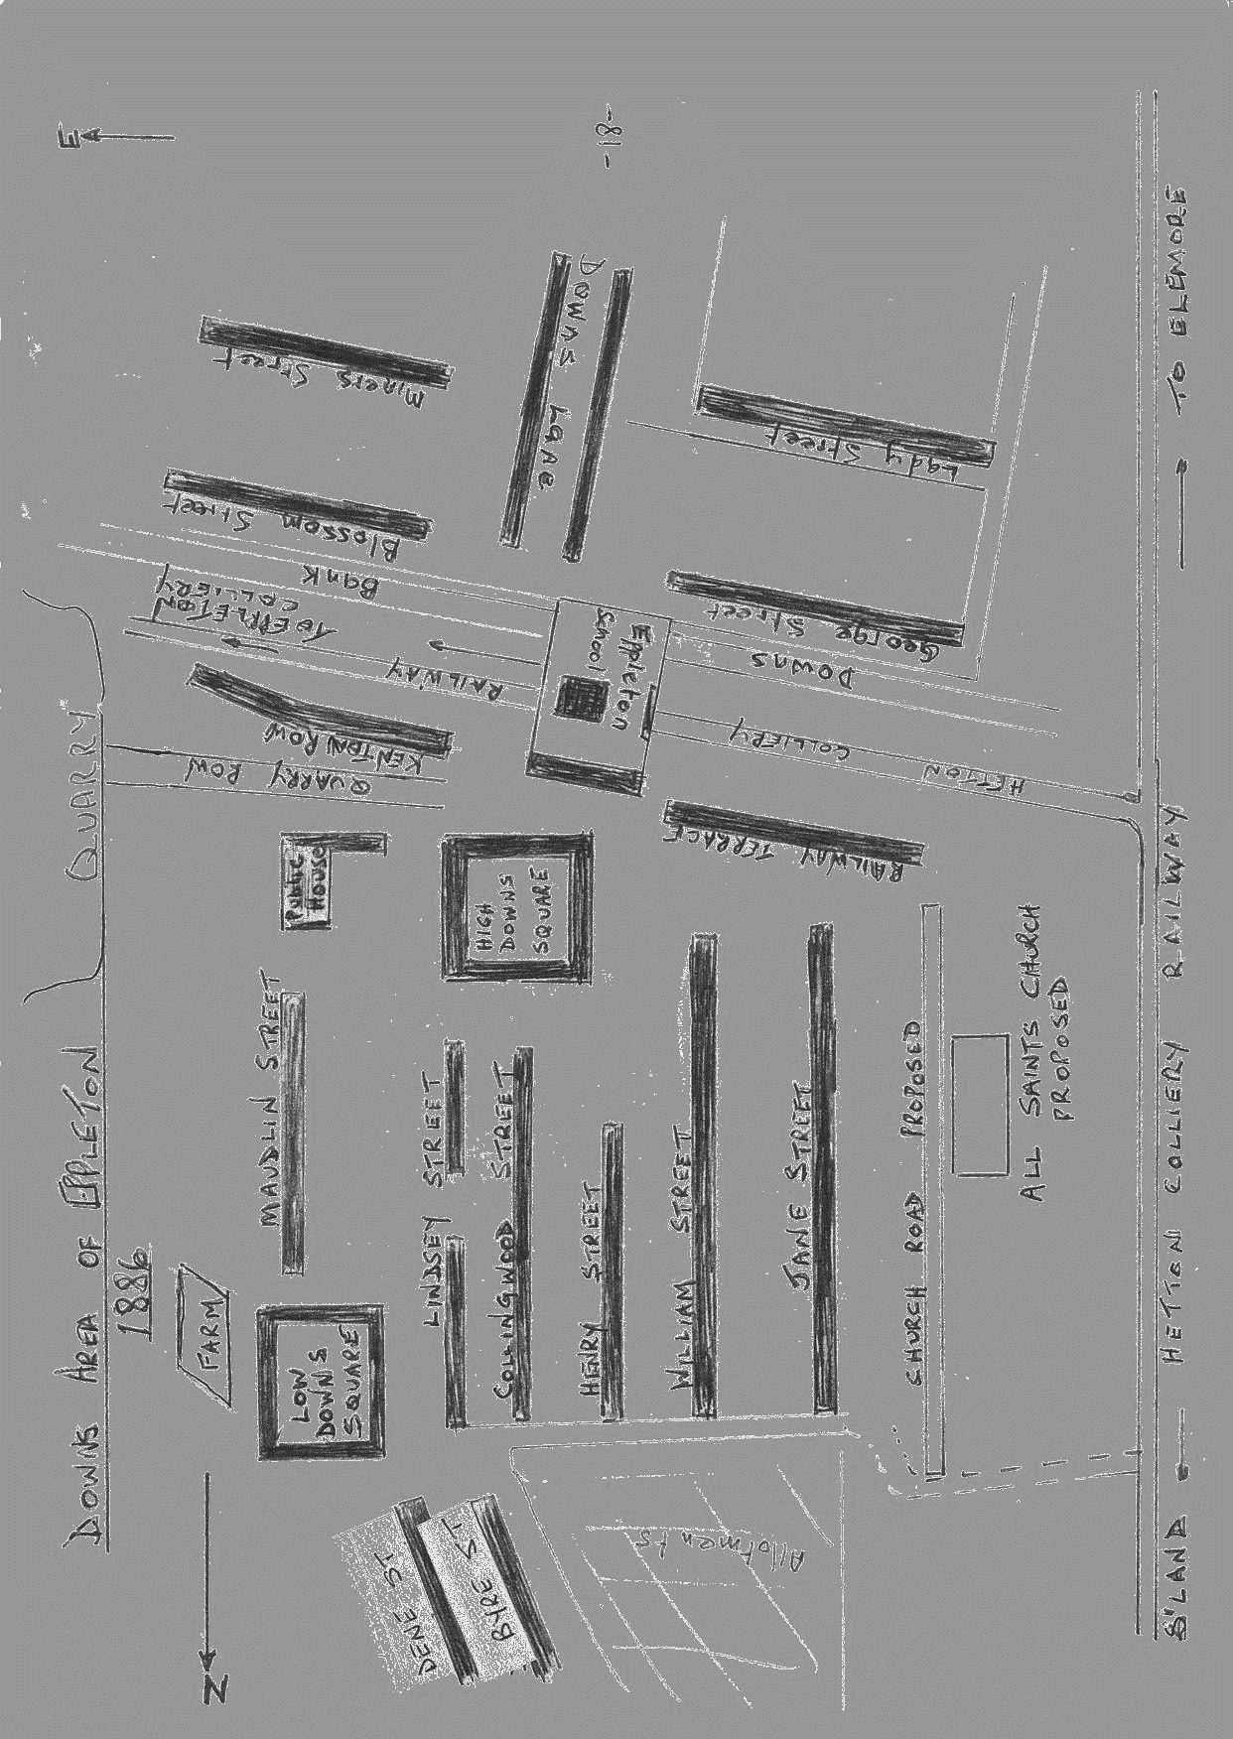
An interesting hand drawn map showing Hetton Downs 1886

In 1911 the Hetton Coal Company was merged with Lord Joicey's Group and Sir Lindsay Wood became Managing Director for the new Company. For a time his father resided at St Nicholas House, Front Street, Hetton. In 1914 the young men of Eppleton, as with many others, volunteered for the Forces in World War 1. Locally on March 1st, 1916, a German Zeppelin flew over Eppleton and released some bombs, with no damage to the pit.

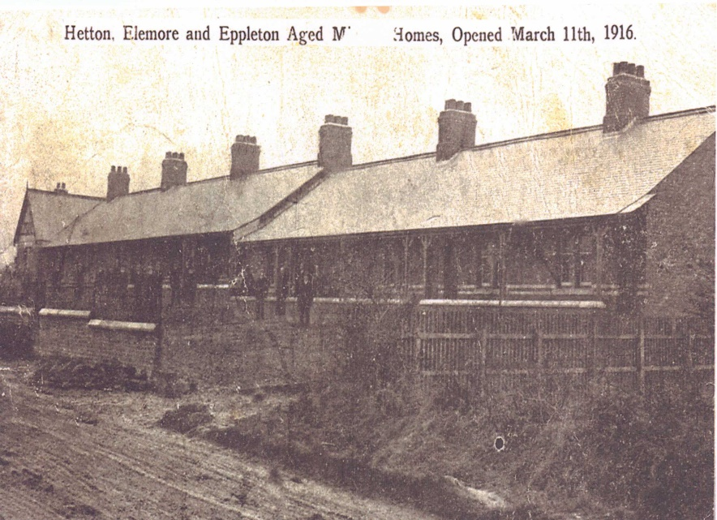
During these swift moving events the first Aged Miner's Homes were built at the Four Lane Ends, Hetton; the foundation stones having been laid on 31st July, 1915, for the Eppleton, Hetton Lyons, and Elemore Miners' Aged Homes Association. They were officially opened in March 1916 by Sir Lindsay Wood. Four years later on 23rd September, 1920, at the age of eighty six, Sir Lindsey Wood died; without doubt he had been a most prominent man in the development of the Coalfield and community.

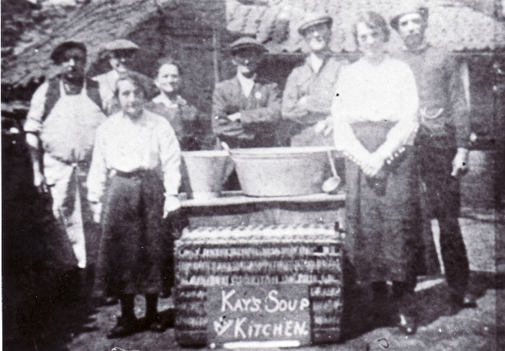
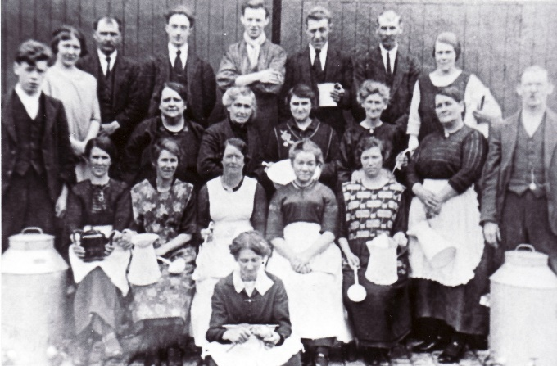
The end of the Great War brought an uneasy peace to the mining industry and in 1921 there was a lock out lasting thirteen weeks.
Soup Kitchen during the strike of 1921
At Eppleton the deepening of the Jane shaft was begun in 1925 with sinking to the Busty seam and the first coals from here were drawn on 17th August, 1925. Then in 1926 there occurred the General Strike in which the miners were to stay out for thirty one weeks.

With the mining communities going it alone for so long in the dispute it is interesting to look at some of the accounts and observe the facts of the time observed in the ironies of poetry and poverty. One writer saw it somewhat poetically in the Durham Advertiser:-

"The business man training up the Durham Coast the other morning might well have envied the miners and the pit ponies the freedom they were enjoying beneath a blue sky. One noted miners by the edge of the sunny sea, the surface of which, from the clean sands to the horizon, was still as a sheltered pool. One saw them also basking in the sun amid flaming gorse, or taking their ease with book and pipe in many a green and fragrant nook of where the coastline rose into the strength of rugged rock. And the pit ponies, of whom there were many, in one green and spacious pasture, were frolicsome and happy. Their coats were glossy and spirits high"

The fact, and the poverty, was captured not quite as neatly in the same paper in an item headed "Concert in Aid of Distress" "under the auspices of the Hetton Engineman's Association, a concert was given in the Miner's Hall, Hetton le Hole, by Mr Jack Hall's party. The artistes, who gave their service free, were Madam Barnard of Hetton. Master M Cruddace the boy vocalist, Messrs T Milburn, A Jackson, A Brown, W Fife, R Fatherley, Jack Hall and Tom Fairbairn the blind entertainer. Miss Creswell was an able accompanist. The concert was in aid of the distress fund and realised £6.

During the strike the Miner's Hall, which had been built in 1883, was used as the main soup kitchen for Hetton as well as for other fund raising affairs including boxing matches and concerts, and it continued to serve the community well until it was finally closed and then pulled down in 1972. Up to this period the Eppleton Miner's Lodge and the Hetton Lyons Lodge had been a combined lodge but just prior to 1926 it had been agreed to separate the lodges so that each could look after the affairs of their respective collieries. Eppleton however, was still to be known as the Hetton Lodge until 1940 when its name was officially changed. In January 1926, Mr William Blanckley was elected treasurer for the Eppleton Miners' Lodge, a position he was to hold for the next thirty seven years to provide service without equal in community affairs and later still attend the meetings of the Lodge long after retirement.

CHAPTER SEVEN
A ROOF WORKING LIKE HEAVY THUNDER

The change most welcome to the Eppleton miners and their families came with the building of the pithead baths; they were erected by the Miners Welfare Committee, following the passing of the Mining Industry Act, 1926, which made provision for the building of such baths. The official opening. on 26th April 1930- was made by Mr Austin Kirkup and the initial management committee was made up of the following representatives:- Trustees: JF Bell; R Stokoe; J Robson; T Golden, .1P; W Blanckley; R Otty; and for the workmen: C Teed; J Hooper; J Paisley; WH Robson; the Secretary of the Committee was Mr William walls.

On the 27th November, 1933, Mr Robert Stokoe, Manager of Eppleton Colliery was killed in a shunting accident outside his colliery office. Mr Stokoe was passing through an opening, between the wagons, on his road to the office, when the engine shunted the wagons and he was crushed about the shoulders and chest.

"Eppleton Pit Heroes", was the newspaper heading in May, 1936. Eight Eppleton miners received awards from the Carnegie Hero Fund Trustees for their bravery when a roof fall trapped a miner in the Busty seam.

Friday, 29th May, 1936, started much the same as any other day, but by mid afternoon a drama unfolded in No 5 Flat Broken Workings, First South District, Busty seam, which resulted in eight men emerging heroes. James Brown, Mark Summers, and Mark Moffatt were all working together in a jud in the First South District, at about 2.25 pm, when the roof above the jud started to break and lower. J Brown and M Summers rush past the tub and on reaching the outbye side of the tub turned round and found W Moffatt was not with them; he was trapped by his fingers between the roof and the tub. A call brought Thomas Whitfield, another hewer, who had been working thirty yards further outbye; they sent for the officials and deputies to come in, who were; Ralph Stoker, Fore-Overman; George Storey, BackOverman; John M Tubby, Deputy; and Albert Simpson, Deputy. The details of what followed are described in the official statements of the officials. The statement from R Stoker to the Colliery Manager, William Stokoe, reads:

"We arrived at the place of the accident at 2.30 pm, the roof was working like heavy thunder. We went into the place and found W Moffatt lying in a crouched position with his hand fast and unable to move and covered by stone, with only twelve inches of space from the tub. I went by the right side of the tub which was only twenty inches from the coal side, with two props ten inches from the side of the tub, to locate the position of this man. We then had to make the place as secure as possible by putting in extra roof supports, as the place was almost alive and the timber was breaking and a larger fall was likely to occur at any time. I got a roof support, which was a sleeper, and another for a headtree and put them under two massive stones, which we could see were gradually lowering down to where the hewer was lying.

We could not wait until a prop was cut, we had to put in the first thing at hand, as it was only two or three feet high then; we also had to put any timber across the stones to cover the man and prevent him from being crushed to death, which I think everyone there thought he would be at any minute as the place was awful.

After I had worked for some time to relieve Moffatt, I had to come from the side of the tub for Storey to relieve me, as there was only room for one person at a time to crawl in and do anything. Whilst G Storey was trying to get some stone off, J Tubby, A Simpson, and I, tried to work some stones from the left side of the tub so as to enable us to get some planks through from stone to stone, in order to cover Moffatt up and thus prevent any further injury. We were expecting a greater fall at any time as the place again had become wicked, smashing roof supports - even the new ones that had just been put in by the men behind us and buttes were crushed to little more than two feet high.

One of us had to remain with Moffatt all this time as he seemed very nervous. He asked us several times to cut his fingers off, or even take his hand off to get him out alive. I told him to be patient and we would get him out alive with his hand and fingers on. Several of the man asked me to cut them off as it was the only possible way to save him; then G Storey asked me to do so; as the place seemed to be getting worse, but I had every confidence that we would get him out without doing this.

We stuck to our work in relieving him as quickly as possible. We tried many ways to get him out, but the position he was in and the little space there was to work in and the condition of the roof above us, were all against us. We tried to drive a wedge piece of sleeper on the top of the tub right up to his fingers and were so far successful. I got his thumb and first and second fingers out, but the third and fourth fingers were stuck very fast and crushed by another large stone. Things by this time were looking very desperate, but nevertheless, we eventually managed to release him; this was about 4.45 pm.

There were plenty of willing workers to do anything that we required, such as reaching timber in, or renewing broken timbers and trying to keep the place safe, while we were trying to get Moffatt out.

After a very great struggle we got him out to a place of safety and after attending his injuries, we had him conveyed to bank as speedily as possible. He then said to us he never thought he would get out alive. He was very brave all the time, under the circumstances, and the only time he gave way was at one time when the roof was breaking and thundering very heavily, and he said "Good old Bill, Aye. thou's done, thou's a gonner".

The statement of G Storey, J Tubby and A Simpson, confirmed what had taken place, as related in the statement of R Stoker. The Deputies, J Tubby and A Simpson were engaged during the action, on setting and replacing broken timbers and making of the wedges which they passed on to R Stoker and G Storey; the four hewers, J Brown, D Wood, M Summers and T Whitfield, assisted by passing timber forward and getting timber where was necessary: the hewers remarked in their statement that they considered that R Stoker and G Storey took the greater risk and their action was worthy of the highest praise, "They were heroes", they said.

One can only admire these men, with complete disregard for their own lives, with complete confidence in each other, they worked together for nearly two and a half hours, under extremely difficult conditions and saved the life of their workmate; W Moffatt, indeed, they were heroes.

The Colliery Manager, Mr William Stokoe, was so impressed by the action of the eight men, that he, through the Mines Inspectorate, had the matter report to the Carnegie Hero Fund Trust for official recognition. Before the Carnegie Trust had reached a decision regarding the eight men's action, Ralph Stoker was informed by the Under Secretary of State that His Majesty the King had been graciously pleased to award him the Edward Medal, (the workers V.C.), for his gallantry in the rescue; this was in October 1936. In November the same year the eight men received notification that their names were to be inscribed on the Illuminated Roll of Heroes of the Trust and were to receive Honorary Certificate of the Trust, which was framed in oak, and a cheque from the Trust Fund; the awards were:- R Stoker — certificate and £20; G storey - certificate and £15; A Simpson, J Tubby, J Brown, D Wood, T Whitfield and M Summers, - each received a certificate and £1O.

The Management in conjunction with the Miner' Lodge, arranged a public function for the presentation of the awards, this was held in the Hetton Workmen's Club on 17th December. 1936, and Mr Greenland Davies, HM Divisional Inspector of Mines, made the presentation. A note of interest was the cost of the function, which reads; hire of hall - free; Irvings concert party - £2. I 0s.0d; hall attendants - 9s.0d; concert chairman - 5s.0d; press reports of function 6d; a total of £3.14s.0d; the cost being shared equally between Lambton, Hetton and Joicey Collieries Coal Company and the Eppleton Miners' Lodge. On Thursday 26th February, 1937, Mr Ralph Stoker, along with his wife attended Buckingham Palace, where he was decorated by the king with the Edward Medal.

Excerpt from http://www.dmm.org.uk/pitwork/html/ema.htm


Eppleton Colliery.
King Edward Medal

Stoker, Ralph, Overman, Eppleton Colliery, Bronze, 29 May, 1936.

Brief details.
Three hewers, James Brown, Mark Summers and William Moffatt, were removing loads of coal from a stook when there was a heavy fall of roof. Moffatt's left hand was trapped and pinned to the top of a tub.
The roof continued to fall; Brown and Summers tried but were unable to free Moffatt. Two other hewers, Thomas Whitfield and David Wood helped them to erect supports to protect Moffatt from large stones that were slowly lowering toward him.
Ralph Stoker and George Storey (Overmen), John Tubby and Albert Simpson (Deputies) arrived shortly after the fall had occured. Falls continued and some supports were crushed immediately they were set.
Stoker crawled into a twenty inch opening beside the tub and uncovered Moffatt who was crouched behind the tub. Stoker set extra supports to help to control stones that were lowering in his direction. An act, that in all probability, saved Moffatt from serious injury.
Later on Storey took over from Stoker in the small passageway.
Stoker and the deputies attempted to reduce the danger around the other side of the tub.
The risk of a larger fall was anticipated and the deputies and hewers set supports in the jud to keep open an access to Moffatt. Moffatt was in shock and begged for his fingers to be amputated so he could get out.
Stoker and Storey managed to drive a wedge between the top of the tub and the stone pinning Moffatt's fingers and eventually, through persistent efforts, Moffatt was freed and dragged to safety.

A story book ending to a tale which may well have come from a story-book, but it did not, it all happened at Eppleton Colliery.

In May 1937, a surface worker's hours were reduced from forty nine hours to forty eight, and in April 1938, the first holidays with pay were introduced. With the declaration of war with Germany on 3rd September 1939, the mines in Durham suffered a setback; the capitulation of France in June 1940, meant a loss of coal exports and consequently pits were either working short time or were laid idle. The loss of manpower in the Durham Coalfield alone was over 23,000 by the end of 1940.


Changes were made which led up to the Nationalisation of the industry. In June 1942, after War Additions had made slight increases to the wages, the National minimum wage structure was introduced, also a White Paper entitled "Coal" was produced. This made provisions for a minister of the crown to take full control of all mines, the establishment of the National Coal Board, and the industry to be added to the list of priority industries in preference to National Service. In January 1945.
The National Union of Mineworkers was formed and the Durham Miners' Association was now to be known as the Durham Area N.U.M. Nationalisation, the term which had been bandied about for so many years finally became reality. Vesting day was Ist January 1947, and flags were hoisted upon winding gears throughout the country and the notice board read:- "This Colliery is now managed by the National Coal Board on behalf of the People'.

The efforts of the early Union men, at one time shackled by the "Bond" had finally come to fruition, and if the common term "our pits" has yet to be realised, at least a start has been made to lay the foundation of a more humane industry, nearer to the hearts of the early workers.

CHAPTER EIGHT
THE SEVEN COMRADES

The coming of Nationalisation brought into being an organisation committed to change the whole face and mood of the mining industry. The problems that were encountered at the time. with rebuilding of outworn plant, modernisation, the restructuring of wages, the updating of safety standards, and the creation of an outstanding system of consultation and conciliation, have now become one of the forgotten challenges in mining history. Locally the effects of the new mood in mining, was to be seen in the massive injection of capital, and faith, which led to the building of the Hawthorn Combined Mine. This was formed by the underground connection of its shaft to the underground workings of Murton, Eppleton and Elemore Collieries. The sinking of the Hawthorn shaft began in July 1952, and was completed in 1958, and in November of the same year the Hawthorn Coking plant was opened. However, before beginning to deal with the technological revolution of these mines, and Eppleton in particular, two events occurred in 1951, which are integral part of the Eppleton story.

On Tuesday night, 4th July 1951, the Eppleton Clerks went on strike over the long delay in their wage negotiations. The strike was unique for two reasons; it was the first strike undertaken by NCB Clerical staff, and it was the first organised by the new union - the Clerical and Administrative Workers' Union - with the leading role played by the Hetton Branch which was the first branch of this National Union to be formed in the coalmining industry in the North of England. The leaders of the Eppleton Clerks were its chairman. Mr JS Ferguson, and its secretary Mr C Stephenson. Also active in its local leadership was Fred Donkin, later to become a member of the Union's National Executive, and Mr Hibbert. Ron Hibbert, who was to give yeoman service to his union, had formerly been a surface lad at Eppleton and had lost an arm and a leg on the railway during a snowstorm outside the Colliery Office in the private enterprise area. He had received no compensation for his terrible injuries, but recovered so well that he later became a valued member of the Office Staff until his tragic death some years later from a heart attack in the Eppleton Wages Office.

It is also poignant for other veteran clerks and members of this union to reflect that two other veteran clerks and members of this union, Mr JS Ferguson and Mr Fred Donkin, also died within months of each other in early 1975.

The clerical strike was to be short lived, for three days later, on 6th July, 1951, and only six weeks after the disastrous explosion which had occurred at Easington Colliery on 29th May, when eighty three men lost their lives, the public was shocked to learn of an explosion at Eppleton in which seven men died, and two more were to succumb a short time later in hospital. The nine men were;- Thomas Laverick Box, 54; Albert Patterson, 40; Richard Parker, 32; James Walker, 44; Allan Hunter, 38; Ronald Foster, 25; Robert Tail, 38; Norman Holmes, 38, and George Willam Hicks, 32. The explosion occurred in the 69a District of the South Busty seam at 2.20 am. Thirteen men were at work in this part of the pit, and four men — RW Ridley. J Sidaway, R Evans and JW Cresswell got out safely. The cause of the explosion was found to be due to a sudden build up of gas in the working face being ignited by a spark from a faulty cable box on a Joy loading machine. None of the three hundred and forty eight men were at work underground throughout the pit at this time were affected. Five hundred men were at work underground throughout the pit at the time. The explosion and the aftermath, however, are still too much in living memory, and it is therefore not intended to re-open old memories and wounds with the finer details of the inquest which followed.
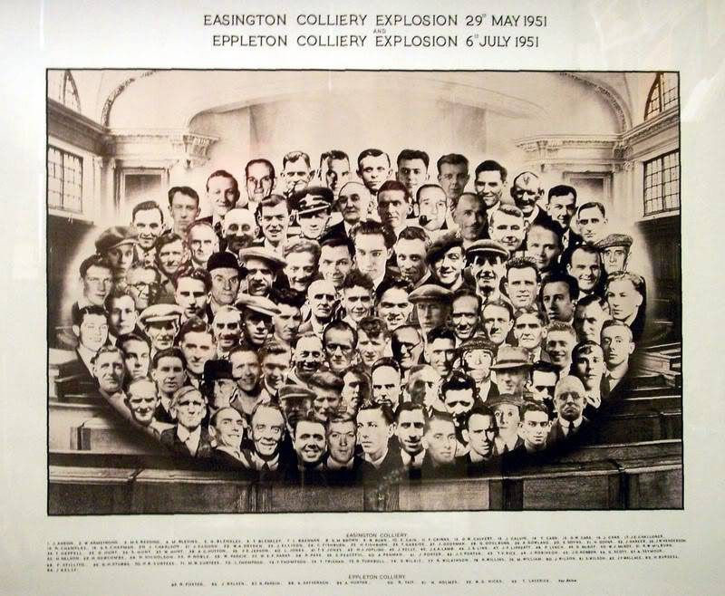
Composite picture of those who lost their lives in the Easington and Elemore explosions in 1951. Origin unknown

In this explosion the Colliery Ambulance Team lost one of its outstanding members, Mr Norman Holmes. At Blackpool, two weeks before the explosion, the Eppleton team was placed second in the Miners' National First Aid championships. Its Captain, Mr Norman Holmes, had won the trophy for the best team captain. The team had an excellent record throughout the Durham Coalfield with successes recorded as far back as 1929. It was well served with men like H Seymour, T Boddy, J Jobson, J Lincoln, E Burt, N Wilkinson, R Hope, T Duff, R Widdowson, Robert Stokoe, R Stoker, J Gilliland, and W Stokoe. Sad to relate there is not an active Eppleton Colliery First Aid Team today, but there are still many who give excellent service to the local St John Ambulance Brigade. A firm link remains nevertheless between the victims of the explosion and the St John Ambulance Brigade, for every year a competition is held for teams in the area for a memorial trophy known as the Seven Comrades Trophy.

The continuing life of Eppleton Colliery under adversity in the sad year of 1951 was exemplified later in that year when the Colliery still managed to be placed third in the "News of the World" production awards for large collieries. The following year fourteen members drawn from the workmen at Eppleton, were invited to London along with the embers of the other award winning collieries to be the guests of the News of the World at a lunch at Wembley Stadium, saw the Rugby League Cup Final and at night saw a show at the London Casino.

A quarter of a century has now passed since the colliery had its last disaster, and although realism prohibits the view that occurrences of this kind are a thing of the past, it is a fact that the colliery has enjoyed a period of higher safety standards to go hand in hand with the technological development of its resources during this time, beginning with the Hawthorn Shaft which brought a new economic security to the area.

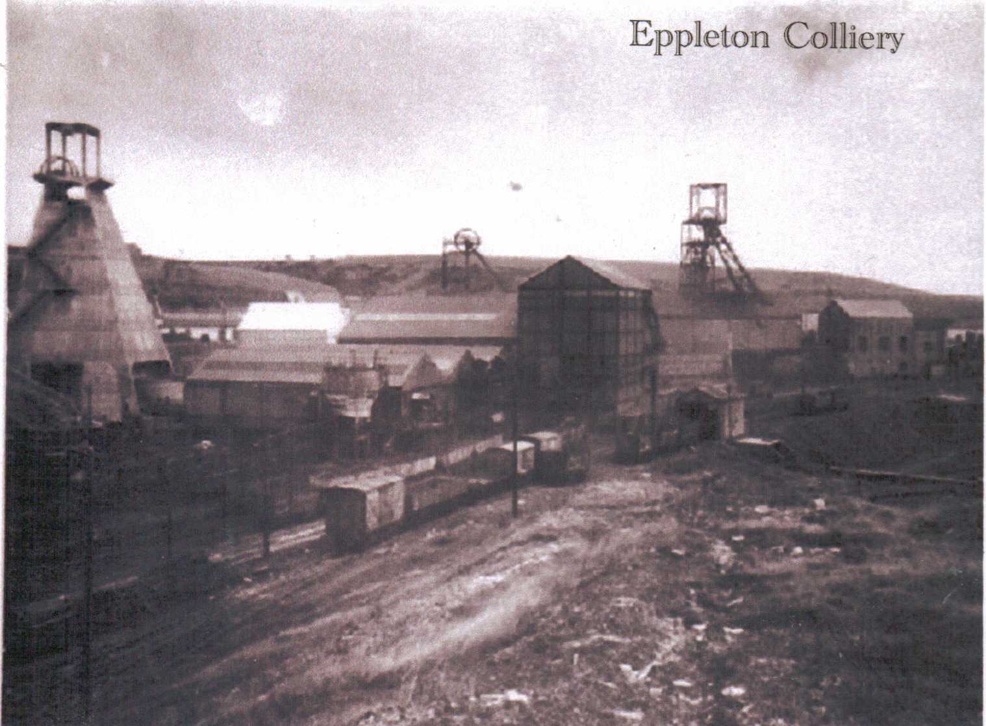
Eppleton colliery 1950s showing 3 shafts

CHAPTER NINE
NEW ARTERIES INTO AGEING BODIES

In many ways the creation of the Hawthorn Combined Mine brought the history of Eppleton to a close. While still remaining an independent colliery with its own management, workforce, plant and results, Eppleton's future is probably so inextricably bound up with the Combined Mine, that its story is now likely to merge into a larger history involving Hawthorn and the Murton Colliery.

The official handout on the reasons for building the Hawthorn complex said that it had been found necessary for new arteries to be put in the bodies of the ageing pits (Murton, Eppleton and Elemore), so as to provide the facilities necessary for the application of the up to date methods of working and transportation. This industrial transplant was also intended to prevent the new group of collieries from being committed to carry on the working of the three ageing pits, each burdened with a mass of out of date plant, constantly deteriorating, and having to work remnants of coal further away from the shafts at the end of old ramifications of roadways. This, with an inability of the collieries to cope with the cleaning requirements of the seams worked would have inevitably resulted in progressively uneconomic working until the pits would have been forced to close.

The importance of the new shaft to the three collieries therefore could be seen a far sighted effort not only to improve and prolong their lives, but also to support and improve the economic background of the local communities, who, while less dependent on the pits than in the old days, still looked upon them as the major employer of local labour. The story of the building of the Hawthorn Complex in this history is largely a matter of repeating much of what was written at the time, probably by Mr Haswell Alder, who not only played a part in the building of the mine, but also later became Group Manager with responsibility for the three collieries – Murton, Eppleton and Elemore. Part of this reading has much that is interesting in the sinking operations. The new shaft was sunk to 1500 feet and 22 feet in diameter, and was lined with concrete of varying thicknesses throughout according to the nature of the ground, varying from 1 foot 6 inches to 2 feet 9 inches. It is also recorded that the beds of water bearing Magnesium Limestone and Permian Running Sands which lay at 276 feet from the surface and comprised 131 feet of strata were frozen by means of a ring of holes bored from a chamber formed in the shaft 26 feet above the beds, and not from the surface as was usual practice. After the shaft sinking was completed, the chamber was filled in with concrete and the shaft walling lined up. This device was used in order to avoid freezing the ground near the surface, and possibly affecting the foundations of the permanent reinforced concrete headgear which was put up and used for the sinking of the shaft.

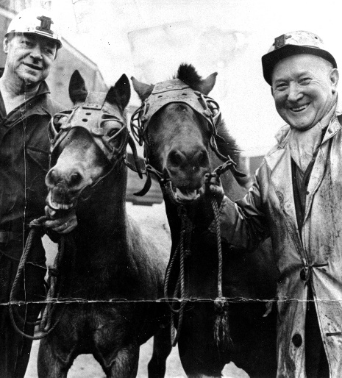
At Eppleton the big job of driving connecting roadways with Hawthorn was under the management of two men; Mr W Elliott and Mr A Barker; with the late Mr J Squires as the Overman in charge of drifting operations. The opening of the Hawthorn shaft in 1958 also saw big changes at Eppleton with the disappearance of the screens (not without epic difficulties in demolition), surface railways, and the like. The opening of the new complex saw some reduction in the level of colliery manpower and the transfers of many of the surface staff to the Hawthorn, and the way had opened for the advanced mechanisation of the underground faces at Eppleton.
Pit ponies with handlers
In 1963 putting and scalloping, one of the traditional methods of mining, disappeared, and with them an era of old piecework system of wages. Pit ponies continued to be used for timber leading for some time after the putters and scallopers had departed from the Maudlin Seam, but were finally brought back to surface in June 1967. It was an era of Flighter Faces succeeded by Plough Faces and then by Shearer Faces as the pace of mechanisation quickened.

Mr F G Swann was the Colliery Manager and Mr T Hill the Production Manager during this period of changing methods and under their direction further rationalisation of the underground transport system was achieved by the driving of a trunk belt conveyor road linking the East Busty workings to a single colliery loading point with a short circuit locomotive haulage service at the Hawthorn Shaft.

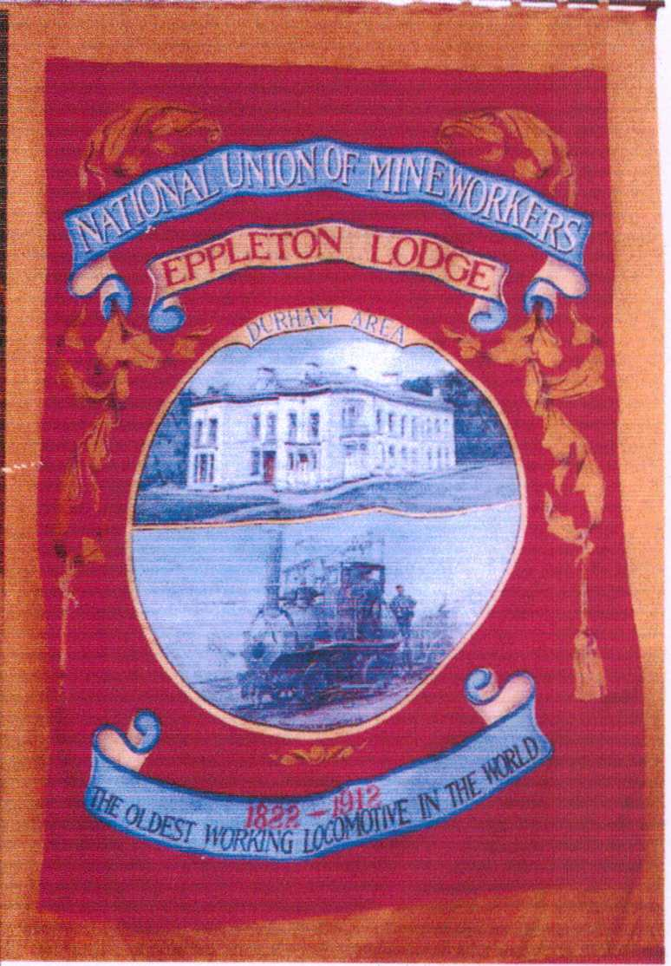
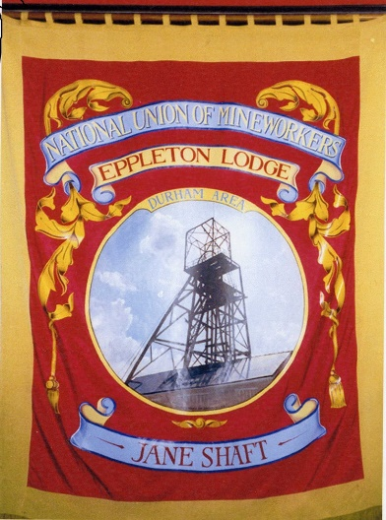
The European record for a single shaft weekly drawing of coals was achieved by Hawthorn for the week ending 19th June 1971, when the amount raised was 51,694 tons. Eppleton's contribution was 19,857 tons: Murton 27,708 tons; and Elemore 4,129 tons. This was not to be Eppleton's highest output for twice later in the same year the colliery produced over 20,000 ton, and was awarded the Area Production Banneratte in 1972 and this was carried side by side with the Lodge banner at the Durham Miners' Gala on Saturday 15th July 1972. The involvement of the community remarked on in an earlier chapter, is also seen today when the Lodge Banner is paraded for the Miners’ and Industrial Service which has been held in the Hetton Union Street Chapel every year since 1957. The service is attended by members and officials of the Eppleton and Elemore Lodges and the mining theme is illustrated with a display of Mining and Safety equipment erected by the Safety officials of Eppleton Colliery.

This record cannot be concluded without some references to the two dramatic interventions of the 1972 and 1974 general strikes in the Coalfields, which finally gave the miners an irresistible bargaining power after more than a century of struggle. Progress not only brought about new mining techniques and developments, butalso a greater sense of militancy among miners. The rundown of the mining industry by Government policy and legislation over the past decade had meant widespread pit closures, with the County of Durham suffering much, if not more, than any other area. Plans for the nation's sources of energy pinned faith to the discoveries of North Sea Gas, the abundance of oil, and nuclear power. Redundancy was a constant threat to bargaining power of the miners leaders who; supported by the Coal Board, and notably Lord Robens, had always protested that coal- would be the Nation's major energy source. Their pleas were ignored, wage increases minimal, and the miners tumbled down the wages league. Signs of militancy began to show, and in 1970 a strike was only averted after a national ballot had failed to reach the required 66% in favour. The rule was changed from requiring 66% in favour of 55% at the National Conference in 1971.

After the breakdown of negotiations in October/November 1971 a national ballot decided in favour of strike action, and an overtime ban was immediately instituted. The strike began officially on 9th January 1972, and was to last for seven weeks. Locally during the strike, the Eppleton management agreed to the request to the local unions to the disposal of old timber on the surface. This was gathered and cut with the assistance of Hetton Rotary Club, and bags of wood were delivered to senior citizens and those in need in the district. Eppleton miners did picket duty at Hawthorn Shaft, and Stockton gasworks where a friendship was formed between them and the Stockton RAOB club. One retired member of the ‘Buffs’ became friendly with many of the pickets, and chatted with them daily. On learning of his death later in the strike, the pickets organised a collection, and the money was handed to the secretary of the Stockton RAOB Club. This money was received too late to buy a wreath so the club decided to buy a shield in their late member’s memory, and this is now competed for annually between the ‘Buffs’ Club and the Hetton Comrades Club by way of an indoor games tournament.
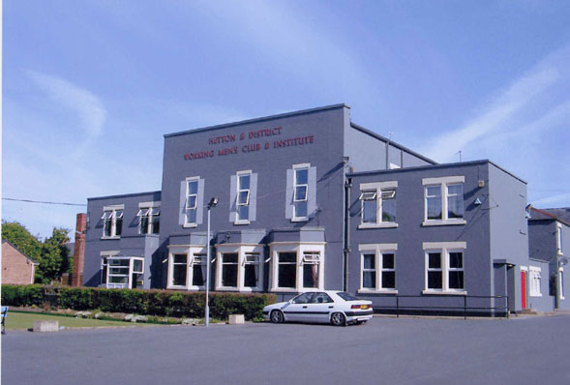
Hetton Big Club
Following the findings of a Court of Enquiry led by Lord Wilberforce the miners the largest single increase in their history. The new bargaining muscle of the miner, was to win again in 1974 against the even greater strength of Government confrontation. The Heath government opted for a general election as a solution, a decision which brought about their down fall, and a further advance of wages for the mining industry. A long road had been travelled from the days of the bondmen of Chapter One in Eppleton Mining History, and it adds a final note of optimism that this bargaining power plus the advancing technology of the industry heralds a better day.

The end of this History brings us to the beginning of the future of Eppleton. A famous saying, recently read, and much quoted, says “What is past is prologue”. The final Chapter contributed by Mr R M Scarr, Agent Manager at Eppleton, provides not an epilogue but the prologue to the future of the development of Eppleton and its community.

CHAPTER TEN
MANY HAPPY RETURNS

The year of Eppleton's 150th anniversary -1975- had seen a dramatic turn round in the fortunes of the coal trade. After fifteen years of contraction the demand for solid fuel is now rising and the National Coal Board is considerably increasing the exploration and development of inland and undersea reserves. Older collieries may anticipate a longer life providing the reserves can be worked in reasonable safety, and a marketable product can be produced.

During a century and a half of mining the upper seams - Main, Maudlin, Low Main, and Hutton - have been extensively worked and were exhausted, with only the deeper Harvey and Busty seams being worked. Both seams are low in sulphur and phosphorous content, and blend with the Murton Colliery output to provide a high quality coking coal.

Face workers at Eppleton will appreciate how variable and unpredictable is the Busty Seam, and how relatively thin the Harvey. Despite these natural difficulties, our Anniversary Year has started well. When conditions permit, high standards of face advance and machine performance are being achieved – the first retreat face in the thirty inch Harvey Seam is now in production.

The demand for our product is high, and the remaining reserves, though not extensive, are well proved. Improving efficiency is a prime management objective as machines and method are utilised to overcome the difficulties the less attractive reserves present.

The workforce has always accepted the challenge of mechanisation, adapting to the new machines, equipment and techniques with enthusiasm. All coal faces are now equipped with powered supports, the roadways are blasted and mechanically loaded, and extensive underground bunkers contribute to a more even, efficient, flow of production.

The health, safety and working conditions of our employees, together with the security of their employment are the main concern of Management and Unions. Consultation on all those matters has long been accepted as part of the daily routine. In this task, Management acknowledge the goodwill shown by Lodge Officials who realise that a successful Eppleton reflects in a successful and contented community. Only National disputes have interrupted the good labour relations which have long existed at this ageing pit.

One hundred and fifty years of mining must inevitably leave some blemishes on the surface landscape, and Eppleton has contributed to the unsightly number of pit heaps in the County. Over recent years a reclamation scheme involving the removal and surfacing of the heaps by infilling an adjacent quarry is trying to redress the balance. This scheme, with the modernisation of workmen’s houses, recently won a National Award for Environmental Improvement.
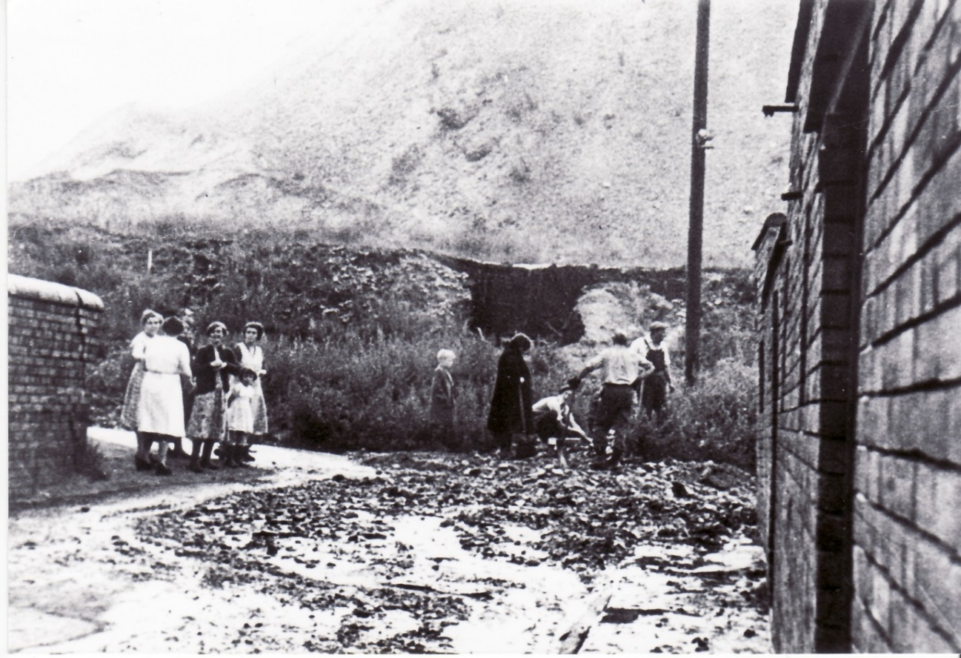
Minor Street with the pit heaps in the background

As this milestone passes, I am so privileged to record the fine spirit and enthusiasm which imbues everyone as Eppleton reassert its proud intention to produce quality coal for many years to come.

The ‘Pit on the Downs’ may yet ring in the 21st Century – and warrant another chapter in its fascinating history.

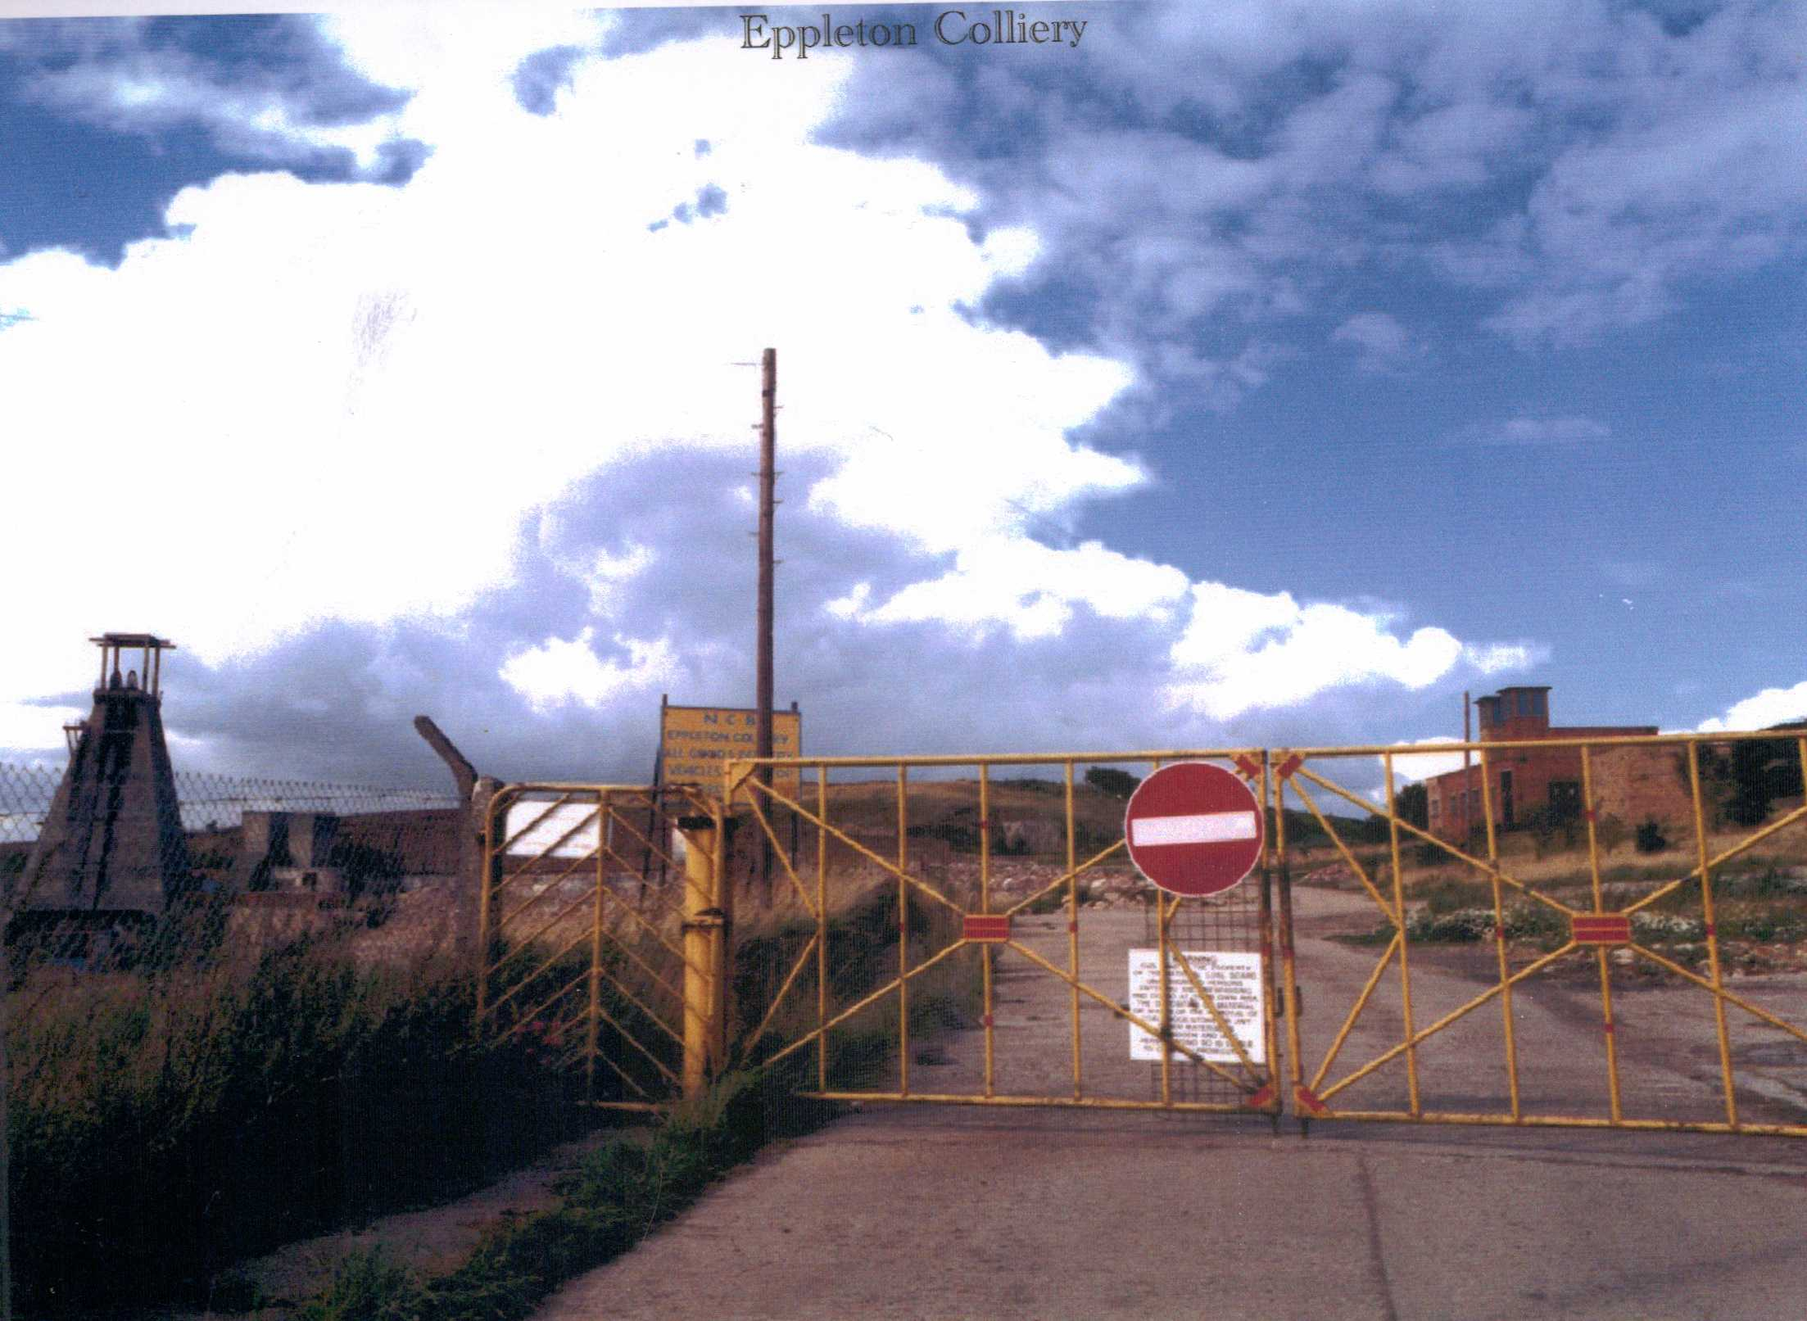
Eppleton Colliery gates after closure

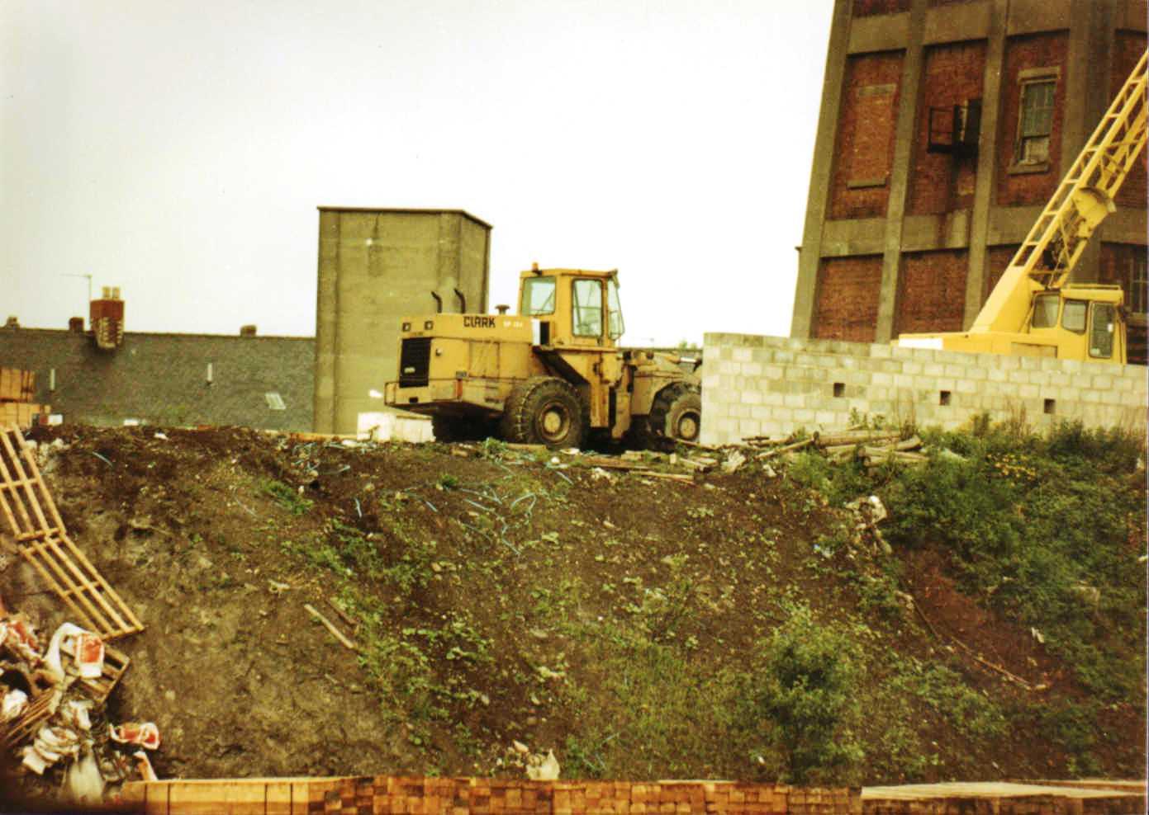
Demolition of Eppleton Colliery
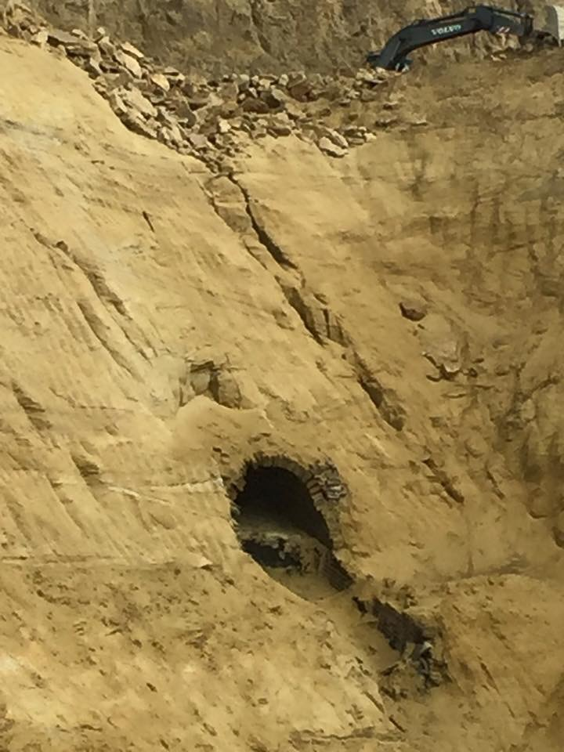
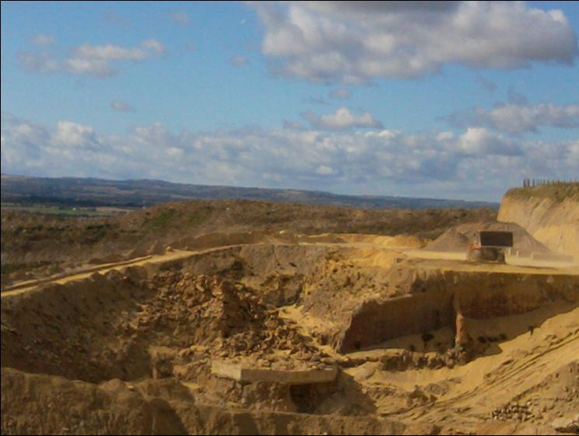
Air vent Eppleton Colliery / Eppleton Quarry 2017
Courtesy of f8photography.co.uk
Base of Caroline Shaft Eppleton Colliery / Eppleton Quarry

