EPPLETON HALL – THE TUG BOAT
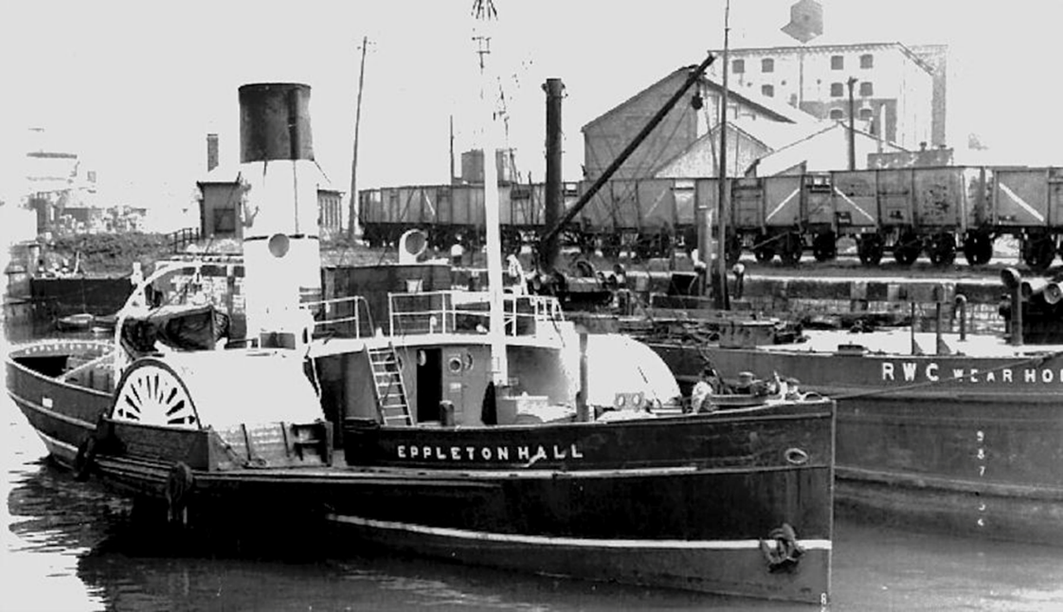
Eppleton Hall was built in 1913, by Hepple & Company Ltd. of South Shields. Not a giant shipyard by any means, but a long-established company that in various incarnations dated back to 1852. The company built ships at South Shields from 1894 thru 1914 building modest cargo vessels & tugs, along with a variety of other vessel types including a ferry, an icebreaker & some trawlers. In 1919. The yard closed in 1923 & was sold to neighbours 'Brigham & Cowan' in 1924.
The Vessel was 166 tons, 100 ft. 6 in. in length, with a single wooden mast forward, it was one of the 34 tugs that they built, of steel & wood for Lambton and Hetton Collieries Ltd. Launched on Sep. 17, 1913. Her livery was black with a smokestack, also in black but with three horizontal red bands - to identify the 'Lambton' fleet. Her crew was likely five in number. She was, in fact, the second to last paddle tug to be built in the U.K.
Eppleton Hall - probably named after Little Eppleton Hall, when it was transferred to the Hetton Coal Co. and became the home of the manager of the Lyons Colliery.
The vessel served 'Lambton & Hetton Colliers Limited' for over 30 years. In 1946, however, the vessel was sold to 'France, Fenwick, Wear, and Tyne Ltd.', of Sunderland, a company also deeply involved in the coal trade. Some changes were made to the vessel to permit the vessel to obtain a certificate to carry passengers. Not to become a ferry or an excursion craft, rather to permit the vessel to 'do a little moonlighting as a passenger vessel' & to transport officials from newly-launched steamers. Her real role was essentially unchanged. The tug also operated on the river Tyne.
In 1964, the vessel was sold to 'Seaham Harbour Dock Company'. The vessel assisted colliers into & out of their mooring berths within the confined area of Seaham Harbour, but for a short while only. In 1967, the vessel was sold to Clayton and Davie Ltd. of Dunston upon Tyne, their business was ship breaking - Eppleton Hall was to be scrapped.
It is most fortunate that the scrapping did not proceed rapidly though much of the ship's wooden interior & structure was burned off & destroyed by an intentional fire. She sat on the mud at the Clayton and Davie Ltd. yard, with water rushing in and out of her, through holes in her hull, as the tides ebbed & flowed.
Enter Scott Newhall, a newspaper magnate from San Francisco, California. Founder and a trustee of the San Francisco Maritime Museum, who wished to preserve a British paddle wheel tug, he bought the vessel in 1969 for £2,400. She was 'saved' & taken to R. B. Harrison & Son's shipyard at Bill Quay, Gateshead, to be repaired and rebuilt. Just three months later the job was accomplished.
On Sep. 18, 1969, the vessel steamed down the Tyne for the last time, under the command of Scott Newhall, bound 'across the pond' for distant San Francisco. With a crew of 11. It would appear that the tug headed west by a circuitous but safer route. She travelled across the Bay of Biscay, south along the coasts of Spain & Portugal. And then via Madeira, Las Palmas & Saint Vincent in the Cape Verde Islands, westward for Georgetown, Guyana, and the coast of South America.
It took her about 6 months to complete the voyage via the Panama Canal. She steamed under the Golden Gate Bridge on Mar. 24, 1970 & arrived at San Francisco to the tumultuous welcome of an assembled fleet of fire-fighting ships & pleasure craft. Visitors from here to San Francisco are surprised to see her there moored to Hyde Street Pier.

