Awards for Gallantry at Eppleton Colliery
His Majesty The King has been graciously pleased to award the Edward Medal to Ralph Stoker in recognition of his gallantry in the following circumstances :—
On the 29th May, 1936, at about 2.25 p.m., a heavy fall of roof took place in a coal-working at Eppleton Colliery, County Durham, where three hewers, James Brown, Mark Summers and William Moffatt, were removing the last loads of coal from a stook. Moffatt was trapped by the fall and his left hand pinned by large frames of stone to the top of a tub. Brown and Summers went to his help while the roof was still falling heavily but were unable to liberate him. With the assistance of two other hewers, Thomas Whitfield and David Wood, they erected supports over the tub to protect Moffatt from the large pieces of stone which were gradually moving down to him. About ten minutes after the fall Ralph Stoker and George Storey (Overmen) and John Tubby and Albert Simpson (Deputies) arrived. Heavy falls were still occurring, and it was difficult to maintain the supports, some of which were crushed as soon as erected. Stoker crawled into a narrow opening of about twenty inches between the tub and the coal side and in a working space of about ten inches uncovered Moffatt, who was lying in a crouched position behind the tub, and erected additional supports to keep back the stones which were lowering towards him. This probably saved Moffatt from serious injury as there was risk of his being crushed to death. After some time, Storey relieved Stoker, the working space being large enough to admit only one man. Stoker, helped by the Deputies, tried to make the position less dangerous from the other side of the tub. Meanwhile the risk had increased, and a larger roof fall was expected. The Deputies and hewers concentrated on erecting supports in the jud to maintain a means of access to Moffatt, who by this time was severely shocked and begging the rescuers to amputate his fingers and so release him. But for Stoker there is no doubt that this quick but dangerous method would have been adopted. Stoker and Storey continued their efforts to move the stone that was trapping Moffatt's fingers and by driving a wedge piece on the top of the tub they were able at length to release the thumb and first and second fingers. The roof then started to "weight" again. Stoker persisted in his efforts and by about 4.40 p.m. succeeded in releasing Moffatt, who was dragged through the narrow aperture to safety.
All those concerned in the rescue acted bravely in the face of grave danger from a further fall of roof, but it is considered that the greater part of the most dangerous work was carried out by Stoker, who showed great coolness, determination and initiative.
Source: London Gazette (09 Oct 1936)
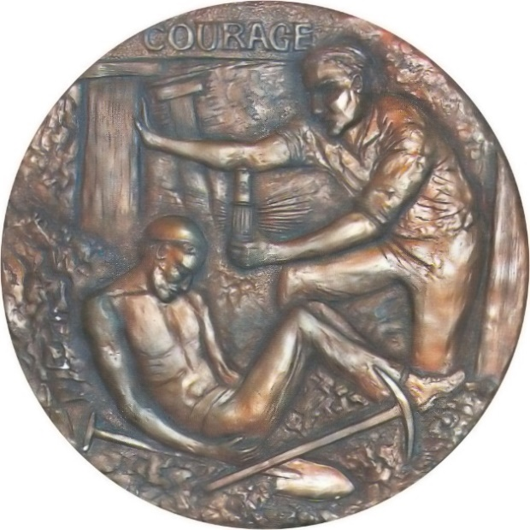

Edward Medal
The Edward Medal was a British civilian decoration which was instituted by Royal Warrant on 13 July 1907 to recognise acts of bravery of miners and quarrymen in endangering their lives to rescue their fellow workers. The medal was named in honour of King Edward VII. The original Royal Warrant was amended by a further Royal Warrant on 1 December 1909 to encompass acts of bravery by all industrial workers in factory accidents and disasters, creating two versions of the Edward Medal: Mines and Industry
The medal associated with mines depicted colliers at work whilst the industry medal had a female figure with an industrial complex in the background.

