Information Sheet America Enters the War
It all happened so quickly. At 7.55am on Sunday 7 December 1941, the first of two waves of Japanese aircraft began their deadly attack on the US Pacific Fleet, moored at Pearl Harbour on the Pacific island of Oahu. Within two hours, five battleships had been sunk, another 16 damaged, and 188 aircraft destroyed. Only chance saved three US aircraft carriers, usually stationed at Pearl Harbour but they were involved in an exercise at sea on the day. The attacks killed under 100 Japanese but over 2,400 Americans, with another 1,178 injured.
Winston Churchill had been trying to get America to join the war against Hitler for two years but the American President Franklin D Roosevelt wanted the USA to remain neutral (not join one side or the other). He had however been secretly helping England by providing food and war materials including ships, aircraft, guns and tanks. When the Japanese attacked the American Fleet at Pearl Harbour the American people were both shocked and angry and it was necessary to declare war on Japan and this was followed a few days later by declaring war on Germany and the other Axis powers.
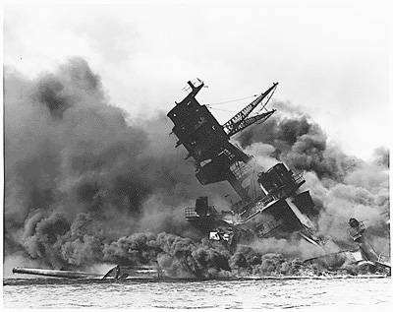
The picture above shows the USS Arizina burning and capsized after the attack

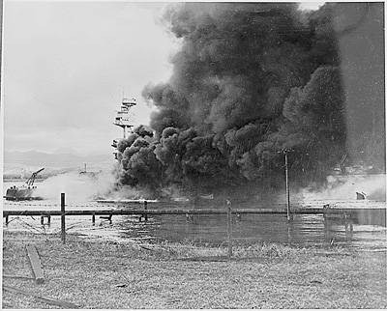
USS Oglala capsized and Burning
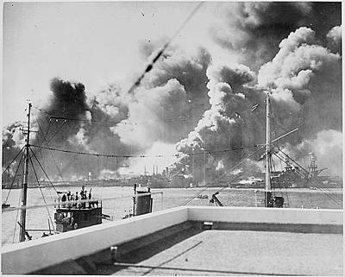
Devastation at Pearl Harbour
The battleships moored along "Battleship Row" were the main target of the attack's first bomber wave. Ten minutes after the beginning of the attack a bomb crashes through the Arizona's two armoured decks igniting its magazine ( the place where explosives are stored ). The explosion rips the ship's sides open like a tin can starting a fire that engulfs the entire ship. Within minutes she sinks to the bottom taking 1,300 lives with her. The sunken ship remains as a memorial to those who sacrificed their lives during the attack.
Highlight the website below then press control and click mouse button to see film of the attack.
http://video.foxnews.com/v/1314417407001/rare-video-of-pearl-harbor-attack-found/

