WAR ACTIVITIES Worksheet Name............................................
Look at the Picture and describe in your own words what you think the girls are doing. Why are they carrying out these actions and why will they possibly be useful?
.....................................................................
......................................................................
.....................................................................
......................................................................
.......................................................................
.......................................................................
......................................................................

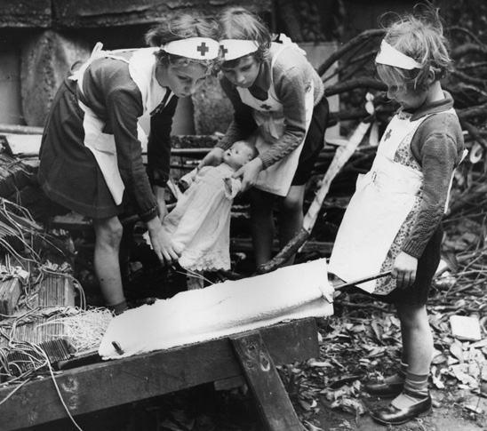

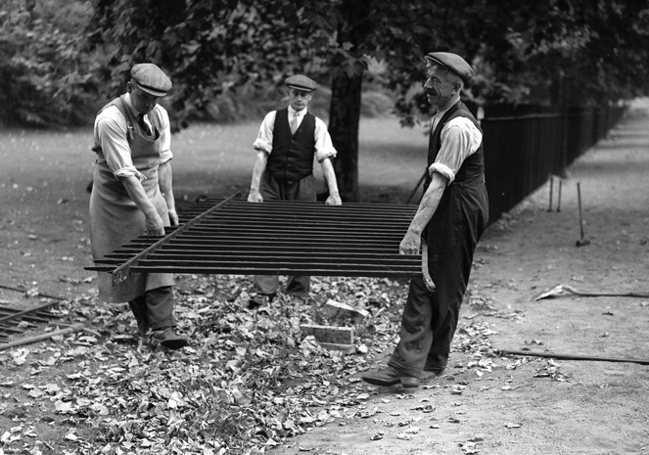
Look at the picture on the left. Remember it is wartime. What are the men in the picture doing? Why are they doing it? What will happen to the railings?
.................................................................
.................................................................
................................................................
.................................................................
.................................................................
.................................................................
.................................................................
...............................................................
.................................................................

