Winston Churchill
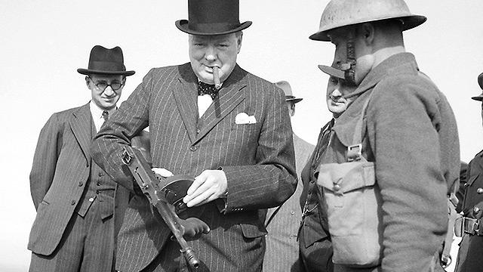
Winston shortly after taking office as Prime Minister examines a tommy gun while visiting Home Guard at Hartlepool.
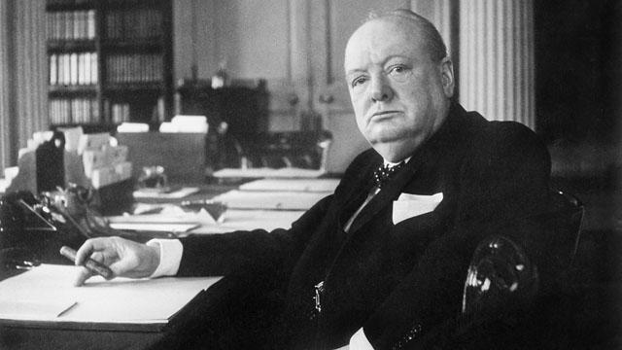
Winston at his desk near the Cabinet Room
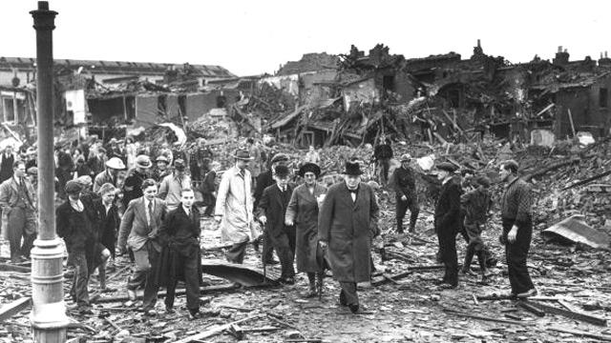
Churchill examines bomb damage in London after an attack during the blitz.

