FOOD Rationing
Why was food rationed in Britain in World War II?
Before the Second World War started Britain imported about 55 million tons of food a year from other countries. After war was declared in September 1939, the British government had to cut down on the amount of food it brought in from abroad as German submarines started attacking British supply ships. There was a worry that this would lead to shortages of food supplies in the shops so the British government decided to introduce a system of rationing.
Rationing made sure that people got an equal amount of food every week. The government was worried that as food became scarcer, prices would rise and poorer people might not be able to afford to eat. There was also a danger that some people might hoard food, leaving none for others.
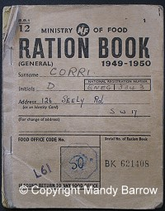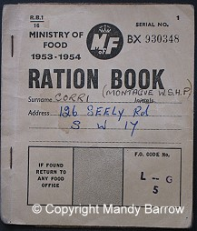
Ration books - notice the dates
These ration books were issued to Doris and Montague Corri.
How long was food rationed for?
Rationing of food lasted for 14 years and ended on July 4, 1954.
How did food rationing work?
Every person in Britain was given a ration book. They had to register and buy their food from their chosen shops. There were no supermarkets, so people had to visit several different shops to buy meat, vegetables, bread and other goods.
When people wanted to buy some food, the items they bought were crossed off in their ration book by the shopkeeper.
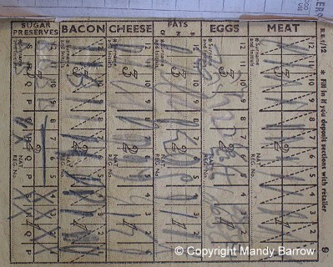
Page inside a ration book
What were the first food items to be rationed?
On 8 January 1940, bacon, butter and sugar were rationed.
What other food items were rationed?
Many different foods were added to the food ration list during the war. These included:
meat (Mar 1940) | jam (Mar 1941) | biscuits ( Aug 1942),
fish | tea (Jul 1940) | breakfast cereals,
cheese (May 1941) | eggs (June 1941) | milk,
tinned tomatoes (Feb. 1942) | peas (Feb. 1942) | dried fruit Jan 1942
rice (Jan 1942) | canned fruit, | cooking fat (Jul 1940)
Some foods such as potatoes, fruit and fish were not rationed.
How much food was one person allowed to buy per week during the war?
The weekly ration varied from month to month as foods became more or less plentiful.
A typical ration for one adult per week was:
Butter: 50g (2oz) | Bacon and ham: 100g (4oz) | Margarine: 100g (4oz)
Sugar: 225g (8oz). | Meat: To the value of 1s.2d (one shilling and sixpence per week. That is about 6p today) | Milk: 3 pints (1800ml) occasionally dropping to 2 pints (1200ml).
Cheese: 2oz (50g) | Eggs: 1 fresh egg a week. | Tea: 50g (2oz).
Jam: 450g (1lb) every two months. | Dried eggs 1 packet every four weeks. | Sweets: 350g (12oz) every four weeks
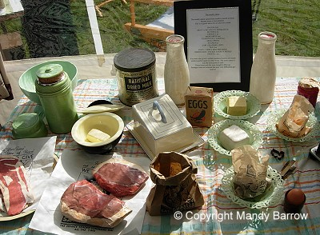
A weeks supply of rationed food for an adult
In addition to the above food, everyone was allowed 16 points per month to use on what ever food items they wished.
How did the government make sure people had enough food?
People were encouraged to provide their own food at home. The 'Dig for Victory' campaign started in October 1939 and called for every man and woman to keep an allotment. Lawns and flower-beds were turned into vegetable gardens. Chickens, rabbits, goats and pigs were reared in town parks and gardens.
De-Rationing
Food rationing lasted for 14 years in Britain, from 1940 until 1954.
Rationing continued even after the war ended:
- Meat rationing continued for 10 years after D-Day (June 1954)
In 1946, when food was just as short as during the preceding years, bread was added to the ration and the sweet ration was halved.

