CLOTHES RATIONING
It wasn't just food that was rationed during World War II. Clothing also became scarce.
Clothes rationing began on June 1, 1941, two years after food rationing started. Clothes rationing ended on 15 March 1949.
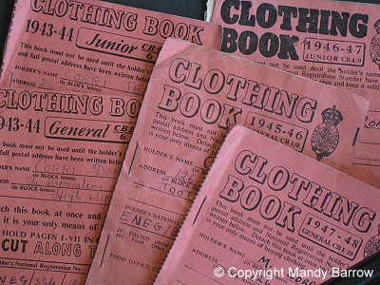
Clothing ration book - Can you spot the two books for children?
Why were clothes rationed during the war?
There was a shortage of materials to make clothes.
People were also urged to "Make do and mend" so that clothing factories and workers could be used to make items, such as parachutes and uniforms, needed in the battle against Germany.
How did people buy clothes when they were rationed?
Everyone was given a Clothing Book with coloured coupons in it. Every item of clothing was given a value in coupons. To buy clothes people handed over their Clothing Book to the shopkeeper. who cut out one of the coupons. They then handed over money to the shopkeeper to pay for the clothes.
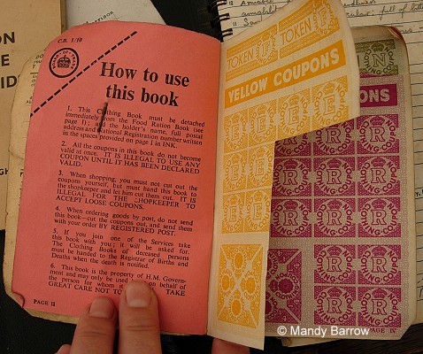
Clothing coupons
The coupon system allowed people to buy one completely new set of clothes once a year.
Where did people get their clothes coupons from?
The government gave every person a clothes ration book full of coupons.
Why were there different colour coupons?
Each page of coupons was a different colour to stop people using up all their coupons at once. People were only allowed to use one colour at a time. The government would tell people when they could start using a new colour.
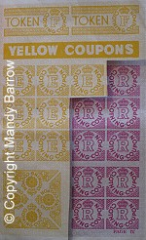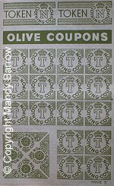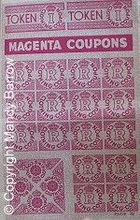
Coupons from one colour could be saved and used with the next colour.
How many clothing coupons could each person use?
Each person was given 60 coupons to last them a year. Later it was reduced to 48 coupons.
Children were allocated an extra 10 clothing coupons above the standard ration to allow for growing out of clothes during a year.
Clothes Coupons
The two images below show how many coupons you would need to buy different items of clothing.
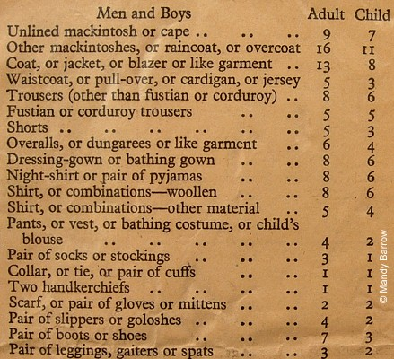
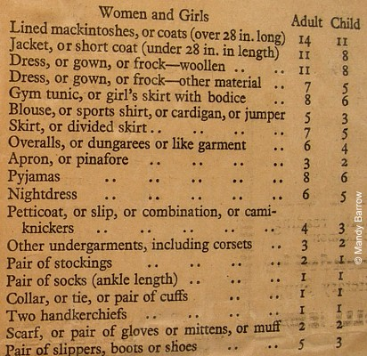
What would you buy with your 60 clothes coupons to last you a year?
What do think would happen if you grow during the year and your clothes don't fit you anymore?

