Spitfire in Drawings Making a composite picture

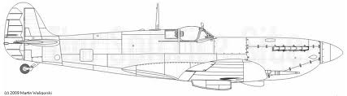

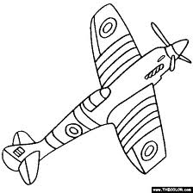
Here are three other drawings of Spitfires in action. Do your best to draw them on to a large piece of paper and then paint thwm after you have put in clouds etc.

