The Battle of Britain
For the first few months of the war, the Germans concentrated on controlling Poland. In Britain, this period was called the phoney (false) war because little fighting took place.

In August 1940 3 months after the collapse of France, Hitler ordered the Luftwaffe (German air force) to destroy the Royal Air Force to gain control of the skies over Britain in preparation for an invasion.

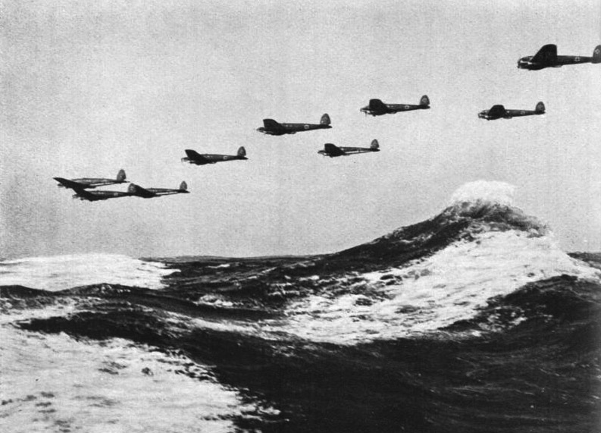
The Battle of Britain is the name given to the efforts of the British RAF to defend the attacks of the German Luftwaffe on British: airfields, aircraft and aircraft factories during the summer of 1940.
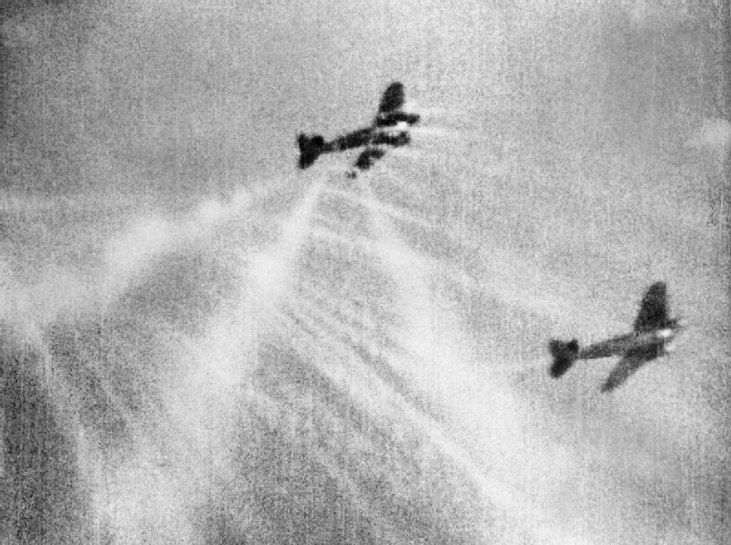
The main attacks upon the RAF were code-named ‘Eagle Attack’ and began on ‘Eagle Day’, 13th August 1940 when they attempted to destroy Radio Direction Finding stations on the English south coast. Later renamed radar (for radio detection and ranging), these stations allowed the RAF to spot approaching enemy aircraft in the skies and plot their likely paths on a map by pushing coloured counters around with rakes. The damaged stations were back working within six hours as the Luftwaffe didn’t return to finish the job off and neglected to knock out the power stations which supported them. Also many were well hidden on the ground and the Germans did not know of their existence.
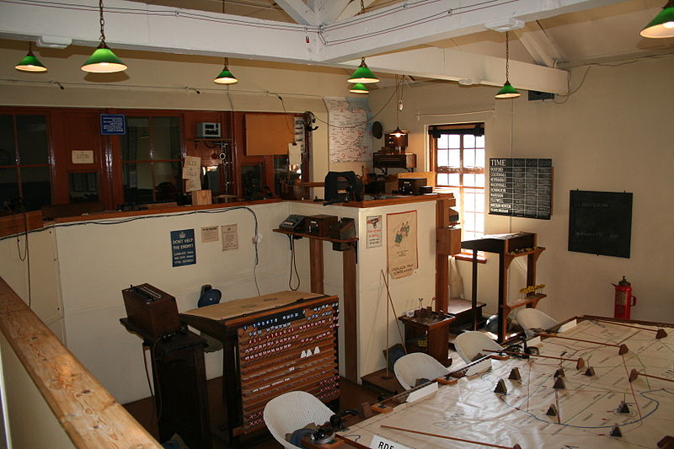

The British Spitfire and Hurricane fighter aircraft had the advantage in the following air battles because they all took place over home territory. Pilots who bailed out could be back at their airfields within in hours to carry on fighting, whilst for the German Luftwaffe crews, a bailout over England meant capture and parachuting in the English Channel meant drowning to death.

On 15th September 1940, ‘Battle of Britain Day’, two massive attacks by the Luftwaffe were fought back by the RAF. It was a decisive (clear) British victory with 26 RAF aircraft being shot down in comparison to 60 German aircraft being destroyed. Winston Churchill summed up the effect of the battle with the words, "Never in the field of human conflict was so much owed by so many to so few". The British fighter aircraft were also able to break up the squadrons of German bombers spreading them throughout the skies where they were unable to get protection from their own fighter aircraft the Messerschmitt ME 109.

Two days later, on 17th September 1940, Hitler postponed his invasion of Britain until further notice following the RAFs strong resistance to German air attacks and the considerable damage the Luftwaffe had received.

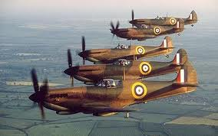

The 31st October 1940 is generally considered to be the end of the Battle of Britain as Hitler now decided to focus his efforts more on night time ‘Blitz’ bombing raids to destroy British cities and demoralise (weaken) the British people into surrender instead.

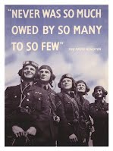
The words on the poster were spoken by Winston Churchill, the Prime Minister in thanks for all that the air crews had done to save Britain.

