How to draw a Spitfire fighter aircraft

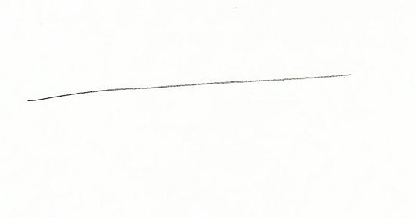
- Draw a line on the paper about 10 cms in length
2. Draw a second line to cut the first line

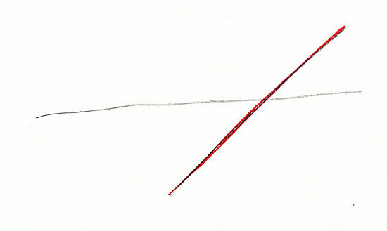
3. Insert a rough oval shape
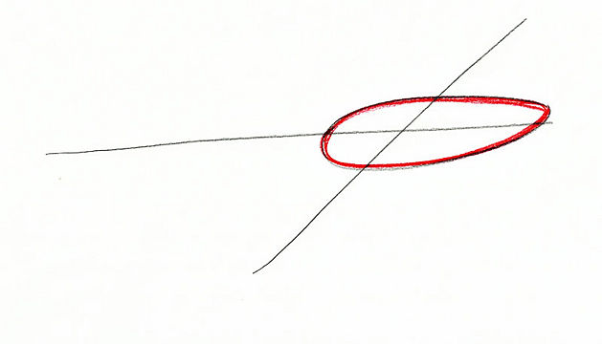
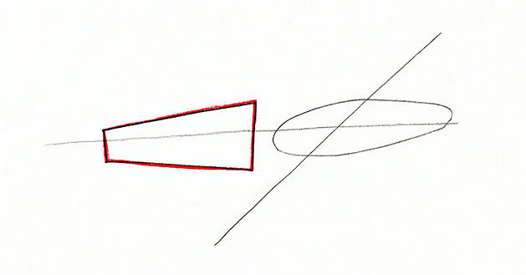
4. Draw a cone shape as shown in red.

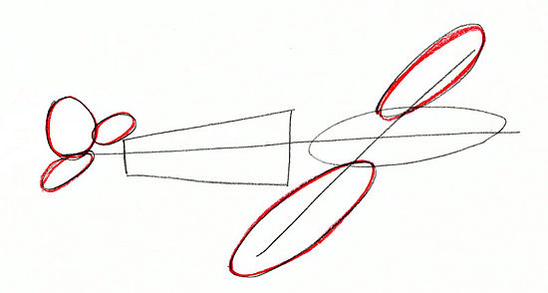
5. Draw in the tail and wings

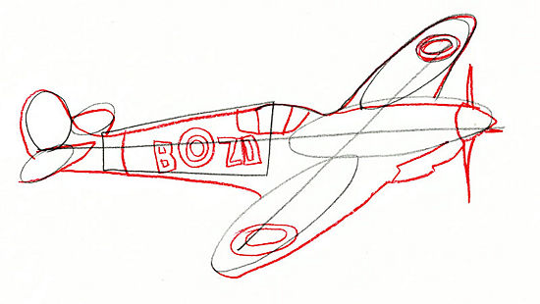
6. Fill in the detail
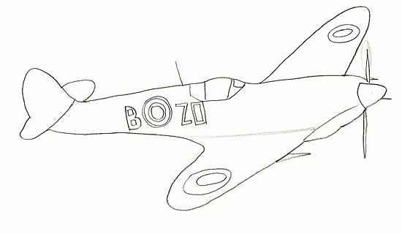
7. Rub out the lines you do not need then paint it as shown below
