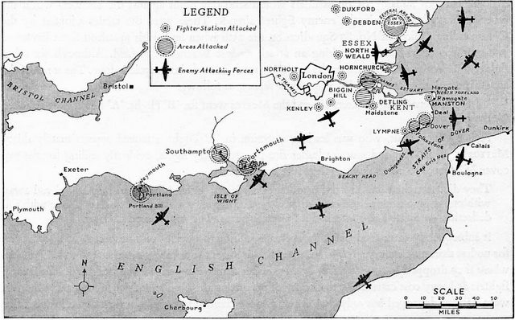
5th September 1940 Colour in the map to show land, sea and bombed areas etc.

