Worksheet Churchill becomes Prime Minster

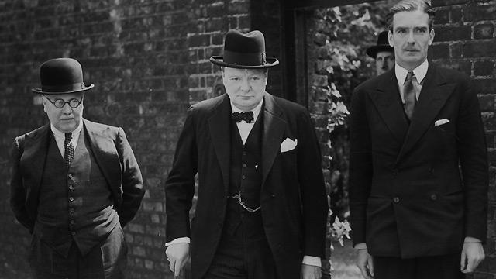
Kingsley Wood
Winston Churchill
Anthony Eden

On 7th May 1940 a debate was called in the House of Commons to discuss the loss of Norway and Denmark. It soon became clear that Neville Chamberlain, the Prime Minister at that time had lost the confidence of many of his friends in the Conservative Party. He tried to build a coalition government but the leader of the Labour Party Clement Atlee would not work with him so he was forced to resign. Eventually within a few days Winston Churchill was voted as Prime Minister even though he was disliked by many in the Government.
He proved to be a brilliant leader and had a great deal of support from the British public. Three days after he took office he told the House of Commons that he had nothing to offer except “blood, toil, sweat and tears”. In his first address to the country he said that he intended to get for Britain “Victory, Victory at all costs. Victory in spite of all the terror, however hard and long the road may be, for without victory there is no survival. “
He became a world statesman, liked and respected by many. He remained in politics for a number of years after the end of the war, finally retiring in 1955 after a lifetime in politics. He was knighted for his service to the country and when he died in 1965 he was given a state funeral and is buried in Westminster Abbey. He is also known as a very talented painter, a pastime which he enjoyed after his retirement.

