Food and the wartime kitchen
In some kitchens people cooked on a 'stove' heated by a coal or wood fire. The stove heated the room and cooked meals. Most kitchens had a gas cooker though some had electric cookers.
Not many people had a refrigerator. People went shopping to buy fresh food most days. To keep flies away from meat, they kept meat in a small cupboard called a 'meat safe'. They kept bread in a bread bin and biscuits in tins. Families ate some tinned foods, such as tinned meat, peas and baked beans, but hardly any frozen foods.
You could only buy fresh fruit grown in Britain, such as apples or pears. Fruits that had to come in ships, like bananas, vanished from the shops. Many ships were being sunk by enemy submarines, and precious ship-space was needed for war materials (such as oil or guns) not bananas.
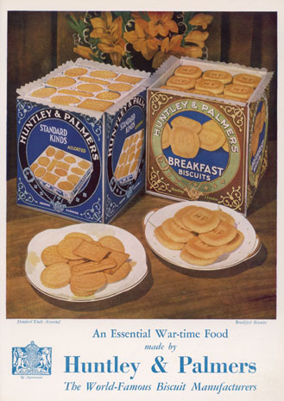
To Do .....
Find out about rationing during the war.
- Make a list of all articles, both food and other things which were rationed during the war.
- How long did rationing last? Why did it last after the war had ended?
- What were ration books and why did each family get them.
- What do you understand by the term “Black Market”?
- What do you understand by the term “Dig for Victory”?

To Do........
Look at the poster below which gave advice to families before they went to bed.
Examine each statement and write a sentence about what had to be done and why it had to be done.

