http://www.secondworldwarni.orgAnderson Shelters
Anderson air raid shelters were the most widely used domestic shelter during the Second World War, but the corrugated iron roofs of the shelters were collected by the authorities at the end of the war, so very few now remain. However, the shelter at the back of one house in Vauxhall is still in good condition, including the frames of the bunk beds on which families tried to sleep during air raids. Further detailed information may be found below the following photos of the Vauxhall shelter:
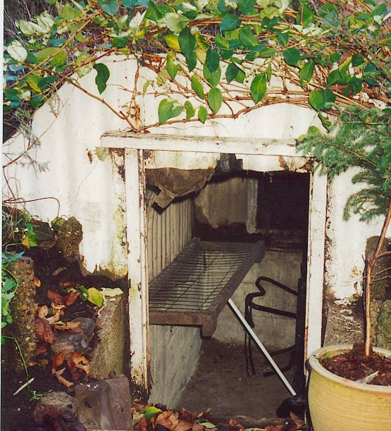... 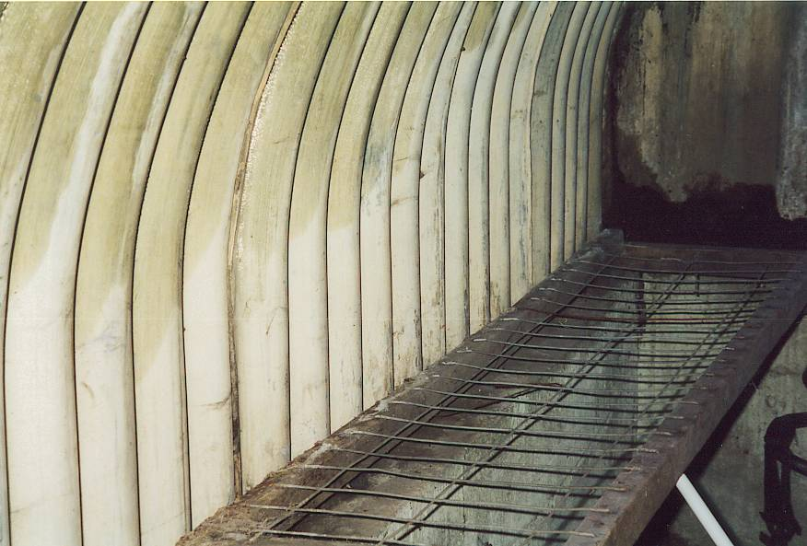

Air Raid Shelters
The first German air attack took place in London on the evening of 7 September 1940. Within months, Liverpool, Birmingham, Coventry and other cities were hit too.
Why were Air Raid Shelters built?
People needed to protect themselves from the bombs being dropped by German aircraft.
As the night raids became so frequent, many people who were tired of repeatedly interrupting their sleep to go back and forth to the shelters, virtually took up residence in a shelter.
Anderson Shelters
What were Anderson Shelters?
These shelters were half buried in the ground with earth heaped on top to protect them from bomb blasts.
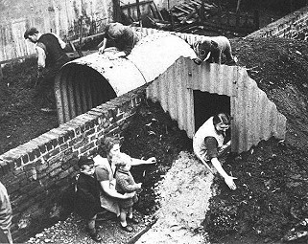
© The Imperial War Museum
They were made from six corrugated iron sheets bolted together at the top, with steel plates at either end, and measured 6ft 6in by 4ft 6in (1.95m by 1.35m). The entrance was protected by a steel shield and an earthen blast wall.
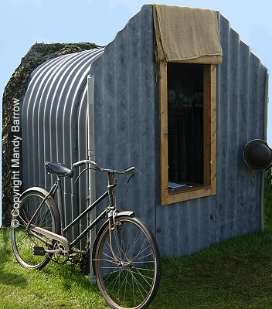
An Anderson shelter not buried.
The government gave out anderson shelters free to people who earned below £5 per week. By September 1939 one and a half million Anderson shelters had been put up in gardens.
What were Anderson Shelters like?
The Anderson Shelters were dark and damp and people were reluctant to use them at night.

In low-lying areas the shelters tended to flood and sleeping was difficult as they did not keep out the sound of the bombings.
How much did they cost?
Anderson shelters were given free to poor people. Men who earned more than £5 a week could buy one for £7.

Morrison Shelters
When was the Morrison Shelter first introduced?
The Morrison Shelter was introduced in March 1941, for people without gardens. The shelter, made from heavy steel, could also be used as a table. People sheltered underneath it during a raid. The Morrison shelter was named after the Minister for Home Security, Mr. Herbert Morrison.
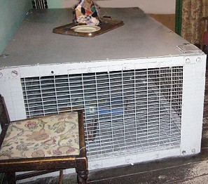
The Morrison shelter was approximately 6 feet 6 inches (2m) long, 4 feet (1.2m) wide and 2 feet 6 inches (0.75m) high.

A model Anderson shelter can be seen on the site below. Hold down control and click on the site
http://www.secondworldwarni.org/primaryschools/docs/Unit%203%20Activity%20Pack.pdf

