The Royal National Lifeboat Institution RNLI
The RNLI is the charity that saves lives at sea
We provide, on call, a 24-hour lifeboat search and rescue service and a seasonal lifeguard service. Our Values reflect the way we do business as an organisation.

Purpose:
The RNLI saves lives at sea.

Vision:
To end preventable loss of life at sea.
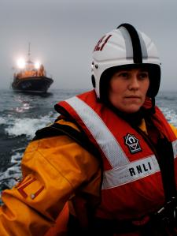

The fleet
The RNLI has an active fleet of over 330 lifeboats, ranging from 3.8–17m in length, as well as a relief fleet. There are also four active and three relief hovercraft.
Different classes of lifeboat are needed for various locations, depending on geographical features, the kind of rescue work that the station is asked to do and the cover provided by neighbouring stations. So RNLI lifeboats are divided into two categories: all-weather and inshore.
All-weather lifeboats (ALBs) are capable of high speed and can be operated safely in all weather. They are inherently self-righting after a capsize and fitted with navigation, location and communication equipment.
Inshore lifeboats (ILBs) usually operate closer to shore than ALBs, in shallower water, close to cliffs, among rocks or even in caves.
Hovercraft can operate in areas such as mud flats or river estuaries that are inaccessible to conventional lifeboats.​
he fleet​ | Lifeboat​ | Launch type​ | Length​ | Max speed​ | Range​ | Crew​
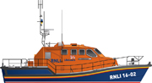  ​ | Tamar​ | Slipway or afloat​ | 16.3m​ | 25 knots​ | 250 nmile​ | 7​
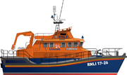  ​ | Severn​ | Afloat​ | 17.3m​ | 25 knots​ | 250 nmile​ | 6​
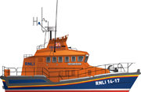  ​ | Trent​ | Afloat​ | 14.3m​ | 25 knots​ | 250 nmile​ | 6​
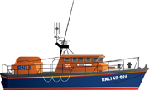  ​ | Tyne​ | Slipway or afloat​ | 14.3m​ | 18 knots​ | 240 nmile​ | 6​
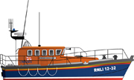  ​ | Mersey​ | Carriage, slipway or afloat​ | 11.62m​ | 17 knots​ | 240 nmile​

History
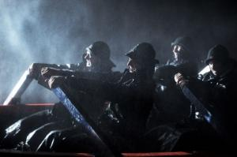
Saving lives at sea since 1824
​The RNLI has saved more than 139,000 lives since its foundation in 1824 as the National Institution for the Preservation of Life from Shipwreck. The name was changed to the Royal National Lifeboat Institution in 1854, and cork lifejackets were first issued to crew members in the same year.
The 20th century saw the RNLI continue to save lives at sea through two world wars. Lifeboats moved from sail and oar power to petrol and diesel, and the first women joined their crews.
Recent years have seen a significant expansion of the service, with the introduction of RNLI lifeguards and the first lifeboat station on an inland waterway, both in 2001.
Read more about key events in the RNLI’s lifesaving history in our interactive timeline or in our downloadable factsheet. (control + click will open these sites)
Grace Darling (1815-42) was 22 years old when she risked her life to help the survivors of the wrecked SS Forfarshire on 7 September 1838. With her father, she rowed for over a mile in an open boat through raging seas.
Grace instantly became the media celebrity of her day. Her story spread internationally and she was showered with attention, gifts and honours, including the RNLI's Silver Medal for Gallantry.
For more information, download our Grace Darling factsheet.
Are you a teacher? Our free educational resources include a key stage 2 lesson plan or key stage 3 lesson plan on Grace Darling. Download now

On Your Wavelength (11-14)
Welcome to On Your Wavelength, the exciting new education resource from the RNLI.
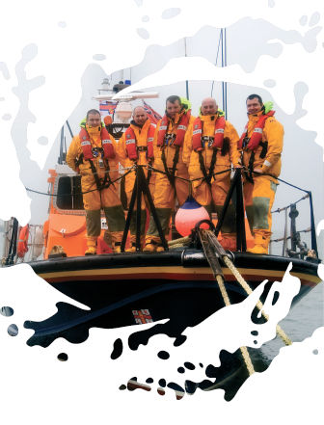On Your Wavelength is a multi-media resource comprising lesson plans, film clips, student activity sheets and an interactive map. This resource has been developed to support the teaching and learning of students aged 11-14 in areas of the curriculum and in the development of personal life skills.
Download the Teacher’s Guide here, containing teacher’s notes, curriculum links, 7 lesson plans and a peer-to-peer toolkit

http://rnli.org/safetyandeducation/teachersandyouthleaders/resources/Pages/On-your-wavelength.aspx

