The Costa Concordia 2012
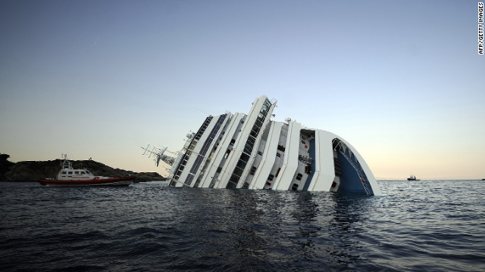
The Costa Concordia struck rocks on January 13 2012 and turned on its side off the Italian island of Giglio.
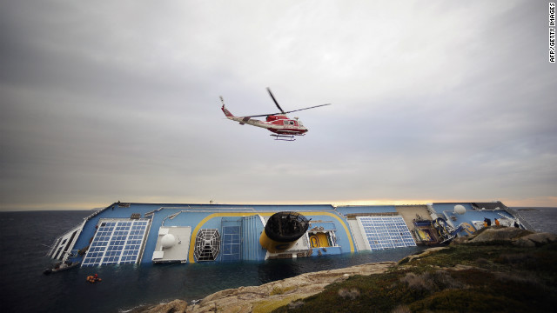 Helicopter flies over the wreck
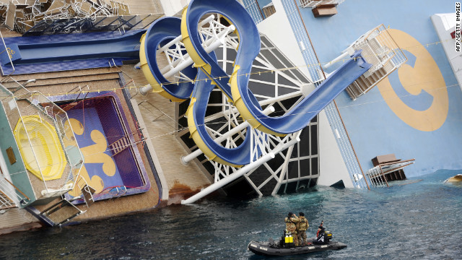 Lying on its side a spiral water slide is on the deck

Costa Concordia disaster
- What happened
- What next for the ship?
Thirty-two people died after the Costa Concordia cruise ship ran aground with more than 4,000 passengers and crew on 13 January, only hours after leaving the Italian port of Civitavecchia. The maps and graphics below reveal details about the vessel and its ill-fated journey.
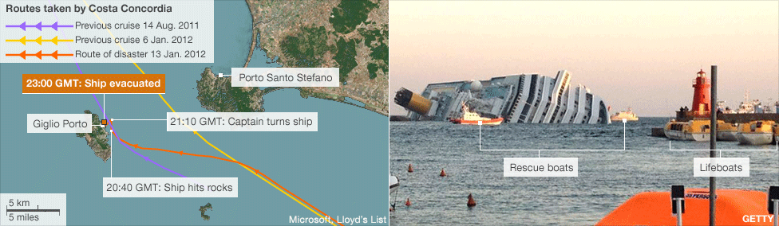

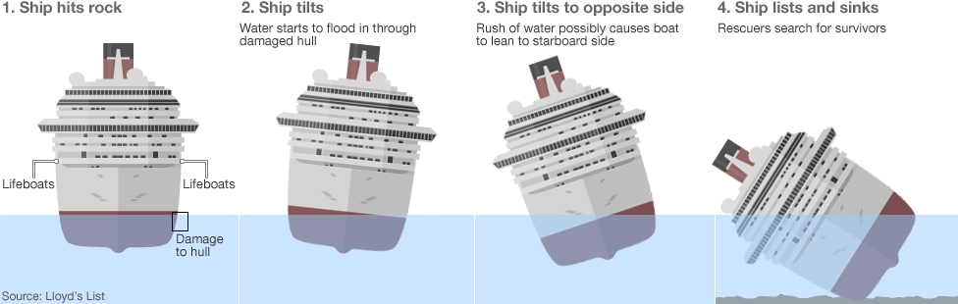
Jump to: navigation, search
Costa Concordia disaster
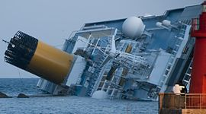
The Costa Concordia aground 08:24pm (20:24), 14 January 2012
Event | Grounding of cruise ship Costa Concordia
Cause | Ran aground on a reef
Location | Off Isola del Giglio, Tuscany, Italy
Coordinates | 42.365347°N 10.921400°ECoordinates: 42.365347°N 10.921400°E
Date | 13 January 2012
Captain | Francesco Schettino
On board | - 4,252^{[1]}  - Passengers: 3,206^{[2]}  - Crew and personnel: 1,023^{[2]}
Losses | 30 dead,^{[3]} 2 missing and presumed dead,^{[3]} and 64 injured
Operator | Costa Cruises
Route | Civitavecchia to Savona, Italy[show]
Wrecking of Costa Concordia
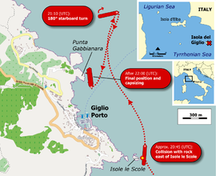
Timeline^{[4]} | (local UTC+1 times)[show]
Media | External audio and videos[show]
The cruise ship Costa Concordia^{[p 1]} partially sank on the night of 13 January 2012 after hitting a reef off the Italian coast and running aground at Isola del Giglio,^{[p 2]} Tuscany, requiring the evacuation of the 4,252 people on board. Thirty people are known to have died;^{[3]} two others were still missing as of October 2012, and presumed dead;^{[3]} and 64 others were injured^{[5]} (at least two seriously^{[6]}). Two passengers and a crewmember trapped inside were rescued in the days after the incident.^{[5][7]}
Captain Francesco Schettino^{[p 3]} had deviated from the ship's computer-programmed route to treat people on Isola del Giglio to the spectacle of a close sail-past or near-shore salute. The ship was on the first leg of a planned 6-port cruise from Civitavecchia when she hit a reef off Isola del Giglio and started to take in water, flooding the engine room and generators, causing the ship to drift for more than an hour off the eastern shore of Isola del Giglio before running aground and being evacuated.
After the event, Schettino was arrested on preliminary charges of multiple manslaughter in connection with causing a shipwreck, failing to assist 300 passengers, and failing to be the last to leave the wreck.^{[8]} He was subsequently also charged with failing to describe to maritime authorities the scope of the disaster^{[9]} (for which seven other officers and managers of Costa Cruises are under investigation) and with abandoning incapacitated passengers.^{[10]}
Bodies of crew and passengers trapped in the wreck were still being found in the first few months of 2012; salvage operations were scheduled to begin in May.
The Costa Concordia entered service for Costa Cruises in July 2006 as the largest ship built in Italy at the time, measuring 114,137 GT,^{[11]} 290.2 metres (952 ft) long, and costing €450 million (US$569 million). By tonnage, it is the largest passenger ship to have sunk.^{[12]} Industry analysts believe the vessel is a constructive total loss.^{[13]} Costa Cruises has offered specific compensation terms to passengers and intends to refloat the ship

