The Andrea Doria:
The Greatest Rescue of All Time
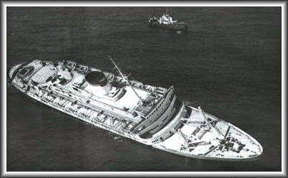
The Andrea Doria (above) listing before the sinking
On June 16th, 1951, the Andrea Doria was launched at the Ansaldo shipyard in Italy. She cost 29 million dollars, and had very advanced safety features. She had watertight compartments, a double bottom, and a double hull. As were the Titanic and Lusitania, she was labeled by some as unsinkable.
She had 16 lifeboats onboard, with a capacity of over 2,000 people. Two of the boats had motors and radios.
On july 17th, 1956, she left Italy on her 101st crossing of the Atlantic Ocean. It would be her last.
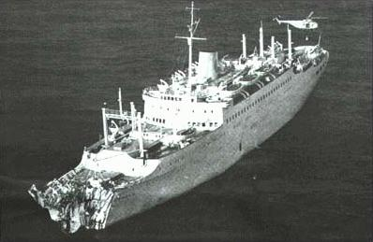
On July 25th, 1956, the Andrea Doria and the Sweedish American Line ship Stockholm were both steaming near New York City.
The Andrea Doria was surrounded by a fog bank. When radar showed another ship (the Stockholm) nearby, she continued on her course. At 11:10 p.m. Eastern Daylight Time, the Stockholm's bow ripped into the side of the Andrea Doria.
On the left is the Stockholm after the collision. Her bow is smashed in, but she remained afloat. Only 5 of the Stockholm's crew were killed in the collision.
Image Credit:
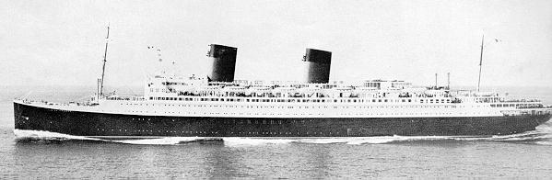
At 11:20 p.m., the Andrea Doria sends out a SOS..."Need immediate assistance." In 34 minutes, the Ile De France responds and heads towards the stricken ship. At 12:45 a.m., the freighter Cape Ann arrives. At 1:23 a.m., the William H. Thomas arrives. At 2:00 a.m., the Ile De France (right) arrives with desperately needed lifeboats, as many of the Andrea Doria's are inaccessable. See this table for the statistics of the rescuing ships.
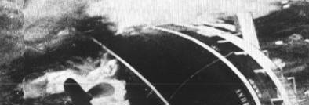
At 10:09 a.m., the Andrea Doria slips beneath the waves and comes to rest in around 240 feet of water. She became a popular scuba diving destination, but only for advanced divers.

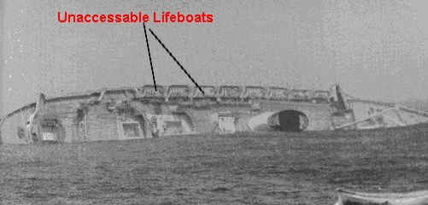
This picture shows why the Ile de France's life boats were so needed. As you can see, on the port (left) side there are about 8 or 9 lifeboats that were impossible to unload due to the list to starboard.

