Lights and Lighthouses
Grace Darling’s father was a lighthouse keeper. What is a lighthouse and why were they important to sailors in times past? What was the job of Grace Darling’s father as a lighthouse keeper? Sailors have always depended on lights and lighthouses to guide them across the seas particularly when they are close to land or there are dangers such as rocks or sandbanks which could wreck their ship.
Lighthouses as such were first used by the Greeks when they lit a fire on a high point at night as a warning to ships not to come close the earliest large light house was one of the 7 wonders of the world at Alexandria in Egypt.
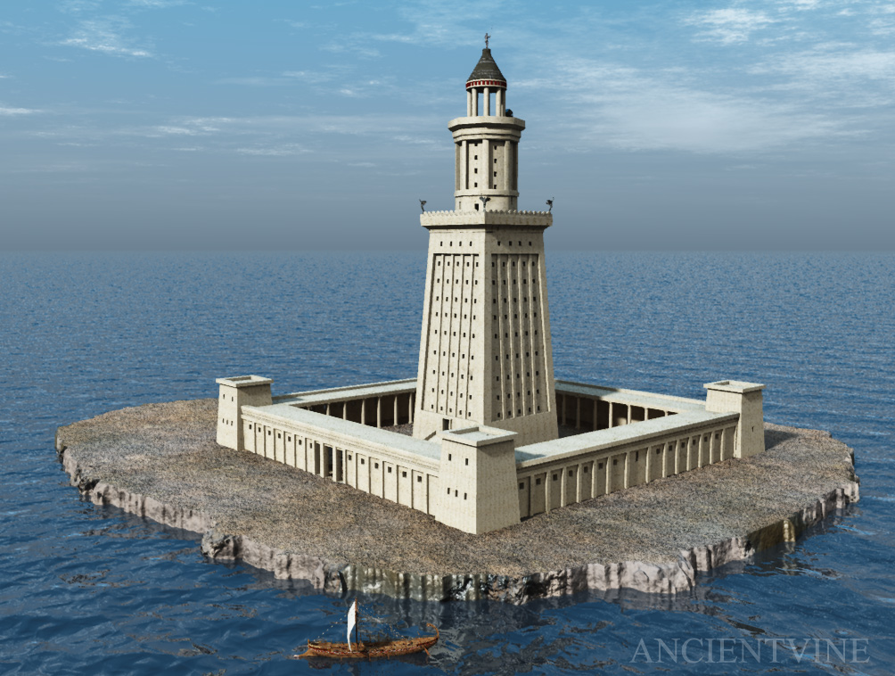
The Pharos at Alexandria we know it existed as many of the stones from it have been found underwater and reassembled on land. It is believed to have fallen from the rock on which it stood during an earthquake.
A lighthouse is a tower, building, or other type of structure designed to emit light from a system of lamps and lenses and used as an aid to navigation for people at sea at sea or on inland waterways.
Lighthouses mark dangerous coastlines, hazardous shoals and reefs safe and entrances to harbours. Once widely used the number of lighthouses around the world has fallen because they are no longer needed as modern navigational aids have taken their place. They are expensive to look after and many have been damaged in the past and have had to be rebuilt at great cost.
Both Sunderland harbour and Seaham Harbour have light houses at the entrance to the port to show mariners where the entrance to the port lies. Lighthouses are different in shape and colour so that they can be easily recognised and compared with the detail shown on a navigation chart
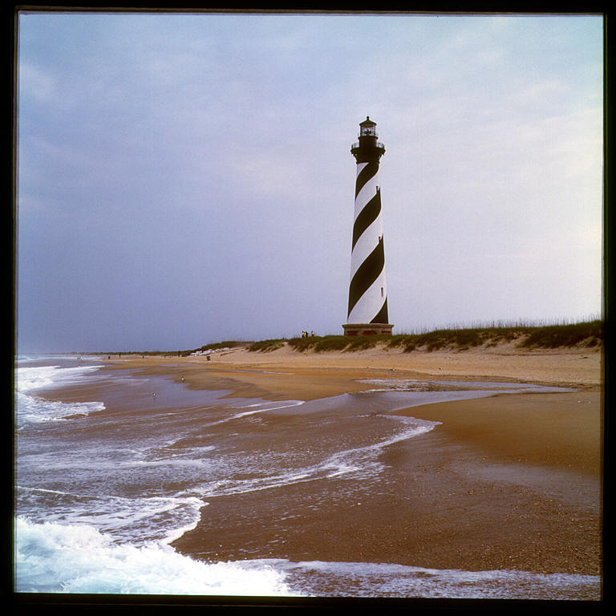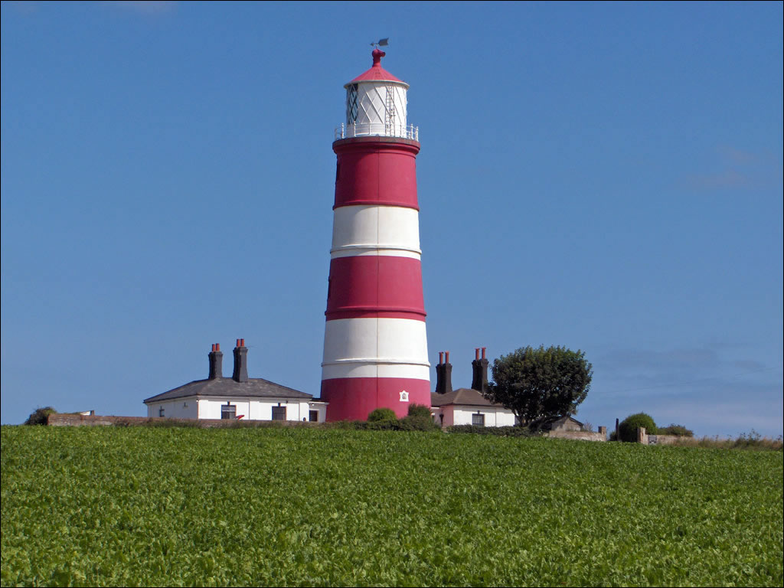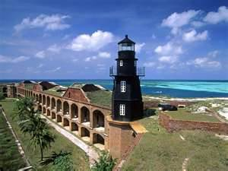
Lighthouses also have different lights, they flash different signals, some have 2 flashes, others up to 7. Some lights have different colours, white, green red. Some change colour depending upon the angle they can be seen from, so a light may change from white to red when the danger gets nearer. Some lights can be seen 30 miles away in good conditions but considerably less in poor conditions such as rain showers or fog. Lighthouses usually have a fog horn near them which they sound in bad weather such as a fog. Mariners can hear the fog horn long before they see the light. How does a lighthouse work?
Lighthouses use beams of light projected through a special lens called a Fresnel lens. Invented by a Frenchman in the early 1800s, the Fresnel lens concentrates beams of light through a prismatic lens which captures and concentrates them, so the light can be seen for many kilometres out at sea. The lens design uses a system of concentric glass rings to concentrate the light. This design is still used today in car headlights and traffic lights. If you look at car headlights you will see that the glass is not flat; by having ripples in it the light can be focused on one point. Lighthouses have certain parts of the glass blanked off e.g. on the side near to the land so that the light is concentrated on where it has to shine. Sometimes a shaped mirror will reflect the light.
Modern lighthouses have a system of rotating (turning) lenses, and newer lighthouses conserve energy by flashing the light on and off. A lens is a shaped piece of glass just as you might find in a pair of spectacles and they make things look bigger, thus a small light can be magnified by the use of a lens.
Lightships used to be common around the coasts particularly where there are sandbanks (shoals). There were 3 or 4 lightships at the entrance to the River Thames, now there are none.
Channels along which ships must travel to keep out of danger are also lit by lights so that they can be seen at night. The lights are fixed to buoys which may have an electric horn or even a bell on them so that they can be heard in fog.
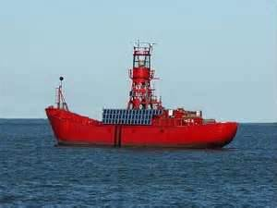 A lightship 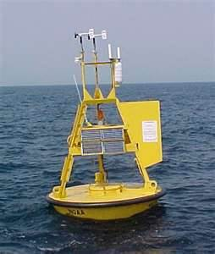 a buoy
Work to do.
- Find out about a famous light house, choose either the Eddystone lighthouse or the Lizard lighthouse. Write two or three sentences about it. Describe where it is built. These lighthouses are manned, how can men /women reach the light to do their job.
- Write down what you think the duties of a lighthouse keeper will be.
- Look at the drawing of cliffs and a bay below. Copy the drawing into your book, then draw a lighthouse on the drawing and write down reasons why you would place it 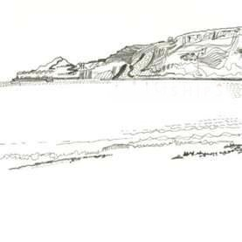
Below are some verses of a poem by Henry Wadsworth Longfellow, a famous American poet. It is titled The Lighthouse. (Not all the verses in the poem have been included.)
The rocky ledge runs far into the sea,
and on its outer point, some miles away,
the lighthouse lifts its massive masonry,
A pillar of fire by night, of cloud by day.
And as the evening darkens, lo! how bright,
through the deep purple of the twilight air,
Beams forth the sudden radiance of its light,
with strange, unearthly splendour in the glare!
Like the great giant Christopher it stands
Upon the brink of the tempestuous wave,
Wading far out among the rocks and sands,
The night o'er taken mariner to save.
And the great ships sail outward and return
Bending and bowing o'er the billowy swells,
And ever joyful, as they see it burn
They wave their silent welcome and farewells.
The mariner remembers when a child,
on his first voyage, he saw it fade and sink
And when returning from adventures wild,
He saw it rise again o'er ocean's brink
The sea-bird wheeling round it, with the din
of wings and winds and solitary cries,
Blinded and maddened by the light within,
Dashes himself against the glare, and dies.
Now answer the following questions in your book
- How is the lighthouse described by Longfellow in verse 1?
- When does the lighthouse shine best?
- In verse three it talks about St Christopher. He is the patron saint of Travellers. Who is Christopher keeping safe?
- In verse 4 he describes the movement of sailing ships on the sea, describe how they move.
- When the mariner was a child he saw the light fade and sink, what does he mean?
- What happens to the bird in verse 6? Copy the last verse into your books.

