Types of Small Boats
Stick this page in your book
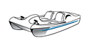A Paddle or pedal (pedalo) boat often found on park lakes
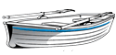 This is a wooden rowing boat
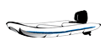
An inflatable dinghy made of rubber with petrol driven outboard motor
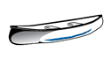
Canoe made of fibre glass, carbon plastic or wood.
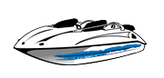 A motor boat for jet skiing or racing. The boat is usually made of fibreglass or carbon plastic
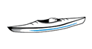 Kayak. A single seater canoe usually made with fibreglass or plastic

. 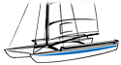 a sailing dinghy. This one has two hulls and is known as a catamaran

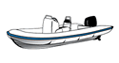A ribbed inflatable boat. A strong type of craft often used by the RNLI.

