How Ships float and what happens to them in heavy seas
When a ship travels through the water there are a lot of forces acting on the ship many of them sufficient to sink the ship. Ships are made in certain ways to prevent damage and sinking. Ships are made watertight so that water cannot enter the ship and if it does it can be pumped out again. A ship is really a number of watertight boxes joined together. If a watertight box is damaged then the ship will not sink straight away because the boxes on either side will still keep it afloat. In a ship these boxes are called cargo holds, in other words a place where cargo is stowed. The cargo holds form part of the hull (main body)of the ship. (Diagram 1. below) Another box at the stern (back) of the ship will hold the engine and a pointed box is put at the front of the ship called the bow. Diagram 2. below

1.

2.

Holds
Bow section
Engine Room

If the ship remains watertight then the air in each of the boxes is sufficient to keep it afloat even though the ship is made of metal and metal easily sinks in water. The condition of staying afloat is called the buoyancy of the ship. It doesn’t matter how big or how heavy the ship is provided it is watertight it will stay afloat. Watertight bulkheads (the naval term for walls), also help prevent fire spreading on a ship.
Each of the boxes is stiffened and strengthened all round the sides, also the bottom and the top so that the ship will keep its shape. The bottom of the box is particularly strengthened by putting a smaller box shape at the bottom of the ship. This is called the double bottom and it does what it says, it doubles the bottom of the ship which is the part which can easily be damaged if the ship runs on to the rocks or beaches on sand etc. It is an extra safety feature to stop water getting into holds and the engine room. When the Costa Concordia ran aground (hit rocks) the rocks burst through the double bottom and flooded the engine room and some of the holds so that enough water got into the ship to capsize it. Thus a double bottom prevents water getting into the main boxes on the ship. See diagram 3.

Upper Deck
Cargo hold
3.

Double bottom or floor
Watertight Bulkhead (wall)

Why do Ships sink?
Ships sink for a variety of reasons :- 1. They catch fire and the fire can’t be put out, 2. The ship sinks in a storm, 3. It hits rocks or some other submerged object such as a wreck 4. They capsize because they are badly loaded or the sea is too rough, 5. They collide with another ship and are holed below the waterline.6. The ship breaks up because it is badly designed.
2. Ships sink in a storm. A ship when it sails on the sea has a number of forces it must battle against. In rough seas the force of water is much greater than the ship can generate with its engines. Ships begin to roll, that is rock from side to side. If they roll too far then they are in danger of capsizing. Ships which are badly loaded where the cargo is not distributed properly in the hold will be subject to rolling more and can eventually capsize. Also if the cargo inside the ship is not fastened down properly it will shift and the ship will list to one side and eventually capsize. A ship which is well loaded will roll one way then come back and roll the other way as the wave passes under it. Recently a ship loaded with Mercedes and BMW cars was passing down the English Channel in a storm. Many of the cars broke their holding ropes and began to move around damaging other cars in the hold and breaking them from their moorings. Eventually they all piled up at the side of the ship and the ship capsized with millions of pounds of expensive cars lost and damaged. Look at the diagrams below and say which ship is likely to capsize first and why ?
1. Look at diagrams 1 and 2. A (shaded boxes) are light cargo and B (plain boxes) are heavy cargo.
2. Now look at diagrams 3 and 4. Which ship is likely to capsize and why? Are they loaded in the best way? If your answer is no then suggest how the cargo can be distributed and draw a diagram in your book.
1 2.
A Aaa

B

3 4.

6. Badly designed ships A number of ships have been lost because they have broken in two. During World War 2 the USA built many ships for Britain called Liberty Ships and T2 tankers. Both kinds of ships were prone to breaking in two and a number sunk because of it. This was because the design of the ships had a structural weakness in the middle if they were loaded to full capacity. To prevent this happening the ships were never overloaded.
In the 1800s ships were often overloaded in the water so that merchants would get more goods moved at the same time and thus save money. As a result many ships sank in heavy seas. To stop this and save the lives of seamen the ships were fitted with load lines using a system developed by Samuel Plimsoll which was placed on the side of a ship and the ship was only allowed to load to the point where the surface of the sea did not cover the plimsoll line.
- Go on the internet and find out about load lines and the Plimsol Line and draw what it looks like then briefly explain why they are there.
- The diagrams below are to be copied in your books together with the explanations.
SAGGING

cargo

HOGGING

Cargo

Large ships are in danger of breaking up because of their length in relation to wave length. If a ship starts to sag in the middle (top picture) then it could break amidships. If the ship is hogging i.e. supported in the middle and at both ends it could break just in front of the engine room. The whole process is known as heaving. Container ships are in danger of breaking in two as they often have large cargoes at each end of the ship. The picture below shows a container ship which split in two in heavy seas off New Zealand in January 2012.

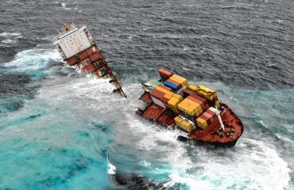 see pictures below
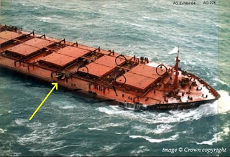 This is a picture of the m.v. Derbyshire which broke in two where the arrow is in a typhoon off Japan in 1980. All hands were lost.
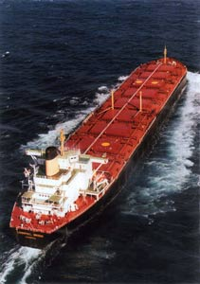 This is the Derbyshire before it broke into two pieces.
This Youtube video shows a bulk carrier breaking in two after its engines had failed then it was pushed on to cliffs where it was pounded by heavy seas.
http://www.youtube.com/watch?v=lG-6Z-1GuuA
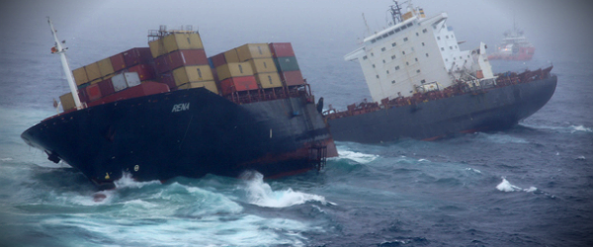

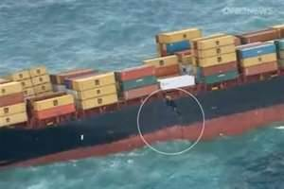This picture shows the ship above breaking in two
Looking at the picture above shows how the weight of cargo and ship was at both ends and not much in the middle thus there was a weakness in the middle and she split in two when it grounded after her engines broke down.
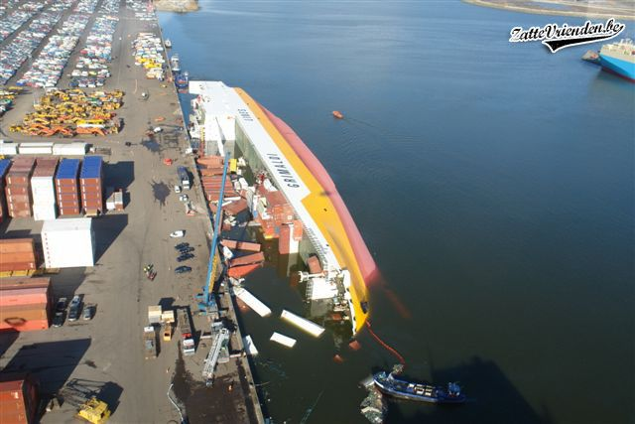Here a container ship has capsized during loading because of poor distribution of the cargo and possible overloading.
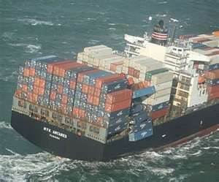this shows how badly stowed and heavy containers can suddenly put a ship in danger. This vessel luckily reached port before further damage was done.

