The International Code of Signals (Flags)

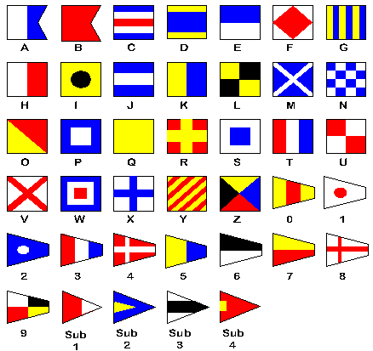
letters | phonetic alphabet | meanings
A | Alfa | Diver below, OR undergoing speed trial
B | Bravo | taking or discharging explosives
C | Charlie | Affirmative/Yes
D | Delta | Keep clear; Maneuvering with difficulty
E | Echo | Altering course to starboard
F | Foxtrot | Disabled, communicate with me
G | Golf | Need a pilot
H | Hotel | I have a pilot
I | India | Altering course to port
J | Juliette | I will send you message by semaphore; On fire with dangerous cargo, keep clear
K | Kilo | You should stop your vessel instantly. Wish to communicate
L | Lima | You should stop, I have something important to communicate
M | Mike | I have a doctor on board. Stopped and making no way through the water
N | November | Negative/No
O | Oscar | Man overboard
P | Papa | "The Blue Peter" All aboard, vessel is about to proceed. At sea: your lights are out or burning badly
Q | Quebec | My vessel is healthy and I request free practique
R | Romeo | The way is off my ship. You may feel your way past me
S | Sierra | My engines are going full speed astern
T | Tango | Do not pass ahead of me, Keep clear, engaged in pair trawling
U | Uniform | You are coming into danger
V | Victor | I require assistance (not distress)
W | Whiskey | I require medical assistance
X | X-ray | Stop what you're doing and watch for my signals
Y | Yankee | I am carrying mails; dragging my anchor
Z | Zulu | To be used to address or call shore stations. Require tu
Individual flags have each got a distinct meaning. e.g.
W means I require medical assistance
Q My vessel is healthy, I require free pratique (passage). This flag is flown when a ship enters a port on any occasion and indicates the shore authorities that there are no diseases on the ship which can be passed on. In years gone by when ships carried people with diseases e.g. typhoid. The ship was put on an anchorage and no one allowed to land until the ship had been cleared by medical authorities.
B I am loading or discharging explosives. It is now used to state that a ship is carrying explosives e.g. gas or oil
The phonetic (spoken) alphabet is used by police, ambulances, coastguards, aircraft etc. for example you may be asked to spell the name of a person, Smith; you could say the name is “ Sierra, Mike, India, Tango, Hotel. In order to spell the name.

- In your books do the following:-
- Draw the International code flags for the words Hetton and School.
- Write out the phonetic alphabet for Eppleton School.
- What do the words affirmative and negative mean and draw their flags.

