Short and Long distance Radio Communications
A communications satellite or comsat is an artificial satellite sent to space for the purpose of telecommunications. Modern communications satellites use a variety of orbits.
For fixed (point to point) services, communications satellites provide a micro-radio relay technology complementary to that of communication cables. They are also used for mobile applications such as communications to ships, vehicles, planes and hand-held terminals, and for TV and radio broadcasting.
Older telephone connections ( land lines) use cables as do communications to computers. Telephone links across the sea go by under-water cables. Newer types of cables which handle many telephone calls at once use fibre optic cables which are made of hundreds of fibre glass cables. Most broadband connections to your home for your computers come through a cable. If the cable is damaged or severed then you lose your connection and we say the connection is down.
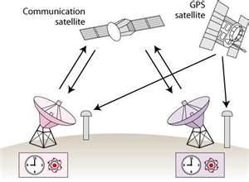 satellite diagram
Here a signal is sent up to a satellite in orbit some miles above the earth’s surface then forwarded on to another satellite dish which picks up the signal and transfers it to the person requiring the signal.
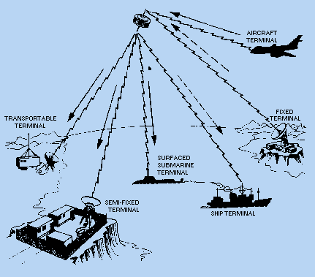
There are 48 communications satellites in the sky at present, all doing different jobs, e.g. carrying TV and radio signals, carrying global positioning systems which are necessary for navigation and GPS signals for SatNavs., camera satellites, military satellites, weather satellites and many more. Ships rely heavily on these satellites to know where they are at any time of the day and night and to send and receive important messages to and from them.
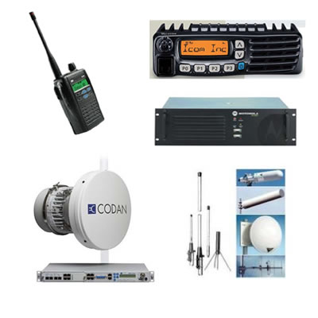Portable satellite equipment

Automatic Identification and Recognition System
The Automatic Identification System (AIRS) is an automatic tracking system used on ships and by vessel traffic services (VTS), e.g. coastguards, river controllers etc., for identifying and locating ships by electronically exchanging data with other nearby ships and AIRS Base stations. AIRS information is in addition to marine radar, which continues to be the primary method of collision avoidance for water transport. It will help with search and rescue missions and accident investigations.
This modern systems allows ships to know where they are, the course they have travelled and at what speed. Tracking is done by satellite positioning systems and computers. It tells them immediately what ships are near them , what courses they are travelling, where the ships have come from, the name of the captains, the cargo they are carrying, the size of the ship and where they are going to. It is being used to stop ships having collisions in fog as well, or if a ship is likely to get into difficulty such as possibly run aground.
Many ships have just disappeared off the face of the earth in the past, probably sunk in storms or sprung a leak, filled with seawater and sunk, this equipment may help find where ships have sunk or likely to get into trouble if travelling into storms etc. It will also allow ships to be tracked as they cross the world’s oceans. Some companies have many ships, as do the navies of most countries, and it is good to know where their ships are at any time. It can also give advance warning of potential pirate vessels which are on the lookout for ships to steal. All new ships are fitted with this system. It will allow the track of the Costa Concordia to be known before it hit the undersea rock and sank.

