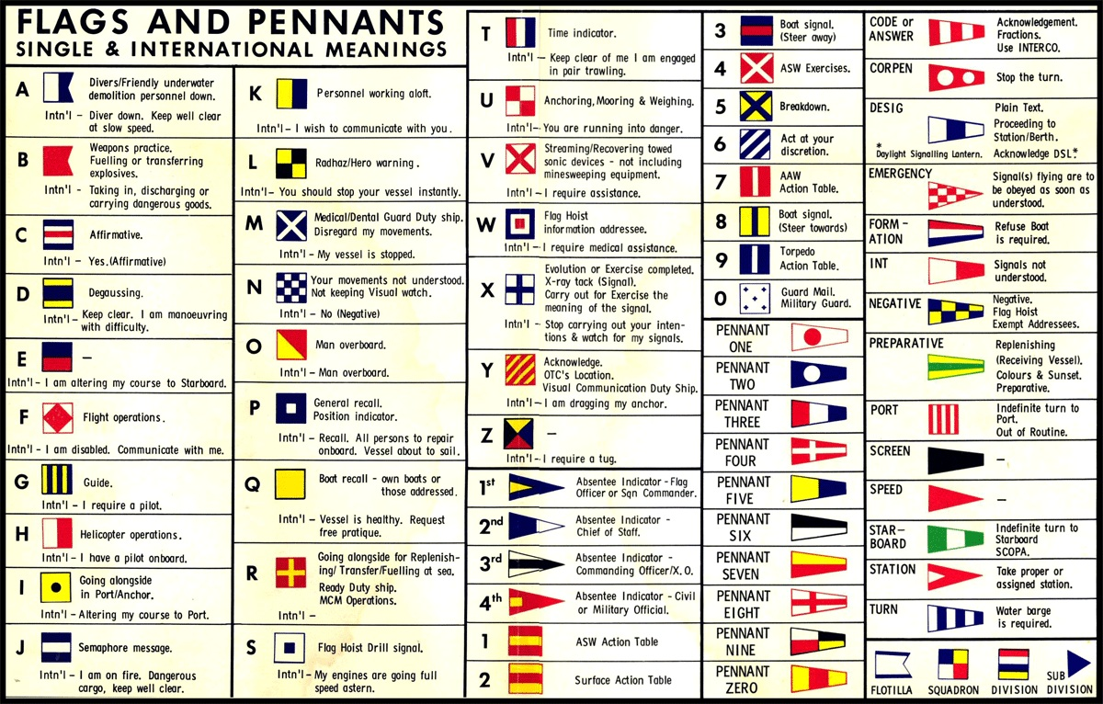
The colour of the flag gives the single letter. The word Int’l = International meaning. All other information is from the Royal Navy code book

