There once was a pirate named Jill.  Who crashed her ship by a hill.  She fell out of a tree.  She grazed her knee.  That clumsy old pirate called Jill.  By Alex A  There once a pirate named Joe  Who sailed all the way to the snow  It was getting cold  All his jackets were sold  That dumb old pirate named Joe  by Chris P | 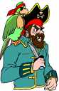
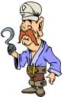 | There once was a pirate named Rex,  He had a bird that pecks,  He fired his gun,  And had a lot of fun,  That silly old pirate named Rex.  By James  There once was a pirate named Ted,  All day he’d sleep in bed,  His cat was fat,  His dog just sat,  That lazy and lonely Ted  By Monika
There once was a pirate named Franklin  Who loved to chew on plankton  Until he got hit over the head  Then they shot him dead  That silly old pirate named Franklin  By Brandon  There once was a pirate named Izzy  And he was always busy  He fell off the ship  And broke his hip  That poor old pirate named Izzy  From Bradey | 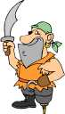
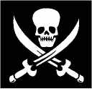 | There once was a pirate Harry  Who hated a man called Larry  He went to the ships  And swayed his hips  That silly old pirate called Harry.  By Ashleigh  There once was a pirate called Bill  Who yesterday got very ill  The doctor came around  And didn’t hear a sound  From that sick old pirate called Bill  By Chris McMillan
There once was a pirate named Jack  Who had a broken back  He fell off his chair  And went into mid air  That poor old pirate called Jack  By Joshua  There once lived a captain Ben  His men were Jim and Glen  He fought for gold  Until he was old  That silly old captain Ben  By Elise | 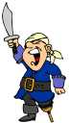
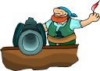 | There once was a pirate named Moe,  Who was a silly old fellow,  He fell into the lake  and ripped his cape,  That silly old pirate named Moe.  By Jessica  There once was a pirate named Jack  Who fell and broke his back  He slept on a rack  He fell in a sack  That poor old pirate named Jack  By Lucan
There was a pirate named Wayne  He loved to feel the pain  He wasn’t very smart  He got hit with a dart  That stupid old pirate named Wayne  By Reece  There once was a pirate called Brad  Who had an old cat that is mad  He likes to rob  His friend is Bob  That dangerous pirate called Brad  By Raymond | 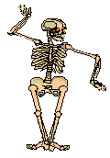
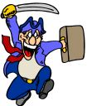 | There once was a pirate called Flynn  He did a really bad sin  He found a penny  Got a girlfriend called Jenny  That lucky old pirate called Flynn  By Aaron.C  There once was a pirate named Bill  His best friends name was Lil  He drank too much rum  His head began numb  That silly old pirate named Bill  By Lyell
There once was a pirate named Jack,
Who liked to wear his big black hat,
He looked overboard,
Then he was bald,
That stupid old pirate named Jack.
by Niall
There once was a pirate named Mack,
He lived in a very big shack,
He went on a ship,
And did a big flip,
That silly old pirate named Mack.
by Erin
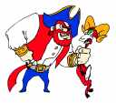 | There once was a pirate named Hook,  Who was a really great cook,  He made apple pies,  With heaps of flies,  That silly old pirate named Hook.  by Shannon  There once was a pirate named Lee.  She once dislocated her knee,  She went to fly,  But instead she cried.  That silly old pirate named Lee.  by Taila
There once was a pirate named Jack,
Who wore a tattoo on his back,
He absolutely loved to fight,
Believe it or not in the night,
That funny old pirate named Jack.
by Michelle
There once was a pirate named Plum
Who liked to suck his thumb
When he went to bed
The huge thumb went red
That silly old pirate named Plum
by Melanie

