Modern ship Navigation
Modern ships are fitted with a wide range of modern sophisticated technical navigation systems. Most of them rely heavily on computers to work properly and global positioning systems using satellites to go from one place to another around the globe.
Here are a few of the systems now in use :-
- The integrated Bridge System :- this is where many of the pieces of equipment and instruments work together providing the right information for decisions to be made by the captain and ship’s officers when working on the bridge.
- Nauto Steer (automatic Steering):- No longer is it necessary to have a man on the wheel to steer the ship except when going into or coming out of a port. The ship can be steered by having a course set and computers work the steering motors which are a long way from the bridge and these make the rudder turn.
- Radar Chart System :- Here a radar will follow a course laid down by computer laid down on an electronic chart, and the course the ship is following. It will also plot other ships or potential hazards such as rocks or land and give warning of them.
- ECDIS (Electronic Chart Display and Information System):_ A system of computer charts showing where the ship is going to and travelling from. These charts show all the hazards such as land, rocks, tide and current information, directions travelled, as well as the track of the ship. This system is tied to the ship’s compasses for direction as well as the engine regulator which controls the speed the ship is travelling through the water.
- Echo sounders;- These instruments give the depth of water under the ship, there is often one under the bow of the ship and another at the stern (back).
- Gyro Compasses:- These instruments along the courses to be set in a certain direction and are also used for giving directions o other objects such as ships and lighthouses etc.
- Fire Safety Systems :- A system which regulates all the sensors which indicate fire throughout the ship and set off fire alarms and fire control systems such as sprinklers.
- Engine Room Controls :- An instrument which controls and regulates the speed of the ship i.e. how fast the ship’s engine goes. It also tells the propellers to turn in certain ways so the ship travels ahead (forward) or astern (backwards). Some big ships are fitted with 2 thruster propellers on each side of the ship at the front (bow thrusters) and at the back (stern thrusters) to move the ship sideways when in dock. Thus the ship can easily be manoeuvred into position when docking or leaving a harbour.
- Security systems :- These systems make sure that watertight doors are secure or all lights including navigation lights are working correctly, telephone systems etc.
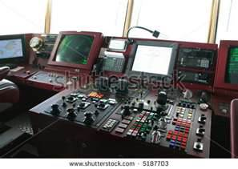
Bridge equipment for driving the engine and steering

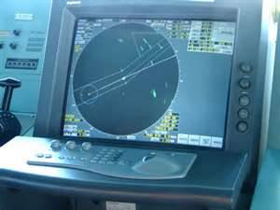 A radar showing ships and their tracks

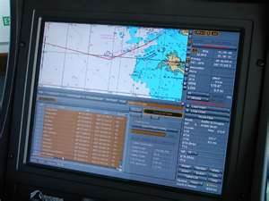 An ECDIS system of electronic charts

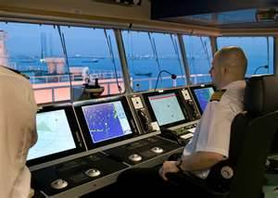 The bridge of a ship

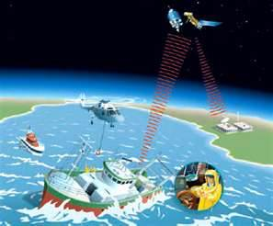 Communications systems
- Communications Systems :- Radios and satellite radio relays. Short wave VHF radios to speak to people all over the ship. Ships telephone system etc.

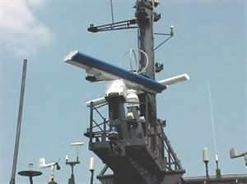 Ship Radar systems

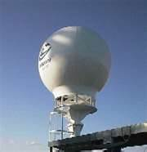 Satellite communications
A Tour of the bridge of Oasis of the Seas
Navigation bridge https://www.youtube.com/watch?v=fqbOhfFJIBU
Safety Centre https://www.youtube.com/watch?v=-hiBjJYAuG4
Future Cruise ships https://www.youtube.com/watch?NR=1&v=4sV8v8fvtFE&feature=endscreen

