The Picton Castle

This is the story of one ship which has done a great deal during its lifetime. Read about it then answer the questions which follow.

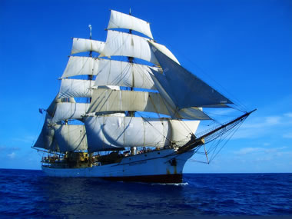

The ship is a completely refitted barque ( a type of sailing ship) so named because of the number of sails and where they are to be found on the ship. It is also known as a Cape Horner as this type of ship regularly sailed round Cape Horn on its journey between Australia and England.
She is 179 feet (58 metres) overall in length, with riveted steel hull, clear oiled-pine decks, steel masts, and wooden and steel yards. She carries 12,450 square feet of canvas sail. In the previous sentence there are parts of the ship which you have no idea where they are or what they look like, well, you will soon be given a diagram to help you.
The ship when full carries 40 trainees and a permanent crew of 12. The Picton Castle is a true working tall ship. Sail trainees take part fully in the ship's operation: handling sails, scrubbing the deck, taking a turn at the wheel, raising anchor, hauling on lines, helping in the galley(ship’s kitchen), going aloft (climbing masts), and keeping lookout. There are training classes in seamanship and navigation, plenty of opportunities to learn about and take part in square-rig sailing and, on the world voyages, to explore exotic tropical ports and islands.

Picton Castle diagram
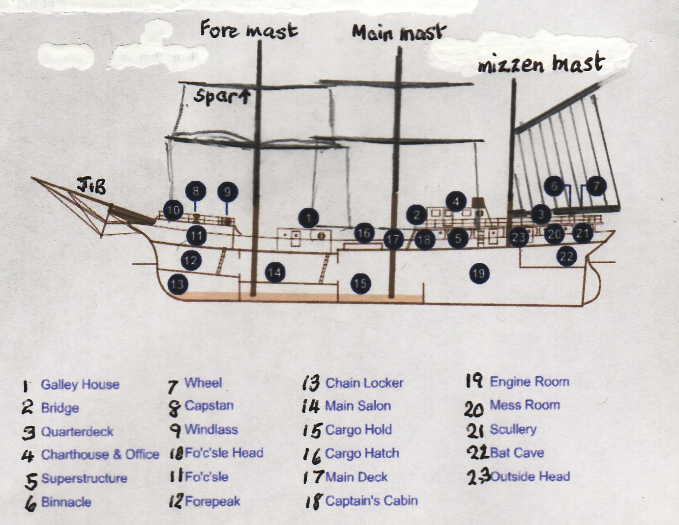
The diagram above shows the main parts of the vessel. Not all the masts and spars or the sails are shown. When all sails are set there are 17 of them.
Explanation of terms :-
- Galley = cookhouse; 2. bridge= where the ship is navigated from and where the steering wheel and compasses can be found; 3. a raised deck at the rear (stern) of the ship[; 4. Charthouse= where the navigation charts are kept; 5.Superstructure= cabins and accommodation above the main deck; 6. Binnacle= a cover for the compass used to steer the ship on its course; 7.Wheel= wheel to steer the ship; 8.capstan= a machine either steam or electrically driven, used to pull in ropes; 9.Machine to lift the anchor and chain; 10 fo’c’sle head= the deck at the front (bow) of the ship; 11. The fo’c’sle= the space under the fo’c’sle for storing ropes etc. 12. The forepeak= a storeroom or water tank at the front of the ship; 13. Chain locker= where the anchor chain is kept; 14. main salon= where the officers eat their meals; 15. Cargo hold= the space in the hull of the ship ( the main part) where cargo is stored; 16. cargo hatch = the hole in the deck leading into the hold; 17.Main deck= longest flat deck on the ship; 18. Captain’s cabin= where the captain sleeps 19. Engine room = where the ship’s engine is to be found. The engine drives the propeller at the stern of the ship. 20. Mess room= where the crew eat their meals; 21.Scullery= where the dishes are washed etc.;22. Bat cave = a low space where a steering motor operates the rudder;23. Outside head = outside toilet.
If you were standing at the front of the ship you would be forward or at the bow, at the back of the ship you would be at the stern and if you were in the middle you would be amidships.
Even though this is an old ship most of the names are still used on ships today. You will meet them again when we look at modern ships.
Your first task now is to find out where the Picton Castle is sailing today. By clicking on the following web address then clicking on the Captain’s Log to find out what is happening. Write in your exercise books where the ship is, draw a map if you can then write a few sentences about what has been happening on the ship.

http://www.picton-castle.com/ship-and-crew/life-on-board.html

