Life on board ship around 1800

FOOD PREPARATION

he galley on large warships around the time of Nelson provided hot food for the entire ship, up to 950 men and officers. Due to the risk of the ship catching fire, however, the galley fire was put out in rough weather or during action. This meant it could be some time before another hot meal was available.
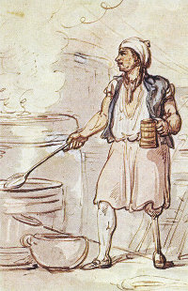
The galley was generally found near the foremast on the gun deck. It was a very small area, considering the number catered for.
The crew ate in groups of 8-12 called messes. Each man would take his turn as mess cook and collect the day's rations from the hold to prepare for cooking for the noon meal. The main diet of seamen was salted beef and pork, along with biscuit, peas, oatmeal, sugar, butter and cheese. For example, each man on Thursdays was entitled to a pound of bread, half a pound of dried peas, a gallon of beer (or substitute), and one pound of salt pork. The prepared food was taken to the galley to be cooked (each mess marked their food with a tag). The mess cook was also responsible for washing up the utensils and generally cleaning the eating area after the meal. He was entitled to an extra issue of rum for his trouble.
In the galley, the seamen's food would be boiled in two large kettles; there were facilities for roasting and other methods of preparation for the captain and officers.
The mess cook also carved and served the meal. To ensure fairness, one of the other men was blindfolded, a portion of the meat was carved, the blindfolded man called out a name and the portion went to that man and so on, until it was served. However this was not always followed, younger mess members were sometimes bullied and deprived of the best victuals by older men. (This method of sharing rations fairly is part of survival training to this day.)
On the days when raisins were issued along with flour and suet, the mess cook was ordered to whistle while he prepared the “duff” (steamed pudding) so that he couldn't sneak some raisins into his mouth!
The galley was cleaned by the cook’s mate, under the supervision of the cook. Sand was used to scour the vast kettles, which were inspected each morning for cleanliness.
Since the early days of sailing ships, the most readily available liquids to take on voyages were water and beer, both of which could only be stored for a short time before they became undrinkable. The beer issue was a gallon (4 and a half litres)a day per man. When no beer was available sailors were given rum which was watered down. This was known as a tot and the custom lasted until 1970 to have a daily tot, in the Royal Navy.

