Environmental Issues and Ship-breaking
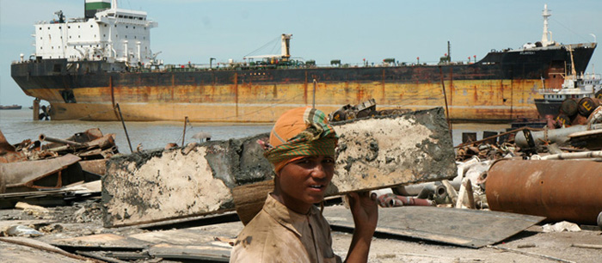
The picture above shows ships being broken up on the beaches of Chittagong in Bangladesh.
- Look at this picture and describe it in detail in five sentences.
- Think about then write down 3 environmental issues which you think are dangerous.
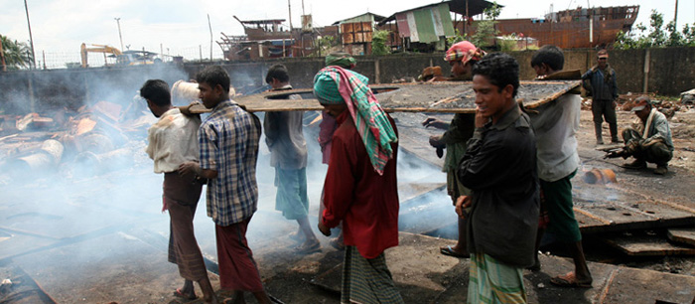

This picture is taken in the same place.
- Explain in your own words what is taking place. ( 3 sentences).
- Is Health and safety important here. Suggest two factors in the photo which support your ideas.

These pictures show what life is like in one place on the earth. It is, however representative of a number of places. Could you live and work here? Would you choose to live and work here? You might have to work like this if you lived here, either that or starve.
How did ship breaking actually start here in Bangladesh. In 1961 there was a massive storm called a cyclone (similar to a hurricane) in the Bay of Bengal next to Bangladesh. During the course of the storm which blew inland a number of large ocean going ships were travelling up the Hooghly river to the port of Chittagong fifteen kilometres inland. The storm and high waves lifted the ships on to the river bank so that they were about half a kilometre from the river. They were high and dry and could not be refloated. They were unloaded of their cargoes and then eventually broken up bit by bit until there was nothing left of them. The metal and other fittings on the ship were taken away melted down, sold or used in other places. The breaking up here was thought to be a good thing since it gave employment to many of the local population and others made a great deal of money by selling on parts of the ships including scrap metal. Thus a new industry started.
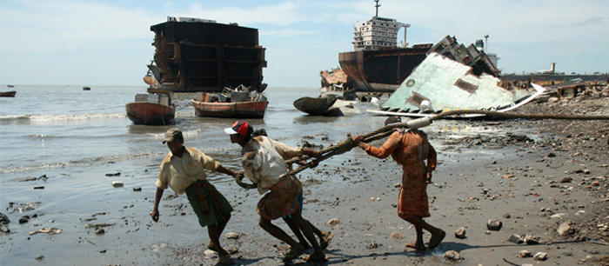
Since that date more than 5000 ships have been broken up in this part of the world. There are other places around the world doing the same thing including, Pakistan, India, Philippines and Turkey.
We all know how ships are born, how majestic vessels are nudged into the ocean with a bottle of champagne and cheers from a crowd. But few of us know how they die. And hundreds of ships meet their death every year. From five-star ocean liners, to grubby freighters and small vessels broken and bent after a hard life.
Shipbreaking is the process of dismantling an obsolete vessel’s structure for scrapping or disposal. Conducted on a dismantling yard, it involves a wide range of activities. From removing all the gear and equipment that are on the ships to cutting down and recycling the ship’s infrastructure. Shipbreaking is a challenging process, due to the structural complexity of the ships and the environmental, safety and health issues involved . Due to cheaper labour costs and fewer health and safety regulations that have to be followed, the developing world including Bangladesh are hosts to the vast majority of ship breaking efforts.
The ships are literally dumped with all their steel, their asbestos, their toxins on the beaches of some the poorest countries in the world, countries like Bangladesh. You can't really believe how bad it is here, until you see it. It could be as close as you'll get to hell on earth, with the smoke, the fumes, and the heat. The men and occasionally women who labour here are the wretched of the earth, doing dirty, dangerous work, for little more than $1 a day.
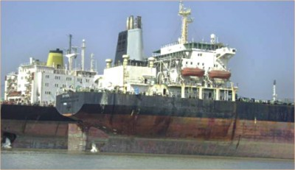Waiting their turn to die, two ships at Sitakunda, near Chittagong in Bangladesh.
Below is part of an article in a local September this year about the breaker’s yards.

A list of dead workers from the year of 2005 to 2012 (September):
A number of 90 workers died in last 7 years 9 months, more than one worker died on an average per month, according to the available information. At least eight workers have lost their lives at the shipbreaking yards in Bangladesh this year, at least 12 shipbreaking workers died on the job in 2010 and at least 15 died in 2011. . Hundreds of end-of-life ships are dismantled every year on the beaches of South Asia without sufficient concern for environmental protection and workers’ rights. The figure is only confirming the deaths which were available to the local sources , media, police station, concerned government agencies, ngos etc. The figure only including the deaths which were occurred on the shipbreaking yards and while the workers were working in the yards. The death could be more than the mentioned figure as its not possible to get the information of some accidents which were hidden by the shipbreaking owners authorities.
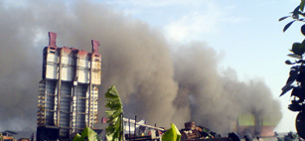
Though shipbreaking has earned a good reputation for being a profitable industry in developing countries there are a number of environmental and human health hazards. Depending on their size and function, scrapped ships have an unladened weight of between 5,000 and 40,000 tons (the average being 13000+), 95% of which is steel, coated with between 10 and 100 tons of paint containing lead, cadmium, organotins, arsenic, zinc and chromium. Ships also contain a wide range of other hazardous wastes, sealants containing PCBs, up to 7.5 tons of various types of asbestos and; several thousands of litres of oil (engine oil, bilge oil, hydraulic and lubricants oils and grease). Tankers additionally hold up to 1,000 cubic meters of residual oil. Most of these materials have been defined as hazardous waste under the Basel Convention. In Bangladesh, ships containing these materials are being cut up by hand, on open beaches, with no consideration given to safe and environmentally friendly waste management practices. Much of the toxins finds their way into the sea around the yard or into the country by means of taking the scrap elsewhere. Chemicals that are highly toxic, remain intact in the environment for long periods.
Ship scrapping activities pollute the seawater environment in the coastal area. Shipbreaking activities contaminate the coastal soil and sea water environment mainly through the discharge of chemicals and toxins.
Asbestos was used in old ships as a heat insulator. As there are no asbestos disposal procedures, during scrapping, workers and the surrounding environment are exposed to the asbestos fibres. Exposure to asbestos fibres (even in very low concentrations) especially through inhaling them may cause cancer and asbestosis. On the shipbreaking beaches, asbestos fibres and flocks fly around in the open air. Workers take out asbestos insulation materials with their bare hands.
It has also proven to be one of the most lethal, as inhaling asbestos fibres can lead to a wide range of lung problems such as asthma and asbestosis - and can also be the direct cause of lung cancer. Heavy metals present in large quantities on the ships e.g. mercury, cadmium, lead, etc., cause cancer of the skin, intestine, kidney, liver or bladder. They can also cause damage to blood vessels. Local hospitals report an increase in these types of cancer.
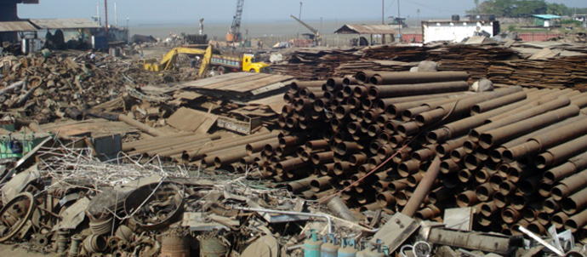
Oil pollution has virtually wiped out the local bird population over the last 30 years. Soils inland are being damaged where stocks of metal are being stored, this will cause problems in the future when land is need for other things.

The Benefits of the Shipbreaking.
1. Production of steel:
The scrapping of ships provides the country’s main source of steel and in doing so saves large amount of money in foreign exchange by reducing the need to import steel materials from other countries.
At present Bangladesh has a demand for 50,0000 tons of metal / steels, but Bangladesh has no iron ore sources or mines, which make ship scrapping the inevitable and important source of raw materials.
A number of new steel rolling mills processing the scrap steel have been built and started in and around Chittagong and this has greatly helped employment. A good number of local industries including heavy and light engineering already been developed depending on the ship breaking industry.
2. Green Industry. In some ways it can be considered a “green industry”. Almost everything on the ship and the ship itself is recycled, reused and resold. The scrapping of ships supplies raw materials to steel mills, steel plate re-manufacturing, asbestos re-manufacturing as well as providing furniture, paint, electrical equipment and lubricants and other oils to the number of businesses that have spouted up specifically as a result of shipbreaking.
3. Taxes. It generates large amounts of revenue for various Government authorities through the payment of taxes. Every year the Government collects revenue from the shipbreaking industry through import duty, yards tax and other taxes.
4. Employment. Despite the conditions that the workers are employed under, this is an industry that employs more than 50,000 people directly while another 0.1 million people are involved indirectly. It provides employment for some of the poorest people from the north of Bangladesh who would otherwise have no employment. This has been the greatest help in a country where most people were living on low wages from agriculture and constantly in danger of starvation.
5. Exports. Since the rise of industrial China which requires huge amounts of steel to support its economic growth the shipbreaking industry is enjoying a boom during a period when the world’s economies are in recession, so leaving Bangadesh with a source of ready income coming in, as many of its other exports are shrinking e.g. clothes and leather goods.
Answer the questions in your books
- Do you think Bangladesh should stop this dangerous industry and help save the planet? Give reasons for your answer.
- Make a list of all the dangerous pollutants and say why they are dangerous.
- What do you understand by the term Health and Safety? How could the situation improve in Bangladesh.

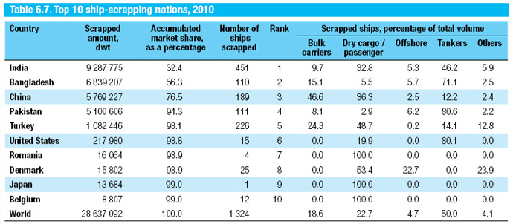
Table of ship scrapping countries around the world in 2010
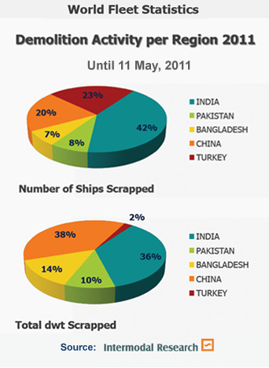
Children can copy the graphs given the figures and using Excel
Dwt stands for Dead weight tonnage
(i.e. the amount of tonnage cargo
carried by a ship)

.

http://siteresources.worldbank.org/INTPOPS/Publications/22816687/ShipBreakingReportDec2010.pdf
http://googlesightseeing.com/2006/08/ship-breaking/
http://www.youtube.com/watch?v=lk0xbjamHt0
http://www.youtube.com/watch?v=mRJYgNc_TNc
http://www.guardian.co.uk/world/2012/may/05/bangladesh-workers-asia-shipbreaking
http://www.bbc.co.uk/news/world-asia-18182706

