The Panama Canal
The Panama Canal (Canal de Panamá) is a 48-mile (77.1 km) ship canal in the country of Panama that connects the Atlantic Ocean (via the Caribbean Sea) to the Pacific Ocean. The canal cuts across the Isthmus of Panama (a narrow strip of swampy land) and is a key connection for international maritime trade. There are locks at each end to lift ships up to Lake Gatun (26m above sea-level) which was used to reduce the amount of work required for a sea-level connection. The current locks are 33.5 metres wide although new larger ones are being built and will be opened by 2014.
Work on the canal, which began in 1881, was completed in 1914, making it no longer necessary for ships to sail the lengthy Cape Horn route around the southernmost tip of South America(via the Drake Passage) or to navigate the dangerous waters of the Straight of Magellan. One of the largest and most difficult engineering projects ever undertaken, the Panama Canal shortcut made it possible for ships to travel between the Atlantic Pacific Oceans in half the time previously required. The shorter, faster, safer route to the U.S. West Coast and to nations in and along the Pacific Ocean allowed those places to become more integrated with the world economy.
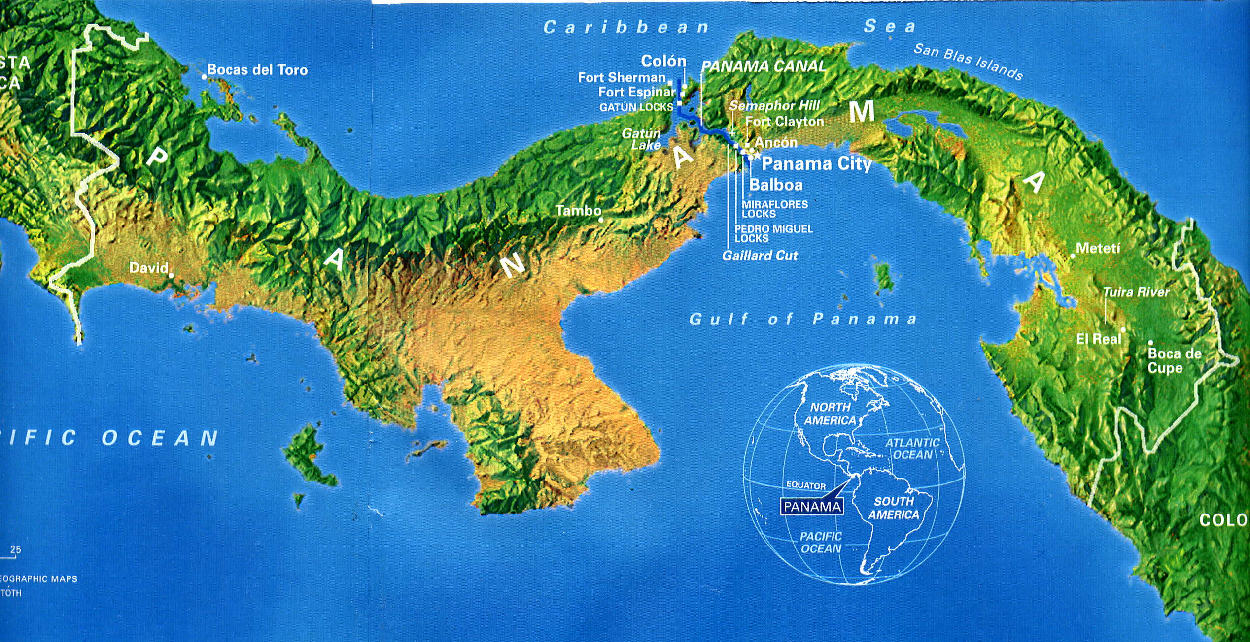
The Canal runs from Panama City (Pacific side) to Colon (Caribbean Sea). Many hundreds of lives were lost building it both from accidents but mainly diseases. It is really one of the wonders of the modern world. About 40 to 60 ships pass through the canal every day and it costs between $80,000 and $200,000 to pass through depending upon the size of ship. Large cruise ships go through and when they enter a lock they have just 2 feet either side and about 6 feet at the front and back, in other words they just fit in.
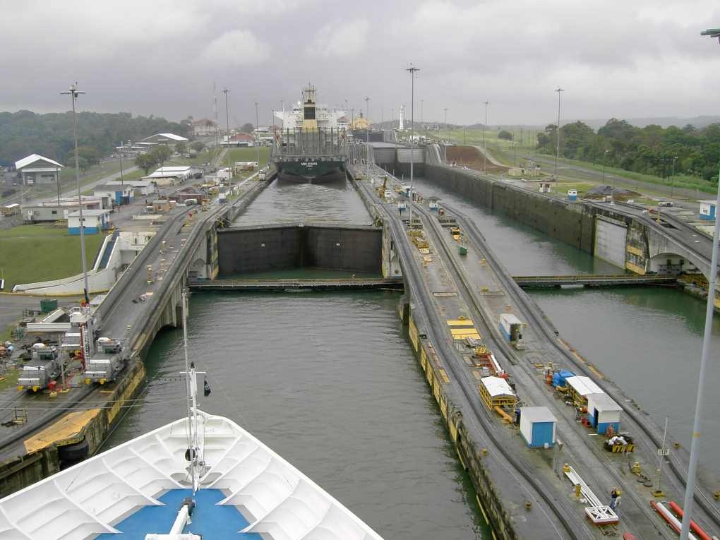
This picture shows a ship about to enter a lock. It will be pulled along the lock by small electric engines called mules. They are on the left foreground painted grey. The ship in front has been lifted up about 13m before it goes into another lock to be lifted a further 13 m before going into a lake. It then sails across the lake taking about 5-6 hours where it enters a further two locks to be lowered another 26 metres.
The locks on the right are bringing through ships going the other way. You can just see a ship painted yellow in the far distance.
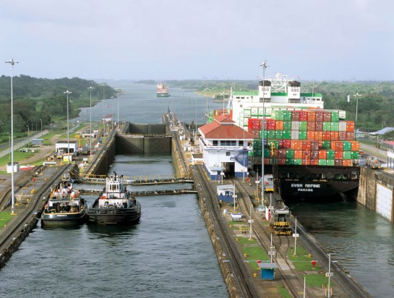Just enough room for the big ship

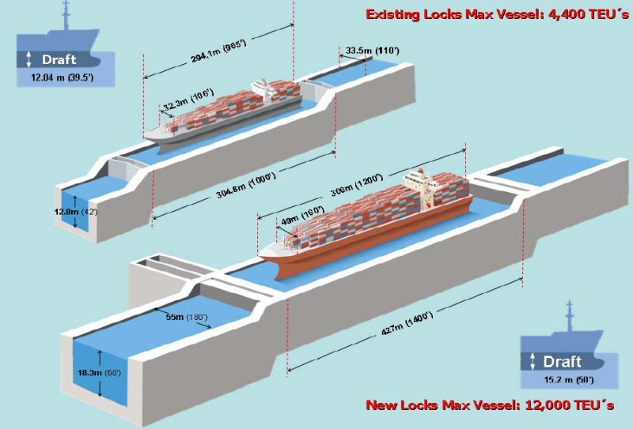
The diagram above shows how the new locks can take much bigger vessels

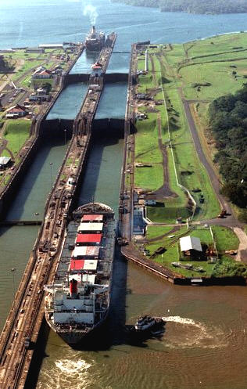 A flight of locks almost like a ladder for the ship to climb

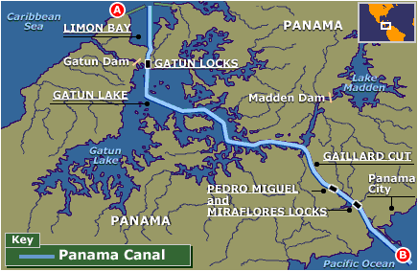
The map above shows the Gatun Lake and the sets of locks each ship must pass through
The addreses below shows a transit of the Panama Canal in 3 minutes using time lapse photography
http://www.youtube.com/watch?v=UflIYqdMhxU

http://www.youtube.com/watch?v=_quhzVvK--Y

