The significance of the Suez Canal

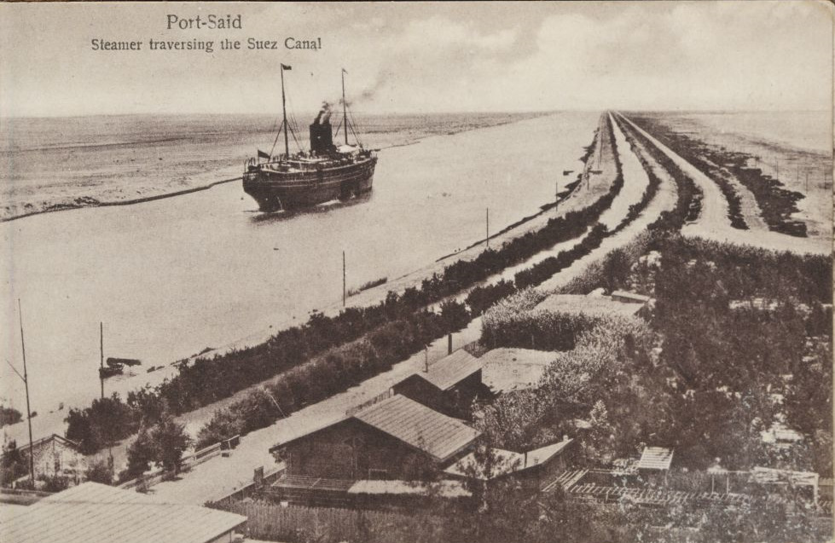
The canal in the 1920s

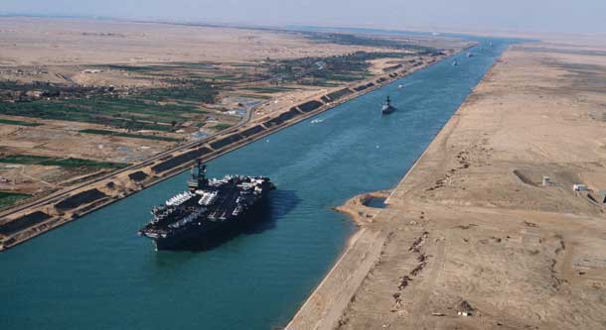
The canal in 2008
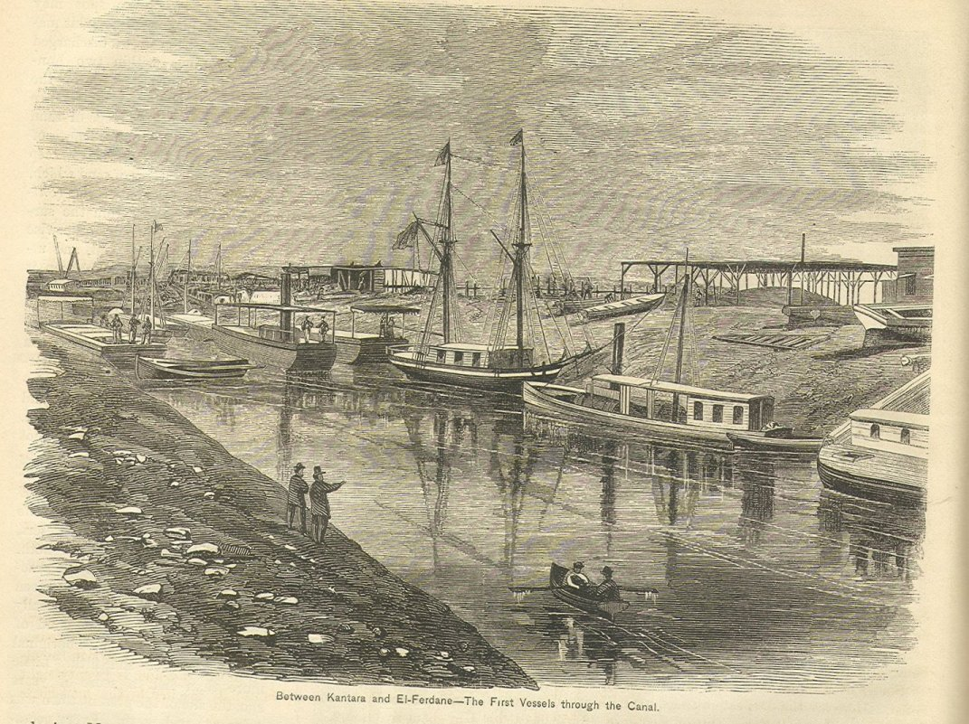
The first vessels through the canal
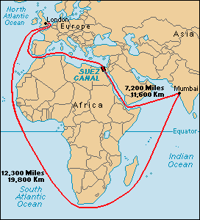
By using the Suez canal the journey from London to Mumbai (Bombay) in India is reduced by more than 5000 miles. This is significant since it not only saves time but also a lot of fuel used by ships as well as wages of the seamen. For years it was not possible for ships greater than 40,000 tons to use the canal as it was not deep enough but in the last 20 years it has been deepened and widened.
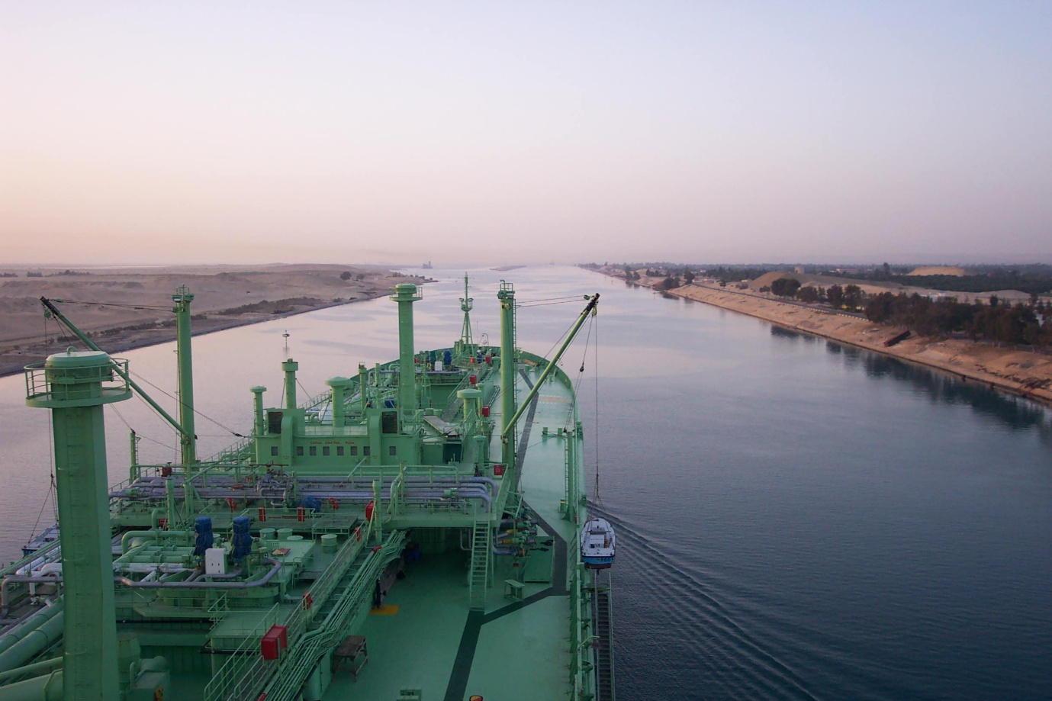
Passing places for ships are limited but looking ahead the canal splits into two and ships tie up in one of them (southbound) while the northbound ships pass by in the other canal. Thw south bound convoy then moves on. Seawater flows freely through the canal

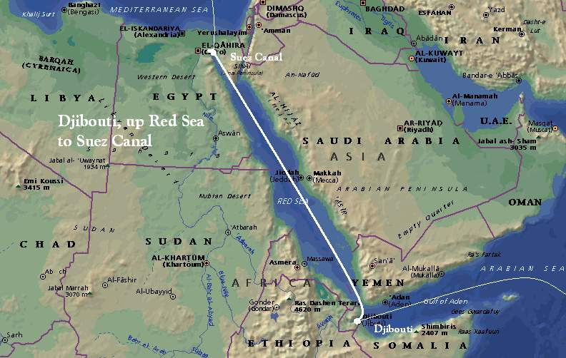
Ships pass into the Red Sea after leaving the canal southbound and into the Mediterranean Sea northbound. There are no locks for the ships to pass through as the height of the Red Sea and the Mediterranean are virtually the same. Ships nearing the bottom of the Red Sea have to be aware of modern-day pirates who have captured many ships since 2000. Ships regularly travelling to Asia or the Persian Gulf pass through the Suez Canal. It takes between 16 and 24 hours to pass through the canal depending on which way ships are going.
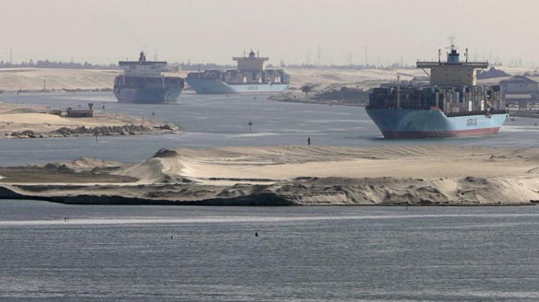
The picture above shows ships travelling in convoy (together) negotiating the southern entrance to the canal.
When first built in 1869 by Ferdinand de Lesseps, the canal was 164 km (102 mi) long and 8 m (26 ft) deep. After multiple enlargements, the canal is 193.30 km (120.11 mi) long, 24 m (79 ft) deep and 205 metres (673 ft) wide as of 2010.

