THE SUEZ CANAL
The Suez Canal is one of the world's most heavily used shipping lanes, with an average of 55 ships using it daily. Completed between 1858 - 1869, the masterpiece of Ferdinand De Lesseps, the Suez Canal immediately cut the distance between Europe and the Far East, allowing vessels to avoid the long and arduous voyage around the Cape.
In 1956, a joint British/French/Israeli attempt to keep the canal out of the political control of Egypt was thwarted and within 11 years the Canal was closed (on 5th June 1967) for exactly 8 years, opening again on 5th June 1975. 54 vessels had been trapped in the canal when it was closed by Egypt.The closure led to huge increases in the price of oil and the birth of the VLCC (supertankers), needed to get oil to Europe in large quanties via the Cape.
The Canal is 118 miles long and the minimum depth is 16.1 metres. Vessels, especially many tankers are built to maximise the possible cargo carriage through the canal (hence Suez max tankers)
Vessels go in regular convoys, either north or south.
1st southbound convoy starts 01.00 hrs every day.
2nd southbound convoy starts 07.00 hrs every day.
The northbound convoy starts 06.00 hrs every day
Transit time 10 - 14 hours.
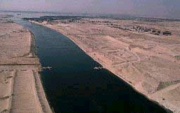
Travel along the Suez canal in 5 minutes time lapse

http://www.youtube.com/watch?v=L0J-VIvKLsc

