A Timeline for the Development of Ships

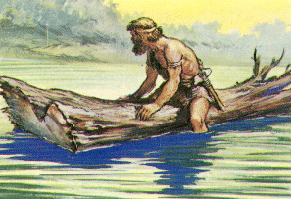 Floating Log
The floating trunk was used to cross rivers and lakes. Used in the period before 20,000 BC.
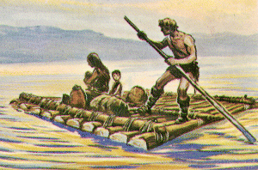 Raft
Rafts proved to be much safer than a single tree trunk and they could carry more.
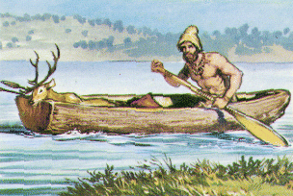 Early boat
Hollowed out logs proved to be an answer and stopped craft from having water splash over the sides

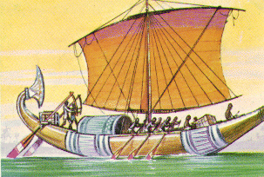 Egyptian Ship
Between 4000BC and 4500 BC larger vessels were being built by the Egyptians to sail on the River Nile. No vessels of this age have been found but there are drawings of them on clay tablets. By 2000BC vessels like the one shown above were in use being moved through the water by both oars and sails. About this time the Ancient Greeks were building ships around 30 metres in length similar to the one above. The Greeks used their vessels for lengthy sea voyages.
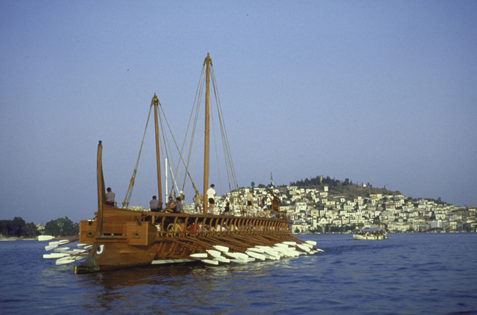 Greek Trireme

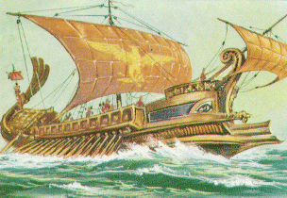 Roman Warship
By 50 BC the Romans were building large ships powered by many oarsmen, usually slaves. The ships were called triremes (3 rows of oars) and quadremes, 4 rows)
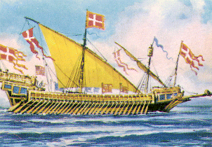 Galley
Gallies were standard types of battleships and merchant ships on the Mediterranean since 10th century. The gally was developed from a Byzantine (eastern Mediterranean) vessel and was being used till 18th century. She was 60m in length, 7m wide, with draught of 3m. Her deadweight was 300 tons and she carried about 500 men. Slaves and prisoners were being used for rowing
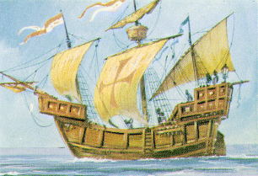 Caravel
Caravel was type of vessel that was wide-spread between 12th and 16th century. She was very suitable for long voyages. She was fitted with three to four masts and she carried about 70 men. Christophor Colombus was using caravel for exploration.
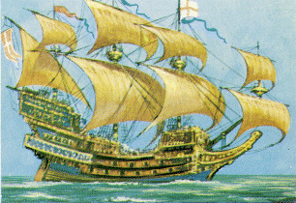 Large Sailing Ship
This huge vessel was used for ocean-going voyages. She was fitted with four masts. 600 to 800 men could board the vessel. Spain was using this type of vessel for communicating with their colonies in America.
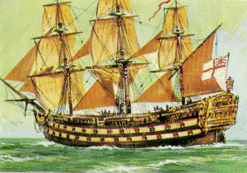 Large sailing ship

About 1750 this type of sailing vessel was constructed. She was the war ship about 70m in length, 15m wide, huge and magnificent, fitted with three masts 70m high. She carried 1000 to 1200 men and was armed with 120 guns. Nelson sailed this type of ship from 1770 to 1805.
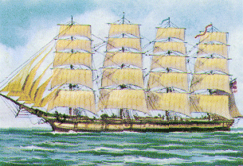 Clipper Ship
Clipper was constructed in America from about 1850 onwards to compete with English vessels. Her deadweight was 800-2000 tons and with her 3-8 masts she could sail at high speed. It took her 13 days to cross the Atlantic Ocean. They were used until about 1920 carrying grain and wool from Australia to the UK.
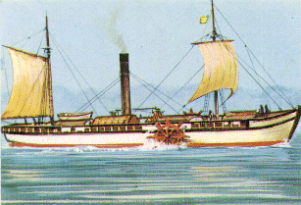 Steam ship
In 1803. an American called Robert Fulton constructed the first steam ship. In 1807. he constructed the steam ship "Klermon". It took her 22 hours to cross the distance between New York and Albany (287 km). In 1819 the "Savanah" was constructed. She was fitted with three masts as well as steam engine. Classic sailing vessels ceared to exist that year. By 1870 there were more steam ships being built than sailing ships.
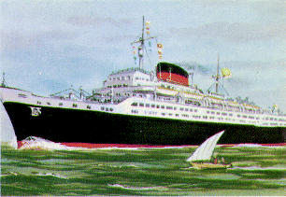 Transatlantic liner
In 1858. Great Eastern was the first large liner constructed. It was a huge steam ship made of steel. She was 211m in length, and her deadweight was 20000 tons. This ship was the forerunner of today's modern ships. Fifty years later there were many iron steamships operating around the world.
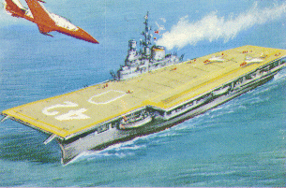 Aircraft Carrier
First built in 1919 aircraft carriers now operate in many navies of the world.

