Nautical Terms and sayings which are often used

1.Batten down the hatches

Meaning Prepare for trouble.
When a ship was likely to run into heavy seas over the decks it was necessary to cover the hatches (the holes in the deck through which cargo went into the ship) to prevent seas going into the ship’s hull and swamping or sinking it.
2.Between the Devil and the deep blue sea
Meaning In difficulty faced with two difficult decisions
The Devil is bad and falling in the deep sea is bad, so when caught between the two we would be in difficulty.

3.Broad in the beam
Meaning Having wide hips or buttocks
The beam is the widest point or part of a ship so are the hips on a body.

4.Copper-bottomed
Meaning Genuine; trustworthy
Copper-bottomed' described ships that were fitted with copper plating on the underside of their hulls. The process was first used on ships of the British Navy in 1761 to defend their wooden planking against attack by Teredo worms a.k.a. Shipworms (actually a type of bivalve clam) and to reduce infestations by barnacles. Ships not coppered soon sank as the worms ate into the wood and softened it.

5. Close quarters

Meaning Close contact with, especially in a military context - close contact with the enemy. Near to something

When ships fought each other it was necessary for the ships to come close together so the gun and cannon shots were more effective. This means getting in close but having some protection for the crews.

6. Chock-a-block 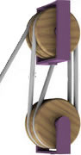

Meaning Crammed so tightly together as to prevent movement

A block and tackle is a pulley system used on sailing ships to hoist the sails. It might be expected that 'chock-a-block' is the result of wedging a block fixed with a chock. That doesn't appear to be the case. The phrase describes what occurs when the system is raised to its fullest extent - when there is no more rope free and the blocks jam tightly together.

7.Know the ropes 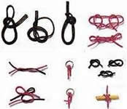
Meaning To understand how to do something. To be acquainted with all the methods required.
Sailors had to learn which rope raised which sail and also had to learn a myriad of knots.

8.Loose cannon

Meaning An unpredictable person or thing, liable to cause damage if not kept in check by others
A loose cannon was just what it sounds like, that is, a cannon that had become free of its restraints and was rolling dangerously about the deck. It could kill or crush a sailor.

9. Shake a leg
Meaning Rouse yourself from sleep and get out of bed. Hurry up.
Shake a leg meant that when sailors heard the phrase it meant hurry up and get out of your hammock. Shaking a leg told the caller that the message had been understood. SHOW A LEG was used when in early days when wives were allowed to share their husband’s hammock in a home port and the call went out the male(husband) had to show a leg that he was in the hammock, and not just his wife, as he had to go on duty.

10. Panic stations

Meaning A state of high alert, often a simulated panic for comic effect

Alarm gongs had already sent the guns' crews to their gun stations and immediately after the explosion on board their ship and if 'Panic stations' (which meant their ship was in possible danger of sinking) was ordered, it was followed in due course by 'Abandon ship'.

Now you are required to suggest meanings and reasoning for the following nautical terms :-

On Your beam ends b) High and Dry c) Get under way d) Cut and run

e) Hard and fast f) Three sheets to the wind g) The bitter end ( the clue is in the picture below

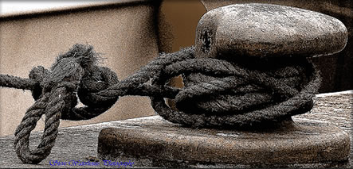
Bitt

Clue for f) 1 sheet = tipsy 2 sheets = stagger 3 sheets =

h) Plain sailing.
.

Top of Form

.

.

