Unusual Houses
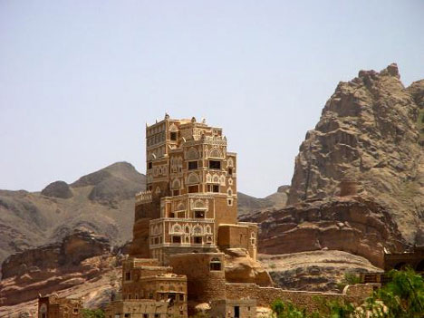
This unusual house is cut from a rock cliff and is the Palace of a holy man (Iman) who lives in Yemen.
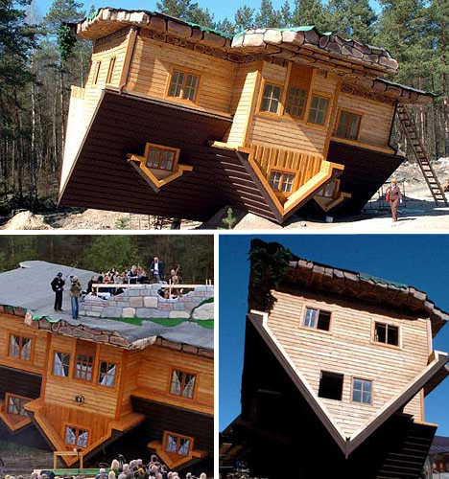
This upside down house is found in Poland just for fun.
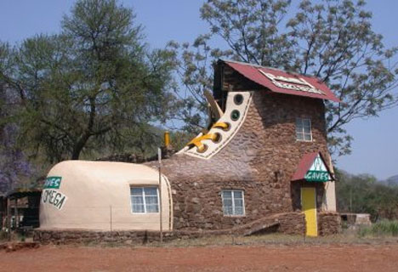Shoe house built by an artist in South Africa

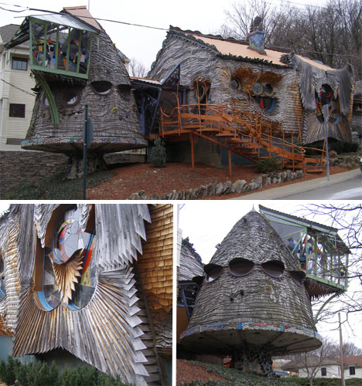 A mushroom house in the USA. It was built by an architect who wanted to experiment with wood.
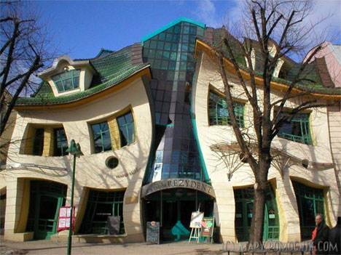 From Poland, the Crooked House. Not really a house but part of a group of shops.
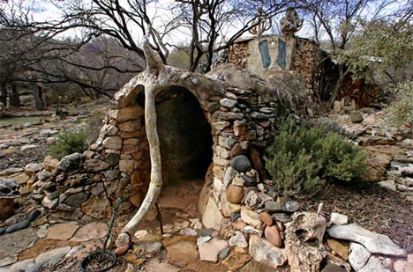This unusual house is partly underground and is made of wire, rubbish and stones. It is much larger than this picture shows and has 14 rooms each of a good size.

Now for Unusual Homes

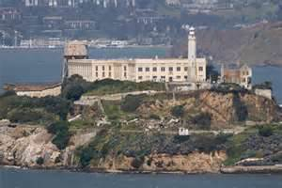This is a picture of Alcatraz Prison in San Francisco home to over 400 prisoners and said to be escape proof (only one man got out of the prison on the island but it is believed he was drowned swimming across the bay. It has been closed for more than 40 years and is a big tourist attraction.
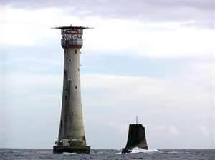This is the Eddystone lighthouse which stands 15 miles out in the English channel. It has usually 3 lighthouse keepers living there and this is their home for 2 months at a time. The flat top allows a helicopter to land there. Next to the light is the stump of an earlier lighthouse broken up by the sea. There are many modern prisons.
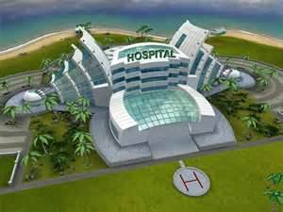 This is a hospital and some patients due to their illnesses are not able to leave the hospital, not even for a day. Thus a hospital is home to them.
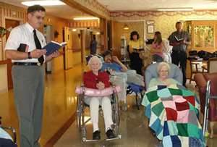 This is a nursing home where long term patients stay who cannot look after themselves. Many are too old or sick to mange by themselves.
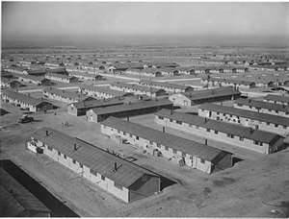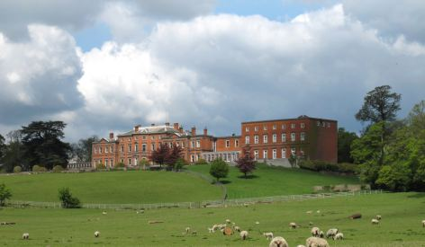
The picture on the left is an army barracks in the USA, the home of more than 8000 soldiers. On the right is a stately home which has been given by the Duke of Devonshire to the nation to make into a home for wounded and disabled soldiers, airmen and sailors.
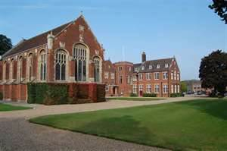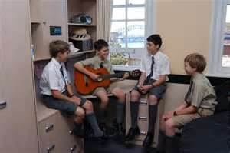
These two pictures show a boarding school. Here children live away from their parents for up to a year before going home in the summer holidays

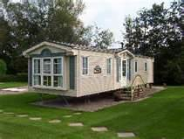People live all year round in a caravan
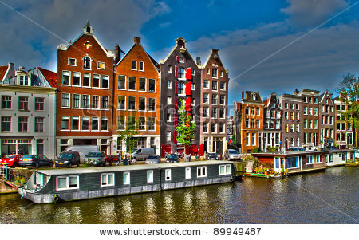Some People live on house boats
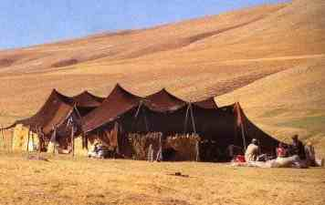 Desert people live in tents so they can easily move about

