Parts of a House 2

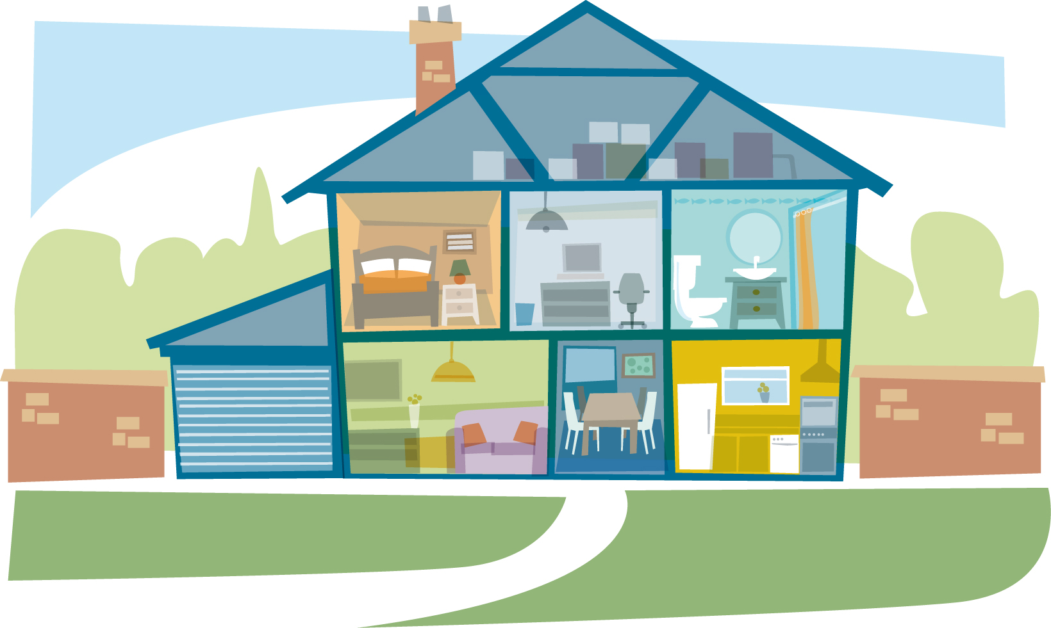

- Look at the box below with names for parts of a house. Fill the spaces above with the correct name
Living Room, Bathroom, Chimney, Garage, Dining Room, Attic, Bedroom

- Write down in your book which rooms are found downstairs and those which are found upstairs.

