Parts of a House 1.
This type of house is common in towns . It is called a 2 up and 2 down. This means 2 rooms upstairs and 2 rooms downstairs. Many of these houses were built more than 120 years ago and have had an extension (more rooms) added to make them bigger. This house has the extension built in the yard at the back. Two rooms have been added, a scullery (kitchen) and a bathroom and toilet. The picture shows an outside toilet (W.C.) which would have been how it was 120 years ago.

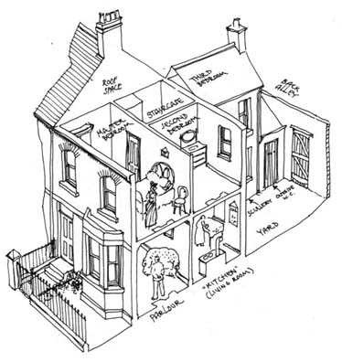
Things to do:-
- Label the picture with the following:- Front Door, Chimney, Extension, Bay window, roof, window
- What was the front room called in Victorian times?
- What type of house is this bungalow, detached or terraced?

