Modern Detached House
Water tank
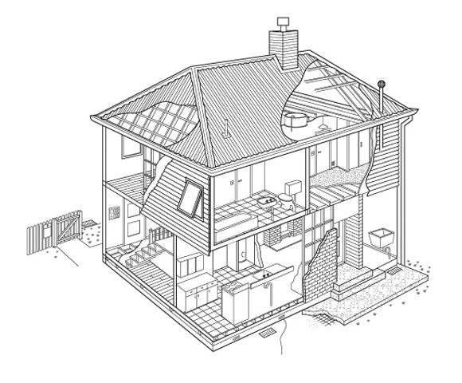
1.
2
3
Utility room for washing machine, drier etc.
4
5
6
7
8
9
10
Put the words in the box against the correct number:-

1. 6.
2. 7.
3. 8.
4 9.
5. 10.

Kitchen, front door, garden, bathroom, back bedroom, patio, back door, attic, stairs, front bedroom

