Looking at Victorian Artefacts - Items Used by Servants
All these items date from Victorian times. Click on some of the items to find out more or use the text links below:
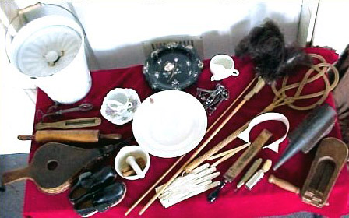
Slop Bucket, Moustache Cup,Feather Duster, Carpet beater, kitchen utensils, wood and leather shoes, housekeeper’s keys and cane, bellows, gloves and glove stretcher, invalid cup, wing collar, shaving utensils, bird scarer and bee smoker

