Furniture in a living room

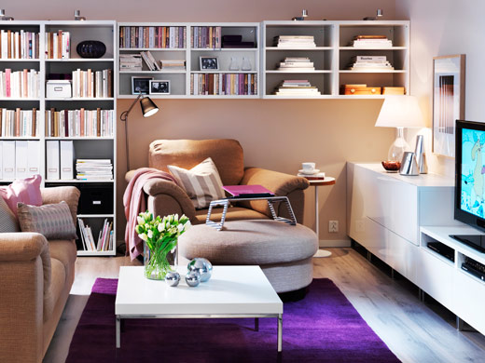
Study the picture above then look at the list below. If the article is in the picture put a tick next to the name on the list below. The first one is done for you.
Sofa (setee) chair bookcase reading lamp light TV
Rug bed foot stool computer kettle coffee table
Pillow Vase teapot cushion picture book clock
Tool chest cupboard sideboard wash basin video player wallpaper

