Class Tasks
- House Survey. Do a simple graph

Do a survey of the class to establish the types of houses pupils live in. Plot the results on a simple column graph (below) or on a pie chart or bar graph.
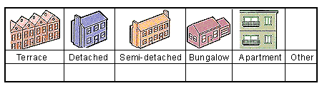

- Street collage

Make a street collage. Each pupil draws and paints a house front, including windows, window sills, guttering and drain pipes, aerials, etc

- Trades people
Can the class add to a list of trades people. Explore pupils' ideas of what these people might do around the house.

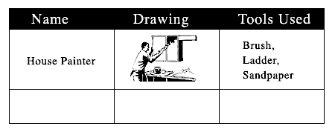
Examples are:- carpet fitter, joiner, plumber, electrician, glazier, window cleaner, TV engineer, gas man, gardener etc.
Answer the question "What is a house?"
Identify the main features of houses.
Identify house types: flat/apartment, bungalow, terraced, semi-detached, detached.
Survey the types of house in which the children of the class live.
Survey the types of house found within easy walking distance of the school.
Study some of the materials used for building.
Discuss the location of individual houses (a) relative to other features of the locality (b) in terms of address.
Discuss changes that have taken place recently at their houses eg repainting, erection of new fence, construction of garage.
Find out how land is used around their house: building, garden, path

