Building a Modern House
Here are some examples of materials which are needed to build a house:-
Bricks, sand, building blocks, cement, roof tiles, wood of all shapes and sizes, metal for beams nails and screws, stone, tiles for bathroom, tarred canvas, insulation materials, windows, doors, sliding doors, garage door, glass for windows
Plastic for water pipes and sewage pipes, plumbing joints, bath, taps, shower, guttering, downcomers. Electrical wires, sockets for plugs,
Kitchen sink, bath, washing sink, electicity junction box. Many other things.
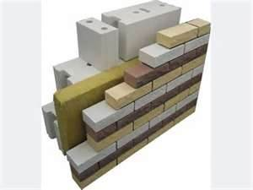Bricks and building blocks
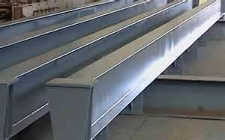 Metal beams
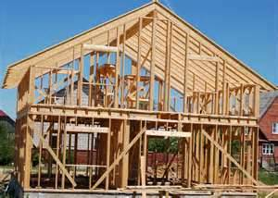 Wood of all shapes and sizes
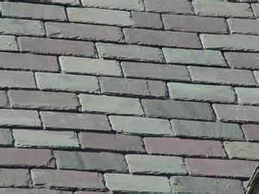Roof tiles 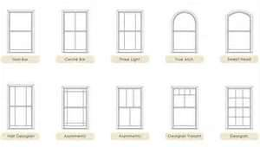 windows
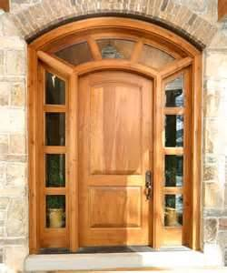 Doors Plastic pipes
insulation material 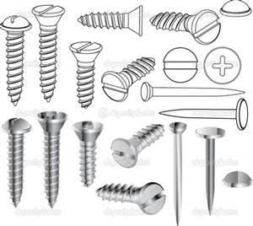nails,screws
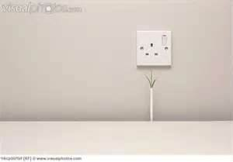wires/sockets 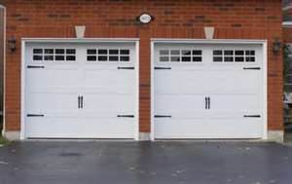Garage door
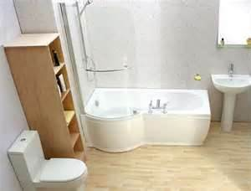Showers, baths and toilets

