6. Homes for Rich People - Modern apartments 2012
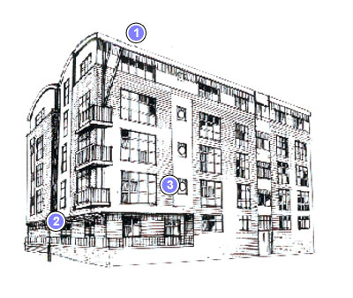

- Top floor penthouse apartment

- Lift and stairs to other apartments

- Large easy clean windows

- No chimneys . Apartments heated by electricity or gas.

