4. Homes for Rich People - Soho House 200 years ago.
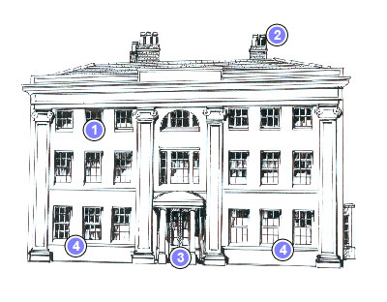

Owned by Matthew Boulton, a button and buckle maker.
- Servants rooms
- Chimneys for room fires
- Beautiful entrance to impress
- Rooms to entertain guests.

