3.Homes for Rich People - Aston Hall 400 years ago
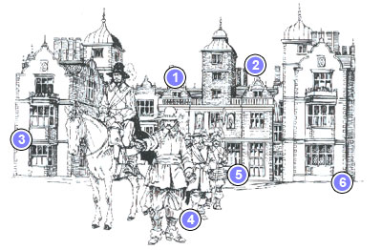

- Rooms for servants
- Towers to show off
- Grand rooms for guests
- King Charles leaving after staying the night
- The Great Hall
- The Kitchen

