2.Homes for Rich People - Weoley Castle 600 years ago
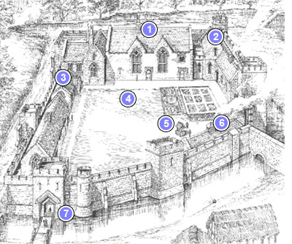

2. 600 years ago

1. The Great hall
2. The Kitchen
3. The Lord’s Chapel
4. The Garden
5. The well
6. The Bakehouse
7. The Gatehouse

