1.Homes for Rich People - A Stone Keep
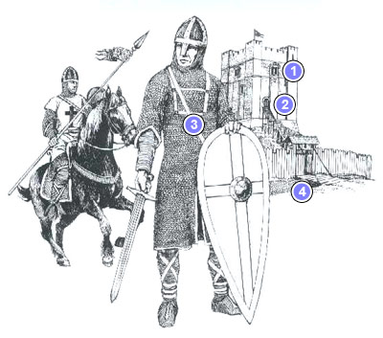 | A

1000 Years ago A Lord’s castle made of stone
1. Rooms for the Lord
2. Main Door
3. Lord in armour
4. Drawbridge

