How coal came to Hetton Part 2
Learning Objectives
- How Hetton and Easington Lane grew as villages
- The development of pits around Hetton.
Hetton in 1820.
If you lived in Hetton in 1820 you would have seen very few houses. The two biggest houses were Hetton Hall which was knocked down in 1923 (the Hetton Centre and swimming baths now stand on the site), Hetton House, (once used as Council Offices and near to the present bus station) and about three farms and a few cottages for the farm workers. There were no houses at Easington Lane, only one farm standing next to a country lane, surrounded by open fields. The lane ran from Easington village to Houghton-le-Spring.
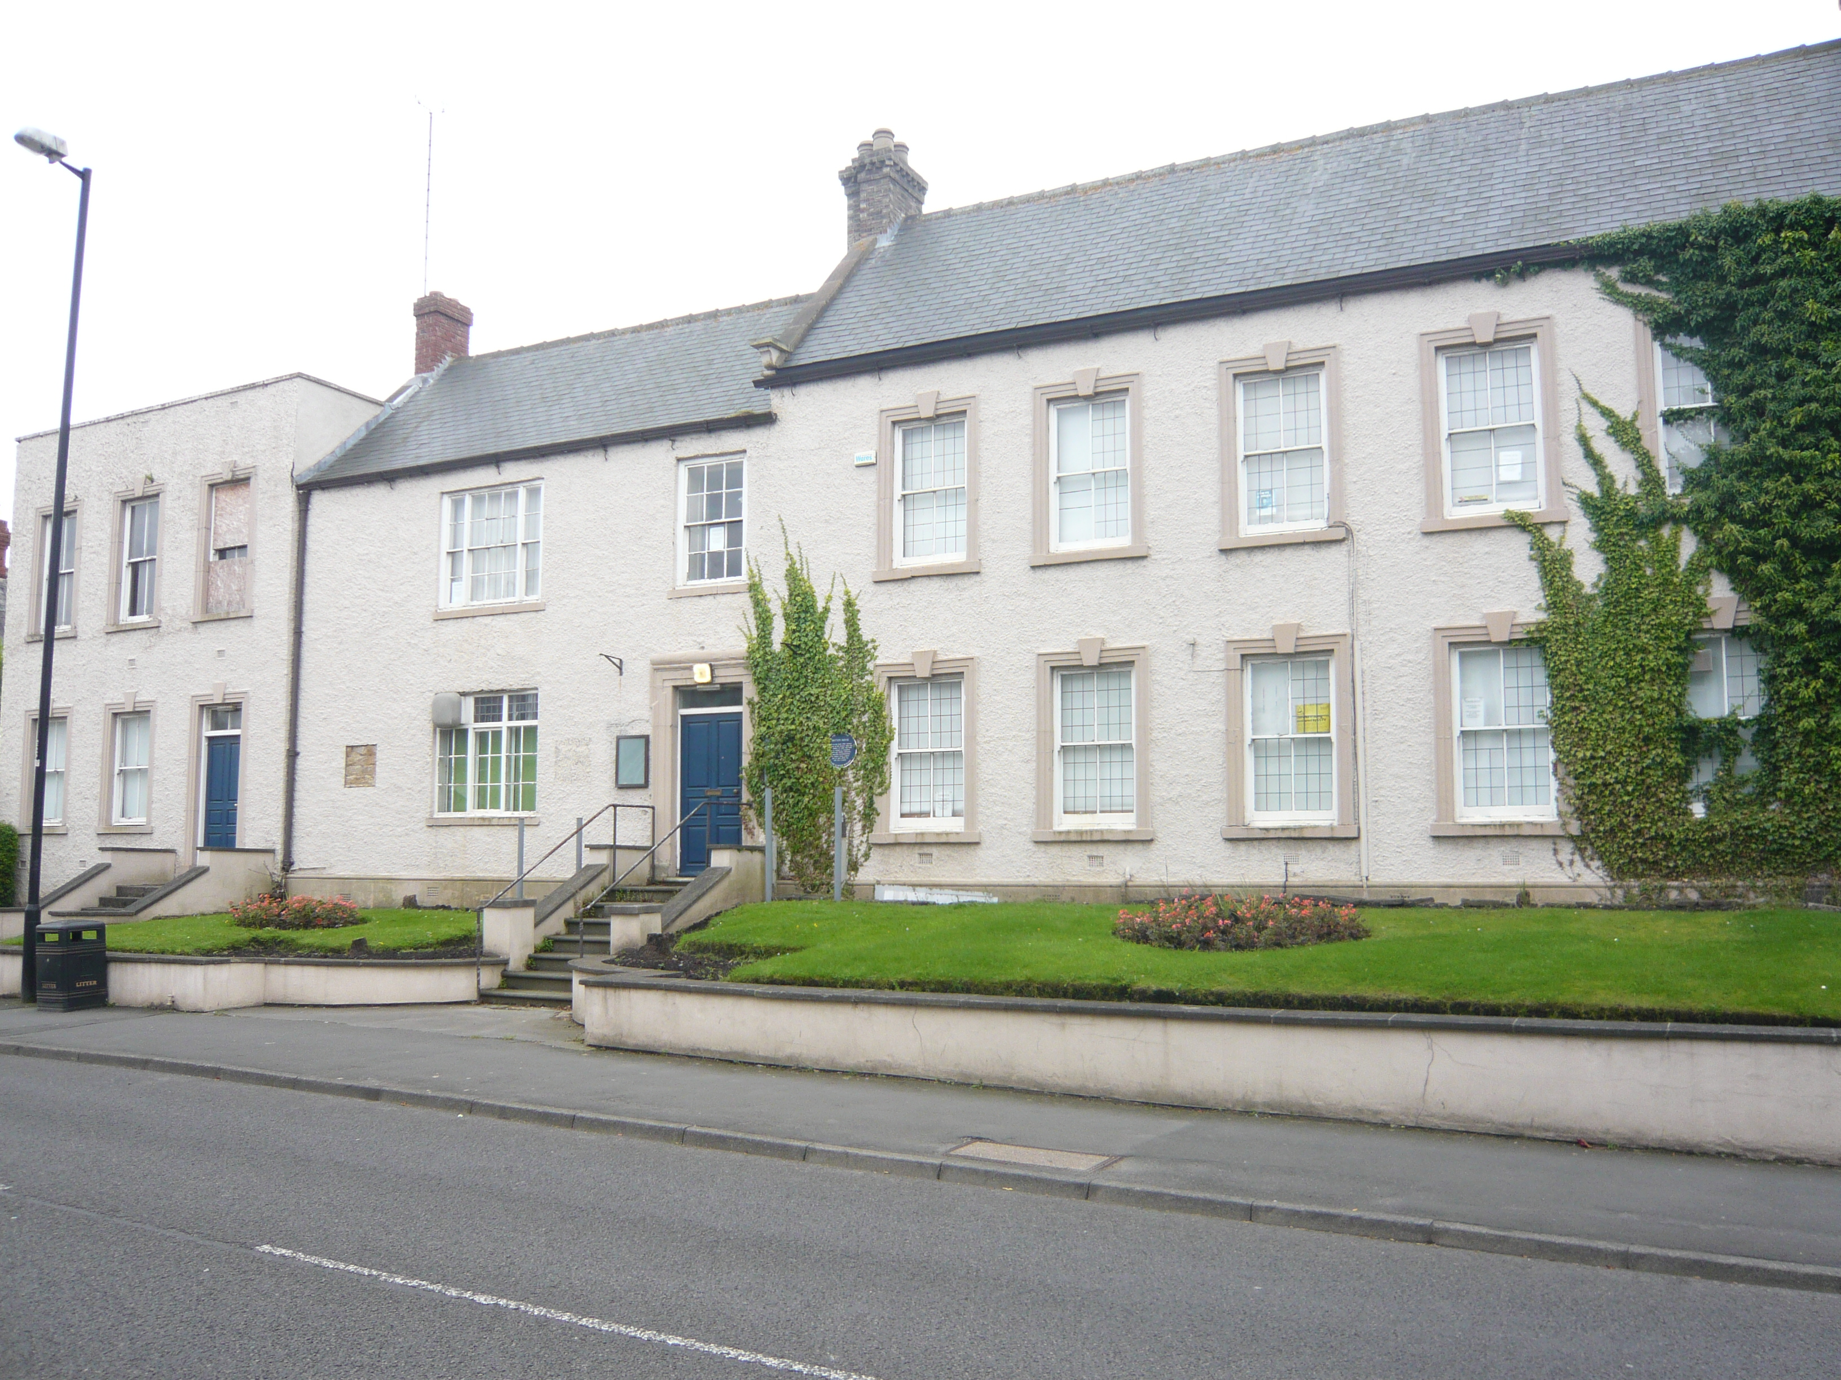
Hetton House as it is today

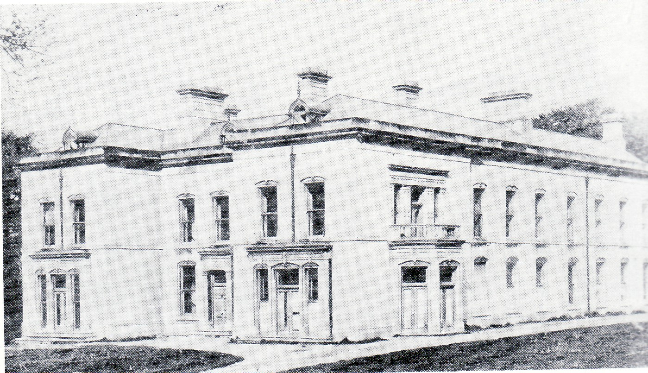

Hetton Hall in 1870. It was demolished in 1923

Coal had been found in 1812 at a pit which had been sunk close to East Rainton, 1kilometre to the west of Hetton. This was the Dunwell Pit. It only lasted a few years before the coal ran out so another shaft was sunk half a kilometre away and called the Hazard Pit.
It was thought that coal would be found in Hetton and the first drilling took place in 1812. The coal seams were much deeper in the Hetton area because on top of the coal measures was a thick band of rock called magnesian limestone. Many miners thought that this extra weight and pressure on the coal seams would destroy the coal. Once the technology for deep mining came along then it was decided to raise sufficient money to start the drilling process into the earth to find out if coal actually did exist at this lower depth. The first drilling in 1812 was unsuccessful since the drill went into an underground lake and the water rushed to the surface. By 1818 new thoughts about drilling took place and a company called the Hetton Coal Company was formed to raise money and drill in a different place. Drilling started in 1819 and the following year coal seams had been found. It was then that a shaft or hole in the ground 30 feet in diameter was started to get at the coal. The shaft was sunk and in November 1822 the first coals were brought to the surface.
As soon as the coal was found at Hetton and a colliery was to be built the Hetton Coal Company began building houses for the miners who would shortly be coming to the area. They started building miners’ cottages at the Lyons area (near to the present fishing lake on the Murton Road) and also at Easington Lane in an area called the Brickgarth.
The cottages were quite small and had only one room downstairs, the living room, and a loft in the roof which could be used as a bedroom. By 1825 about 100 cottages had been built in the two areas and more were to follow as new pits were opened.
In 1825 Elemore Colliery was started and within two years coal was being brought to the surface. Easington Lane and the Lyons continued to grow in size and by this time more than 500 men and boys worked at the Lyons pit. Easington Lane got a High Street with shops and pubs and more people came to live there.
In 1825 a new pit was sunk at Eppleton (on the limestone hills) but it had problems when both water and then sand flooded the shaft. It took eight years to solve the problem and the first coal came out of the colliery in 1833. In the meantime many new miners’ cottages were built in the area known as Low Downs and Hetton-le-Hole, ready to give houses to the many miners who were coming to live there and work in the pits. Thus the village of Hetton-le-Hole grew quickly in size with shops and pubs while the Downs, closer to the pit at Eppleton had the land on which the cottages could be built.
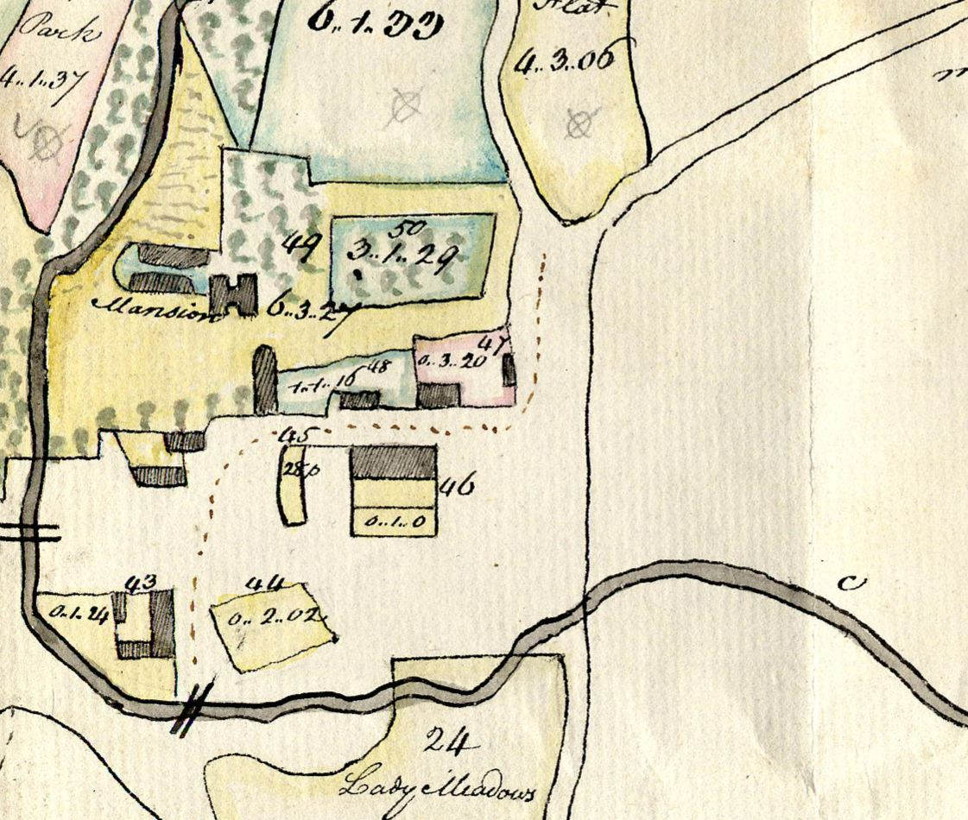
Downs Lane
Hetton Hall
Hetton House

To Easington Lane
Hetton in 1776
Hetton Beck

