How Coal came to Hetton Part 3
Learning Objectives
- How Hetton and Easington Lane grew as villages
- The development of pits around Hetton.
Hetton Lyons pit wasn’t the first pit to open in the area. In 1810 -1818 two pits were opened between East Rainton and the tiny village of Hetton-le-Hole. These pits were called the Dunwell Pit and the Hazard Pit. By 1820 the Dunwell pit had closed as it ran out of coal but the Hazard Pit continued to grow. As the village of Hetton grew a number of miners worked at the Hazard Pit. In 1839 a colliery at Moorsley opened called The North Hetton Colliery and later on it joined with the Hazard Colliery which was only three fields away from it.
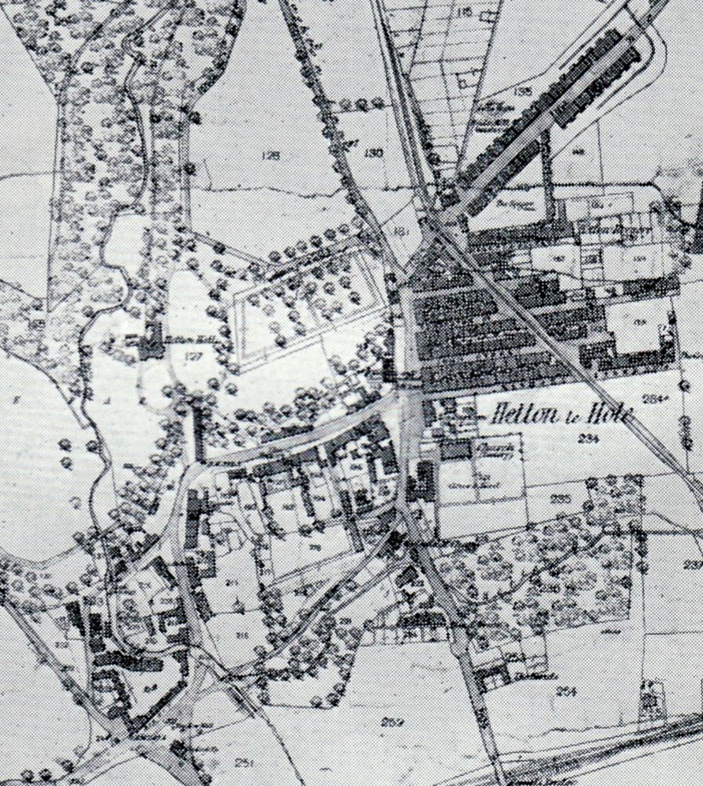
Hetton-le-Hole in 1856

Following the successful drilling which took place 1819 – 1820 and the sinking of the shaft in 1821 the new colliery was called the Lyons Colliery, named after the Lyon family who lived in Hetton House and who owned the land on which the shaft was sunk. The shaft was much deeper than others in the neighbourhood and was the first deep mine to go through the magnesian limestone strata (rock layers). Other mines would soon follow at Murton, Seaham and South Hetton as well as at Elemore close to Easington Lane.
Lyons Colliery
Magnesian limestone
Yellow sand
Shale
Coal measures
Coal seam
Shaft
cage

