How Coal Came to Hetton Part 6
Learning Objectives
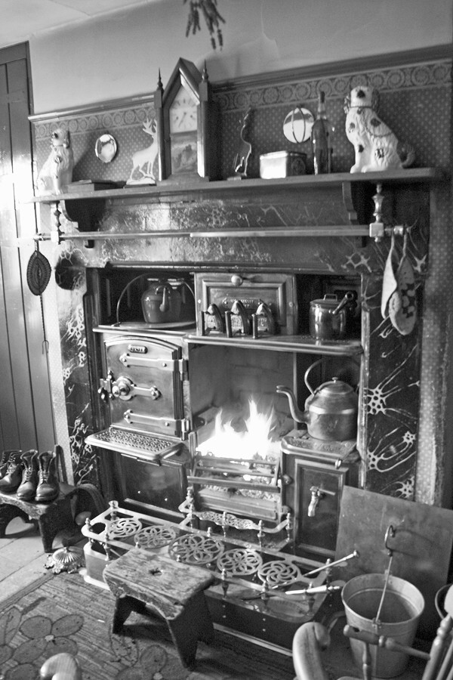
- To show the inside of a miner’s cottage and the living conditions of a miner’s family.
Hot water Boiler

Warming Plate
Blazer (to make the fire burn hotter)
Oven
Pan plate for warming food
Ash Bucket
Coal Fire
The fireplace was the most important place in the cottage. It was here that cooking and baking was done. It provided the only hot water in the house for cooking, washing and bathing in a tin bath. The living room was the warmest room and the ashes from the fire were taken and put down the toilet or thrown out into the street. The fireplace was thoroughly cleaned at least once a week.

Every miner’s cottage had a tin bath. The cottage had no bathroom or running water. A miner coming home black from a shift at the pit got bathed in front of the fire. The hot water came straight from the boiler, the large kettle and big pans put on the fire to heat up.
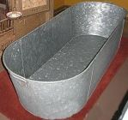
There was no inside toilet in the cottage, they were placed in a back yard or in the street, often some metres away. They were NOT flush toilets, the lid lifted up so that ash from the fire could be thrown on top of the toilet waste. In hot weather they were smelly. Every week or so during the night the soil man came with his horse and cart and dug out the waste from a door at the back of the toilet.

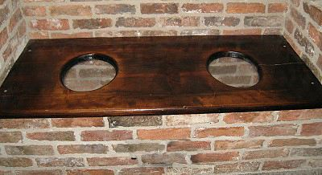

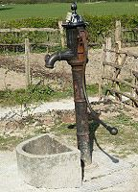
The water pumps were an important change to a mining village. When the first miners’ cottages were built in the 1820s fresh water had to be bought from a water carrier who collected it from a spring in the ground or you could collect it as rainwater that fell on the roof then into a barrel.
By the 1850s water was pumped from underground lakes and springs and there would be one pump for the whole street or in the yards of the bosses cottages. Running water was finally lead to houses and taps fitted 100 years later in the 1920s.

